SWAPA Students Aim for the Stars at the 2018 RASNZ Conference in Christchurch!

John Drummond

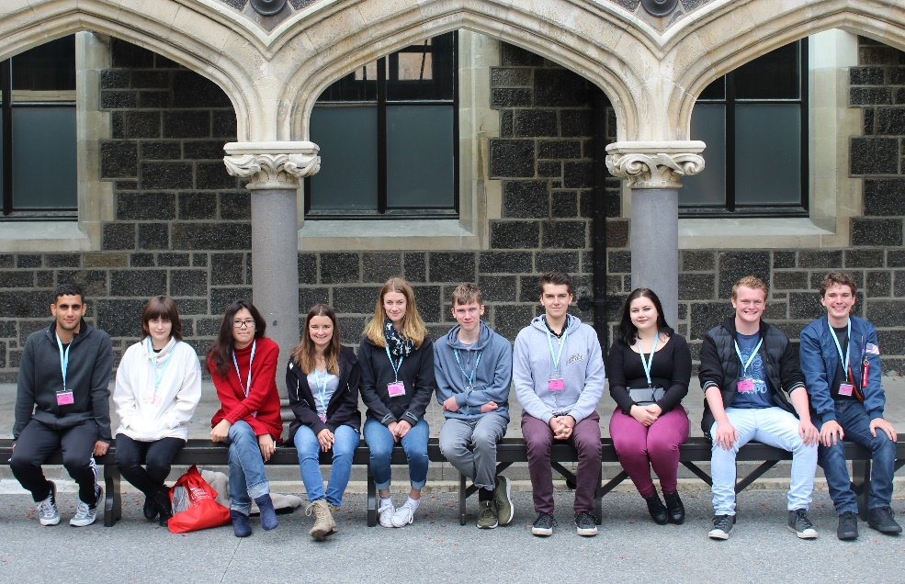
Those who attended the highly successful RASNZ conference in Christchurch in May 2018 will, like last year, have noticed a number of younger faced attendees. Some of these were high school students who attended as members of the SWAPA (Students With A Passion for Astronomy) scheme. This scheme, instigated by Prof John Hearnshaw 4 years ago, invites high school students from around Aotearoa to submit a 300-word essay stating why they have a passion for astronomy and why they should be chosen to attend the RASNZ conference free of charge. Email invitations were sent to nearly 500 high schools & 72 excellent entries were received. Of these, 10 were chosen as winners. These ten SWAPA winners won free conference registration, free entry to the Saturday night banquet, free travel to/from the conference and their accommodation was paid for. This due to the very generous donation of Michael Snowden. In addition, the ten SWAPA students received a one-year membership subscription to the Royal Astronomical Society of New Zealand.
2018 SWAPA winners at the University of Canterbury. Left to right: Zariab Karkaria, Odette Louw, Phoebe Pou, Emma Fairweather, Masie Hopkins, Mitchell Nairn, Zane Hunt, Zoe Brown, Matthew Tattersall, Forester King. Photo: unknown.

On the Saturday morning, before proceedings, these year 13 students met with three professional astronomers - Karen Pollard (University of Canterbury), John Hearnshaw (University of Canterbury) and Nic Rattenbury (Auckland University) - to talk about possible careers in astronomy, physics, etc. The questions asked by the students during this pre-conference talks breakfast were excellent.

During the conference it was very pleasing to see the students meeting with and discussing astronomy with professional and amateur astronomers. The enthusiasm and maturity shown by them was meritorious. They were also drooling over telescopes, binoculars and other goodies that RASNZ sponsor, ASTRONZ, had at the conference.

The SWAPA scheme will run again in 2019 at the conference in New Plymouth. If you are a high school student and would like to enter, please write a short statement of no more than 300 words explaining why you would like to attend the conference and why you are interested in astronomy. This statement should be sent to the RASNZ Immediate-Past President, John Drummond (email: kiwiastronomer@gmail.com ) by Friday 15th March 2019, 5 pm. Include your name, gender, age, school, year of study at school in 2019, city, email address, telephone contact and science teacher’s name/phone/email. The winners of the competition will be selected for their clear enthusiasm of astronomy, seniority, and good English in their submitted statement. Alternatively, a printed version can be posted to John Drummond, PO Box 113, Patutahi 4045. This SWAPA competition is most applicable to students in Years 11-13, however excellent students in Years 10 or below should not be deterred from applying. Results will be sent out in early April 2019.

John Drummond
RASNZ Immediate-Past President

See http://www.rasnz.org.nz/groups-news-events/events/32-conference/542-conf-swapa2019 for student comments

