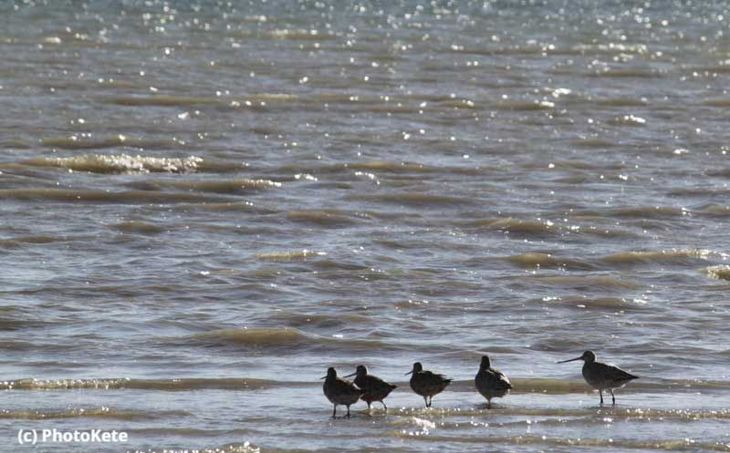Sea week—Kaupapa Moana 2019

Seaweek 2019 is Saturday 2 to Sunday 10 March.

The theme for 2019 is **Tiakina o Tātou Moana—Care for our Seas.**

Part of this theme involves understanding the life cycles of  animal and plants that live in the ocean.

Seaweek is a chance to develop understanding about the elements that make up the ecosystem of te moana, and raise awareness of importance of care of the sea.

The science resources below make good starting points for discussions about the relationships between animals and plants that make the sea their home.

Resources about interdependence in the sea:

* [Rocky shore food web](https://nzcer.us3.list-manage.com/track/click?u=b4267ae33b4ec83afacabc0ef&id=5b7267f965&e=8f61c7dba4)(Level 4)
* [Who eats whom at the rocky shore?](https://nzcer.us3.list-manage.com/track/click?u=b4267ae33b4ec83afacabc0ef&id=13bec39629&e=8f61c7dba4)(Level 4)
* [Living in the ocean](https://nzcer.us3.list-manage.com/track/click?u=b4267ae33b4ec83afacabc0ef&id=77f9353a0c&e=8f61c7dba4) (Level 4)
* [Pāua](https://nzcer.us3.list-manage.com/track/click?u=b4267ae33b4ec83afacabc0ef&id=032129fb9b&e=8f61c7dba4)  (Level 4/5)
* [Cockles](https://nzcer.us3.list-manage.com/track/click?u=b4267ae33b4ec83afacabc0ef&id=9f7d3a0d9a&e=8f61c7dba4) (Level 5)
* [Feeding relationships in the Southern Ocean](https://nzcer.us3.list-manage.com/track/click?u=b4267ae33b4ec83afacabc0ef&id=e116af9996&e=8f61c7dba4)  (Level 5).

Resources about environmental issues which impact on the beach:

* [Rubbish on the beach](https://nzcer.us3.list-manage.com/track/click?u=b4267ae33b4ec83afacabc0ef&id=7b3bcd68c9&e=8f61c7dba4) (Level 1/2)
* [Amongst the sand dunes](https://nzcer.us3.list-manage.com/track/click?u=b4267ae33b4ec83afacabc0ef&id=e5ca2bb73c&e=8f61c7dba4) (Level 2)
* [Cleaning up the beach](https://nzcer.us3.list-manage.com/track/click?u=b4267ae33b4ec83afacabc0ef&id=fee2f28964&e=8f61c7dba4) (Level 3)
* [Beach clean- up](https://nzcer.us3.list-manage.com/track/click?u=b4267ae33b4ec83afacabc0ef&id=d7f2e2926d&e=8f61c7dba4) (Levels 3/4).

The resource [A Mystery Photo](https://nzcer.us3.list-manage.com/track/click?u=b4267ae33b4ec83afacabc0ef&id=ad96ac1974&e=8f61c7dba4) looks at evidence of the impact of human rubbish on animals. And the resource [What do you know about the greenhouse effect?](https://nzcer.us3.list-manage.com/track/click?u=b4267ae33b4ec83afacabc0ef&id=8030d6528f&e=8f61c7dba4) (Level 5) looks at students' understanding of the effects of greenhouse gases on climate change, including on oceans.

Resources about things that live in the ocean:

* [What makes a fish a fish?](https://nzcer.us3.list-manage.com/track/click?u=b4267ae33b4ec83afacabc0ef&id=41fc0ad466&e=8f61c7dba4) (Level 2) - classification
* [Is it a fish?](https://nzcer.us3.list-manage.com/track/click?u=b4267ae33b4ec83afacabc0ef&id=38877097af&e=8f61c7dba4) (Level 3) - classification.

You can also find out more about a range of events, activities, competitions and calls to action at [Seaweek.org.nz](https://nzcer.us3.list-manage.com/track/click?u=b4267ae33b4ec83afacabc0ef&id=17198c8ae3&e=8f61c7dba4).