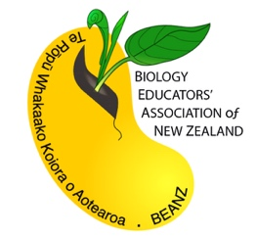
BEANZ Waikato

invites you to

St Peter’s School Cambridge

for a

Homeostasis
(AS 91604)
Workshop

Al Dixon (Te Aroha College) will present this workshop looking at the teaching and assessment of AS91604. This will include:
- Looking at examples of assessment tasks and marking schemes
- Looking at moderator feedback
- Sharing learning and assessment resources

Date: Tuesday 4 June, 2019
Time: 9am-9:25am tour of St Peter’s, 9:30am-3pm workshop
Location: Science Block, St Peter’s School Cambridge (see attached map)
Parking: Please park by the Gym, which is on the right hand side as you come up the drive
Cost: Free, but PLEASE BRING YOUR OWN LUNCH

Nb. There are some lovely cafes within driving distance, but our campus provides a great venue for a picnic and there are comfortable lounges. There is a microwave available.

Tea, coffee and water will be provided.

Register for this workshop by adding your details to the registration document at: https://docs.google.com/spreadsheets/d/1o9UZRulCKIzkHhSc-ckw2gM5ANCrRMPlXZWjjb0sCQU/edit?usp=sharing

All participating schools are expected to provide a teaching or assessment resource to share at this workshop.

