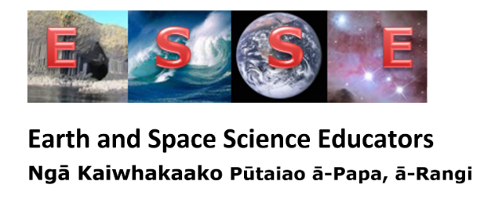
Earth and Space Science teacher support day – Science with ESS course
When: August 19th, 2019. 9.00 am – 3.00 pm
Where: Kohia Centre. Gate 1, 78 Epsom Ave, Epsom, Auckland 1023, parking at Gate 2, 76 Epsom Ave, Epsom, Auckland 1023
Cost: No fee – the Network of Expertise funding covers this
What to bring: your computer and a good class practical activity if you can
Morning tea provided; bring or buy your own lunch.
To register contact Jenny Pollock earthspacenz@gmail.com or jenny.pollock2@gmail.com

Earth and Space Science Educators Networks of Expertise: MOE00908

Outline of the day:
9.00 – 10.30 am
- Welcome, House Keeping, Introductions
- Background to the Network of Expertise funding. The teacher support now available – ‘For teachers, by teachers’.
- Internal assessments – what has worked, or not, and what teachers would like to try.

10.30 am: Morning tea
LEARNING OUTCOMES: At the completion of the course participants will be able to feel more confident in their teaching and delivery of Earth and Space Science or Science with ESS. They will have been introduced to their regional representative and will know where to go for support when they need it.

- Internal assessments continued
- Sharing of good practical ideas

12.30 pm: lunch
- Ideas for Geology and other types of field trips.
- The future – the standards review and what this
means to Earth and Space Science
- Feedback

3.00 pm: Finish
Jenny Pollock is the Chairperson of ESSE and is administering the ESS Network of Expertise funding for ESSE. Jenny is a retired ESS teacher and has been a key person in the development and resourcing of Earth and Space Science. She has extensive experience in both internal and external assessment and resource writing.
John Smith (Rosmini) is one of the ESSE regional representatives for the Auckland region.

Website for Earth and Space Science: www.earthspacescience.org.nz

