Drawing in Science

In the electronic age there is still a place for scientific drawing. Just as with our language and writing style, drawing in science is different to drawing in everyday life.

Artistic drawing | Scientific drawing
We draw to catch an impression of something | We draw to record and communicate information, not make art.
Sometimes we do not worry too much if it is not an exact replica, people get the idea – an impression. We use shade and colour | The drawing has crisp, clear lines and is intended to be a good replica. We tend not to use shade or colour.
Not all of us are good at making art like this. | We don’t have to be an artist to create a successful scientific sketch.
May have a title and artist name. | Has title and sometimes scale or magnification. Often includes labels (names) or annotations (descriptions & explanations).

What makes a good scientific drawing? We can use the mnemonic ABCDE:
Accurate – with respect to size, shape, texture. Clean, even, continuous lines - needs sharp pencil
Big – large enough to see details
Colourful – when needed, coloured pencil is better than felt pens as the lines are crisper
Detailed – not just any kauri leaf, but the kauri leaf you are drawing. See activity below.
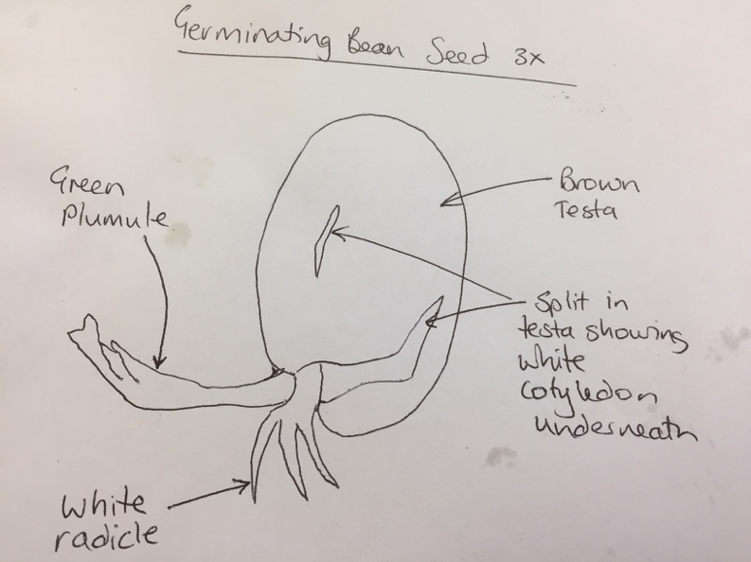
Explained – labels, annotations, questions

An indication of scale is useful.
To calculate scale:
Height of diagram ÷ Actual height
e.g. magnification of 3X means diagram is 3 times bigger than its subject.

Activity
- Give each student a leaf of the same type but with individual differences.
- They will need pencil & paper.
- Ask them to draw and label their leaf. Allow plenty of time, 10-15 minutes.
- In groups place the leaves in the middle and the drawings around the outside. Ask students not to put their drawing next to their leaf
- Ask students to match a drawing and leaf that is not their own. Artist says if right or wrong.
- As a group, then as a class discuss:
  - What helped you make a match?’
  - What do you notice about the different drawings?
  - Did you notice any other differences between drawing as an artist and drawing as a scientist?

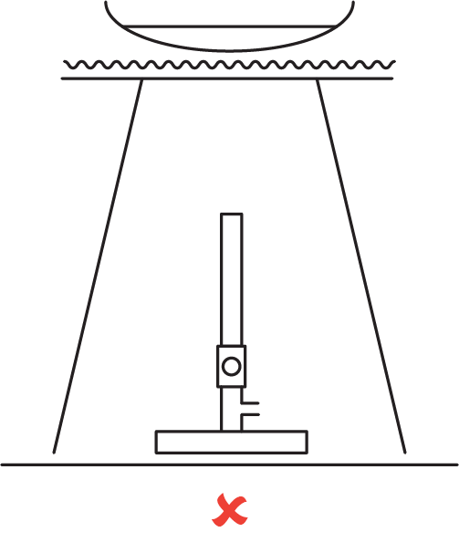
Drawing equipment
Again we need to remember we are recording and communicating information, not making art. We want to represent scientific equipment and experiments in a simple and clear manner. Remember ABCDE, also
    - Use a sharp lead pencil.
    - Draw objects in two dimensions (as below)
    - Draw clean, single lines.
    - Don’t close off openings of glassware (as below)
    - Use a ruler to draw straight lines.
    - Don’t shade or colour in.
    - Don’t ‘float’ objects (as alongside)
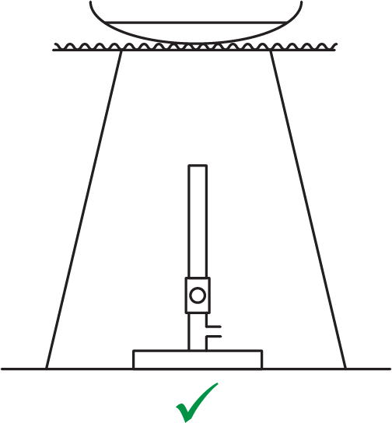
    - Label objects with simple straight lines, when needed
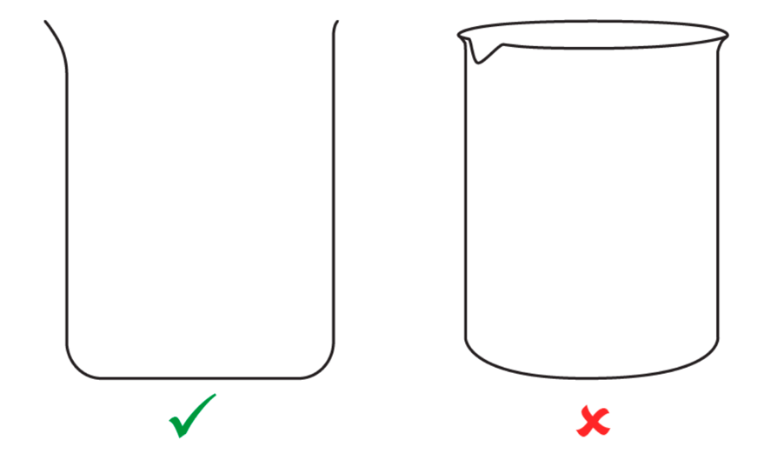

Drawing Cells
Remembering ABCDE, also: Onion cells with Iodine stain, 100X
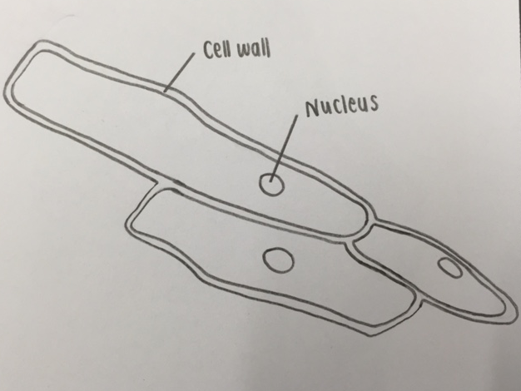
- Draw what you see, not what you expect to see
- Do not draw air bubbles
- Draw as simply as possible with clean cut (not “hairy”) lines
- Draw a few representative cells, not the whole field of view
- Carefully draw cells touching, if that is what you see.
- Indicate thickness of walls, membranes
- Label with ruled lines
- Include a title with name of organism, name of any stain used and magnification

References
https://www.calacademy.org/educators/lesson-plans/introduction-to-scientific-sketching
https://www.goodscience.com.au/year-7-chemistry/scientific-diagrams/

