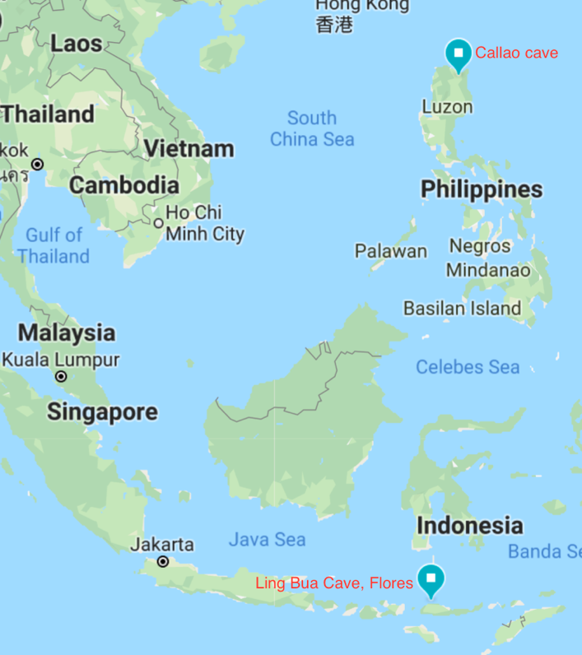
New species of hominin, Homo luzonensis

Thirteen hominin bones found in a cave are so unique that archaeologists have determined they stem from a distinct hominin species, although others question whether the researchers have enough evidence.

In the early 2000s, Armand Salvador Mijares, a graduate student at the University of the Philippines, was digging at Callao Cave, on Luzon, looking for traces of the first farmers on the Philippines.
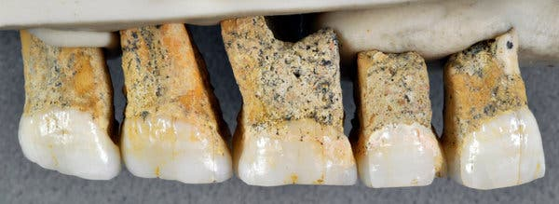
Luzon seemed especially difficult for ancient hominins to reach, so archaeologists thought that digging into deeper, older layers of soil wouldn't yield much. When Mijares first excavated this cave in 2003, he found 25,000-year-old evidence of human activity, but he didn't dig any deeper than about 1.2m down.
Figure 1 Map showing position of H luzonensis and H floresiensis excavation sites.
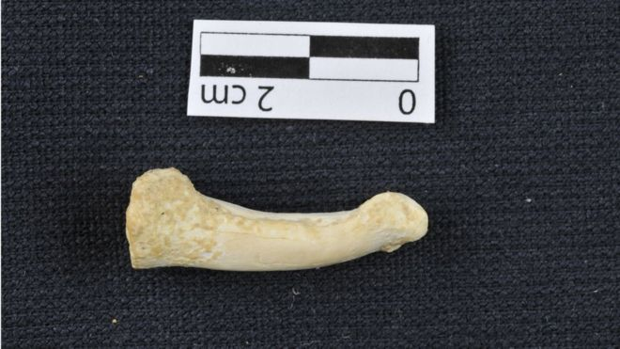
Then in 2004, researchers unearthed 50,000 year old Homo floresiensis at 6m depth in the Ling Bua cave on the island of Flores in Indonesia. Mijares, thought digging deeper might be worth it after all and returned to Callao Cave in 2007 to have another try.
Figure 2 Upper teeth from left, 2 premolars & 3 molars
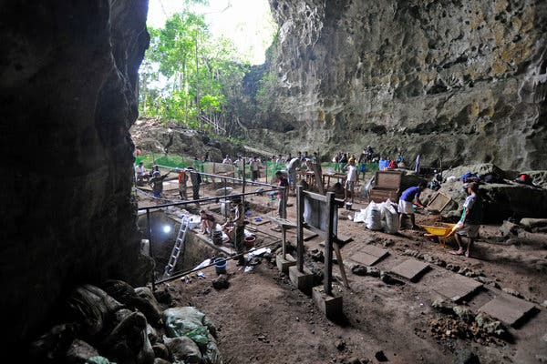
At 2.7m depth Mijares’ team found a layer of breccia, a type of rock formed from a jumble of other materials. This layer contained fragments of bone that had washed into the cave long ago - deer, pig, and a nearly complete foot bone that looked human. They returned as funding allowed, in 2011 and 2015, digging deeper and finding more bones each time. At first Mijares and his colleagues, thought the bones might belong to a small-bodied member of Homo sapiens. But as the digs found more bones their ideas changed.
Figure 3 Curved toe bone suggests climbing was still an important activity for this species. Florent Detroit.
In April 2019 they published analysis of their findings - 3 toe bones, 7 teeth, 2 finger bones, and part of a femur, from at least 3 individuals. These fossils have been dated using uranium series ablation to between 67,000 and 50,000 years ago.

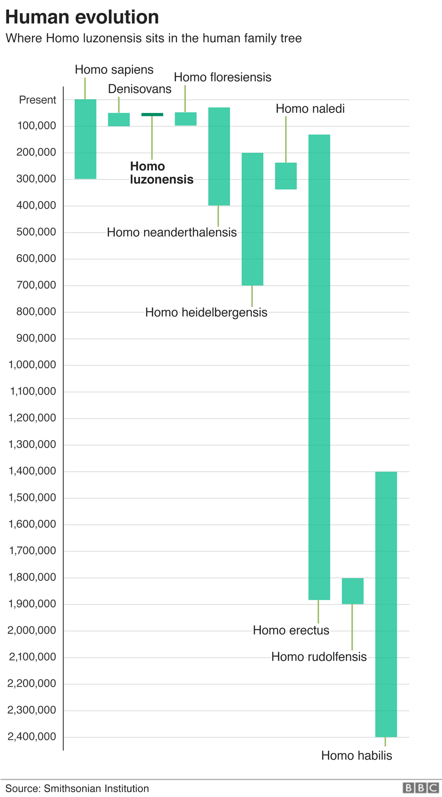
The small fossils' curves and grooves reveal an unexpected mix of both ancient and more advanced traits. The teeth are very small (8 mm across) and their shapes are relatively simple (modern trait); one upper premolar has three roots (ancient trait); and one foot bone resembles those of the ancient australopithecines. The tiny teeth suggest that H. luzonensis was short (less than 1.2m tall), although this is not conclusive due to the lack of larger bones.
Figure 4 Excavation site. Callao Cave Archaeology Project.

The combination of features is new, leading the research team to think they have a new species which they have named Homo luzonensis. While many scientists laud the research for its thoroughness, others feel 13 small bones and teeth is not enough evidence from which to define a new species. Though the scientists attempted to extract DNA, they were not successful, as exposure for millennia in the heat and humidity of the tropics degrades DNA.
Anthropologist Shara Bailey, an expert on ancient teeth, notes that South Africa's Homo naledi also has features that look both ancient and modern. She takes the two discoveries as a sign that “mosaic” evolution was more common among hominins than once thought.
There is also some evidence of tool use. In 2010 a deer bone found in the same sediments bears what look like stone-tool cut marks, suggesting H. luzonensis was a toolmaker and hunter. In 2018, Mijares and his colleagues found stone tools and a butchered rhinoceros skeleton that were more than 700,000 years old, not too far from Callao Cave – but was this toolmaker a relative of Homo luzonensis or not?
Figure 5 Where H luzonensis sits in the human family tree. Smithsonian.
Another major unknown is how the ancestors of H. luzonensis reached the Philippines, as up til now all evidence suggested hominin dispersal 150,000 years ago occurred over land – they walked. But Luzon has never been connected to the mainland by a land bridge even at the height of the ice age (when ocean levels were at their lowest). Stone tools dating to 150,000 years old have also been found on another Indonesian Island, Sulawesi. Evidence is accumulating that in the remote past hominins have successfully settled on several different islands in south-east Asia – Luzon, Sulawesi, Flores. This pattern suggests they probably did not get here accidentally - they may have rafted or boated and it may have been intentional.
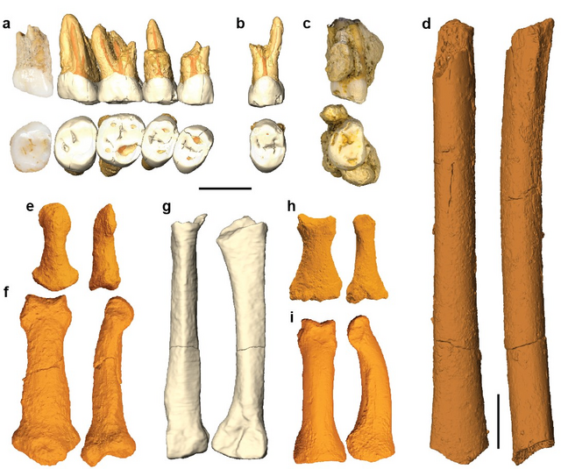
Figure 6 Two views of each of the H luzonensis fossils found.
A = post canine maxillary teeth B = premolar (left P3 or P4) C = Molar (right M3) D = juvenile femoral shaft E =distal manual phalanx F = intermediate manual phalanx G = 3rd metatarsal H = intermediate pedal phalanx I = proximal pedal phalanx

Sources
- https://www.bbc.com/news/science-environment-47873072
- https://www.nationalgeographic.com/science/2019/04/new-species-ancient-human-discovered-luzon-philippines-homo-luzonensis/
- https://www.wsws.org/en/articles/2019/08/21/humn-a21.html
- https://www.nytimes.com/2019/04/10/science/homo-luzonensis-philippines-evolution.html
- https://www.theguardian.com/science/2019/apr/10/new-species-of-ancient-human-homo-luzonensis-discovered-in-philippines-cave
- https://cosmosmagazine.com/palaeontology/the-struggle-to-understand-the-hobbit
- https://www.the-scientist.com/news-opinion/new-species-of-human--homo-luzonensis--identified-in-the-philippines-65722

