Activities to start the year in Science

Nature taster activities
Designed to pick up and go like a recipe card, these six 'nature taster' cards make it easy to get outdoors and use nature for teaching and learning.

The back of each card explains the internationally recognised pathways to nature connection research. The pathways have been found to improve wellbeing and to grow a positive attitude towards caring for nature. These ‘nature taster’ activities have been designed to provide pathway opportunities for learners.
These outdoor activities could be used as icebreakers in Term 1 to support building relationships with each other and your local natural environment.
Check out the benefit facts of teaching in nature - every card has a different one!
https://www.doc.govt.nz/education-naturetasters

Draw a Scientist
This is a good start-of-year activity at any level to surface students' prior understandings of the Nature of Science and the demographics of scientists. The teacher guide suggests how to draw the most out of the ensuing discussions https://bit.ly/2NtKnR0

Cube science starter activity
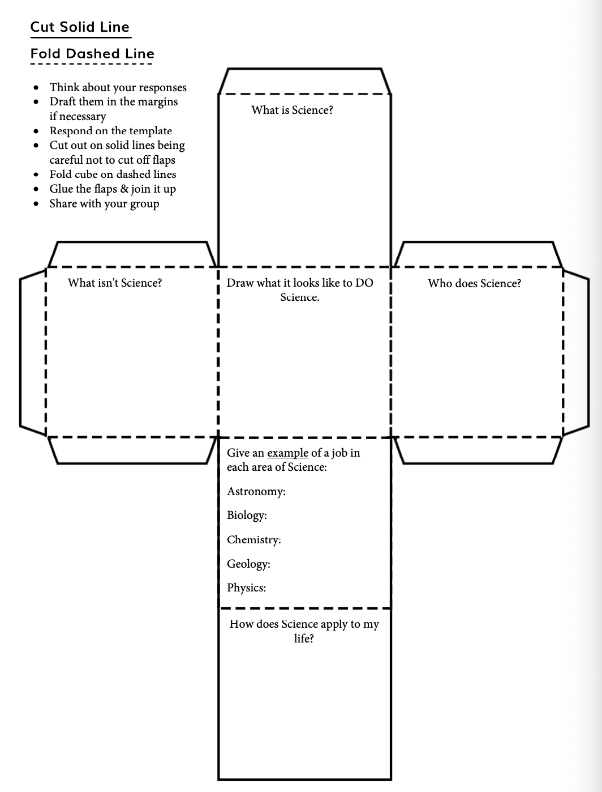

This is also a good time to find out about your students. Adapt these as you see fit.
Tick those you have experience of. Add others relevant for you.
Lego or mechano Cooking
Walking in the bush Keeping pets
Farming / gardening Fixing things
Hunting fish/bird/pig
Making models
Learning challenges – what do you find difficult?
Learning strengths – what are you good at?
Successes in Science?

What are your goals (in-school) & aspirations (beyond school)?

What are your family’s/ whānau goals & aspirations for you?
What are your interests?

What activities do you do in your own time?

What languages are spoken at home?

What is your ethnicity?

NAME:

