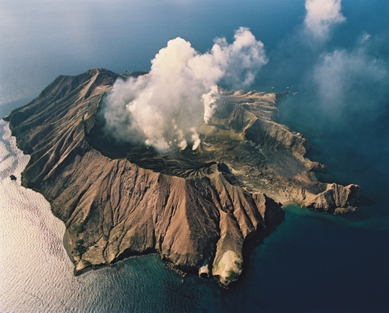**Whakaari / White Island**

Whakaari / White Island is an [andesite](https://en.wikipedia.org/wiki/Andesite) [stratovolcano](https://en.wikipedia.org/wiki/Stratovolcano), also called a composite cone volcano, 48 km off the coast of Whakatane. It is made up of layers of lava and ash and was formed by the subduction of the Pacific tectonic plate below the Australian plate. The exposed island is only the peak of a much larger [submarine volcano](https://en.wikipedia.org/wiki/Submarine_volcano), which rises up 1,600m from the seafloor - 70% of this volcano is underwater. It is NZ's most active volcano, built up by almost continuous volcanic activity over the past 150,000 years.

The name Whakaari means "to make visible" or "exposed to view". The full Māori name for the island is *te puia whakaari*, meaning the dramatic volcano. Whakaari was named White Island by Captain Cook in 1769 because of its dense clouds of white steam.

Figure 1 White Island is often seen capped by clouds of steam. GNS

Whakaari is a private scenic reserve, visited by tourists and scientists. Daily tours bring more than 10,000 visitors to the island

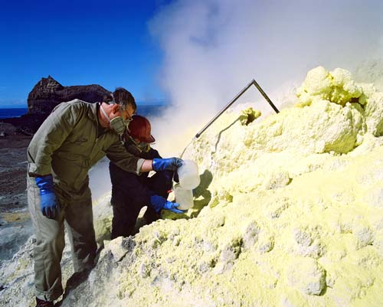every year. They are given hard hats and gas masks to protect

against the sulphurous steam and must wear fully-enclosed shoes.

GNS’s GeoNet program continuously remotely monitors volcanic activity with webcams, seismometers (measuring earthquake activity) UV spectrometers (SO2 emission rate) and GNSS (ground deformation). Scientists from GNS frequently visit White island to collect gas and water samples, and other geophysical data and make general observations. Information bulletins are sent to 300 recipients to advise of any changes in activity.

Craters and fumaroles continually produce gases – mainly steam, CO2 and SO2. As a result small clouds can often be seen above this active volcano. On several occasions Whakaari has been more active - previously erupting in periods spanning 1975-2000, 2012- 2013 and 2016, mostly emitting steam, sulphur and ash. In 2016, a shipping container was placed on this island to act as an emergency shelter in case of an eruption.

Figure 2 Scientists collect gas samples. GNS

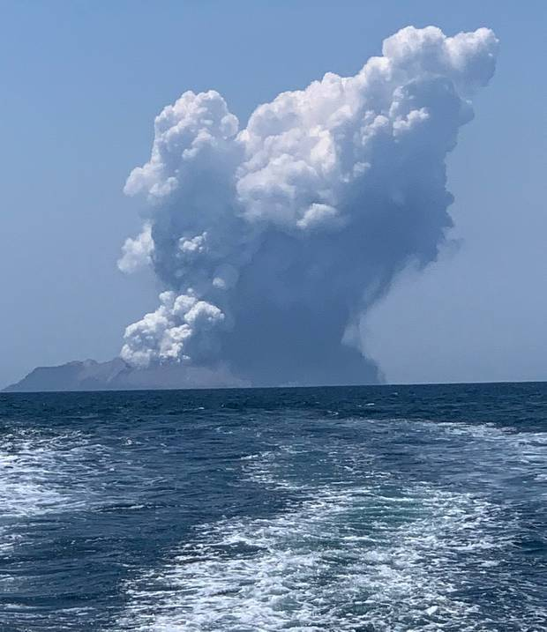

On 9 December 2019, a total of 47 visitors were on the island - one helicopter had just landed, one boatload was departing after an hour on the volcano and passengers from another boat had disembarked and were making their way to the crater. Suddenly at 2:11pm the volcano erupted for 1-2 minutes at the main crater, sending an ash cloud 3.5km into the air.

There was little or no warning, as is typical of a phreatic (steam-driven) eruption. Ground water heated by the shallow magma had been trapped in rock pores in a superheated state. In a phreatic eruption the pressure on the hot and trapped water is released suddenly. Water then expands to 1,700 times its original volume at super-sonic speed, with catastrophic results. As well as this, the volcano released a pyroclastic surge, hurricane-like currents of wet ash and coarse particles that can cause deadly impact trauma.

This phreatic explosion was accompanied by emissions of gases: H2S, a broad spectrum poison that can stop the heart in high concentration; SO2 and CO2, which make the steam cloud highly

Figure Massive cloud of ash and steam in the 2019 eruption. Twitter

acidic - it can sting the eyes and skin, affect breathing and damage

equipment and clothes.

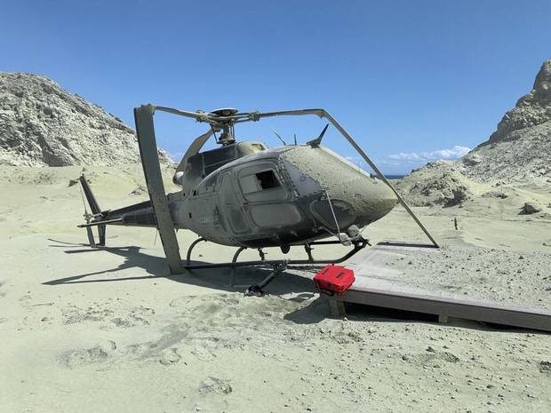People walking towards the crater were directly in the path of this deadly mix. It was a warm day and many were wearing shorts and tee shirts, so there was a lot of exposed skin that was severely burnt by superheated steam and acidic ash. The only visitors who were fairly unscathed were 2 in the group with the helicopter as they followed the pilot’s instructions to get into the nearby water.

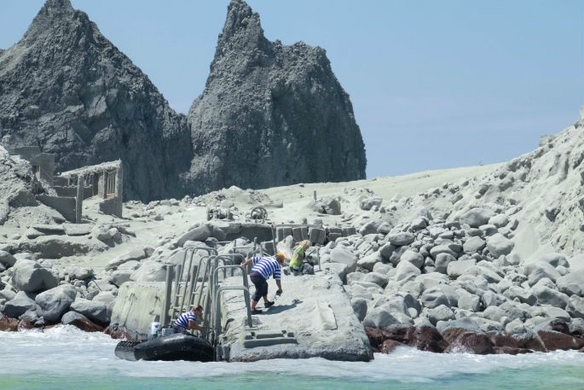After the initial danger had passed, the boat departing and others waiting responded, sending inflatables to pick up ash-covered and wounded survivors arriving at the shore. Load after load of survivors were pulled onto the boats, laid on the deck and water poured over their scalded skin. Clothes were stripped off to reveal huge blisters underneath. Victims were wrapped in foil blankets to keep them warm for the 80 minute trip back to Whakatane.

Figure 4 This 1.2 tonne helicopter was shoved off its landing platform damaged by the blast and remains on the island.. Instagram

The walk from the crater to the shore takes 15 minutes but some were too injured to walk that far. Three local helicopter pilots and crew heard and saw the eruption and arrived to help. Breaching civil aviation rules they landed right in the crater just after the eruption when the risk of further eruptions was still high. As it was steamy and hard to breathe the men donned gas masks. Working as a team they located 12 survivors, carried them to the 3 helicopters and took them to Whakatane. Their brave actions saved 10 lives.

Figure An inflatable arriving at the shore, wounded being helped over rocks. Twitter

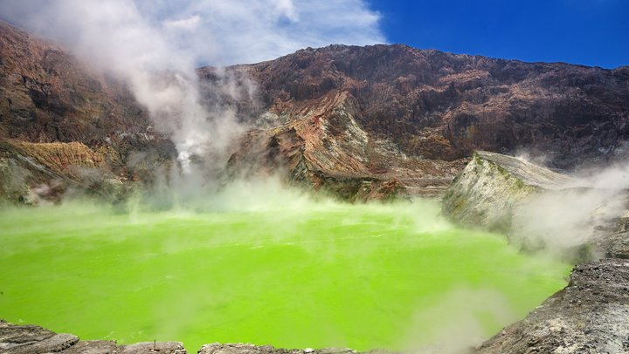Of the 47 on the volcano, 39 were evacuated off the island that day (11 later died), 6 bodies were recovered 4 days later and 2 are still missing, presumed dead. Many were overseas visitors, most from Australia and America – and 4 NZ guides were on the island. The evacuees arrived first at Whakatane hospital, a small facility with 6 nurses and 2 doctors in ED. Staff from all over the hospital came to ED to help (e.g. cleaners, admin staff) as did 2 carloads of clinicians from Tauranga. Thirty survivors with burns to over 30% of their bodies were in severe pain and 22 required help breathing.

Figure 6 What the crater lake looked like before the eruption. Blogspot

Although 13 Australians were later repatriated home, 27 patients were sent to NZ’s 4 intensive care burns units (Middlemore, Waikato, Hutt Valley, Christchurch) and 120 m2 of skin was ordered for importation from USA and Australia to treat them. A skin donation (which can be stored frozen for up to 5 years) is used as a dressing to help patients stay infection-free till they are well enough to have skin grafts taken from their body. Those that survive will need months of specialised hospital care - normally this is 1 week’s care for every % burnt – but these burns were complex because as well as burns from heat & chemicals they had extensive blast injuries.

Figure 7 Helicopter-view of ash covering the island. Auckland Rescue Helicopter Trust

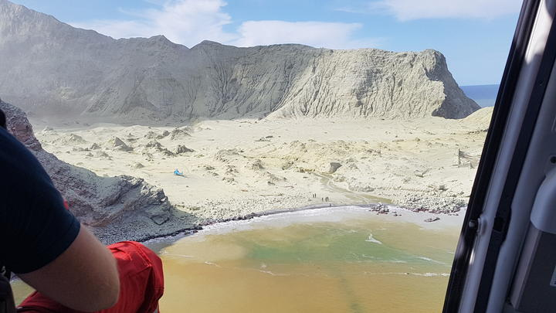As a sign of respect to those who had lost their lives, local iwi placed a rahui over the nearby coast and islands. This temporary ritual prohibition encompasses all maritime activities in the area, including fishing, swimming. The rahui was lifted on December 28.

**Sources:** Various pages from

<https://www.geonet.org.nz> <https://www.gns.cri.nz> <https://thespinoff.co.nz/>

<https://www.nzherald.co.nz> <https://www.rnz.co.nz> <https://www.stuff.co.nz>