Coronavirus
A new pathogen, has recently appeared in Wuhan, a large city in China. This new coronavirus is being called 2019 novel coronavirus, or 2019-nCoV.
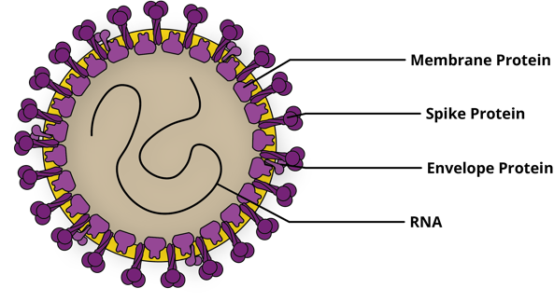
Type
Viruses are very simple pathogens consisting of genetic material surrounded by a protein coat. They contain no organelles because all they do is hijack cells to make viruses. The main viruses that cause influenza (flu) in humans include rhinoviruses and coronaviruses.
Figure 1. Structure of 2019-nCoV. The native antigen

Coronaviruses are round and surrounded by a halo of spiky proteins, resembling a crown. Of the 4 types of coronaviruses, only 2 (alpha and beta) infect humans and they are responsible for 10 - 30 % of colds around the world. This family of viruses includes severe acute respiratory syndrome (SARS), Middle East respiratory syndrome (MERS) & influenza (flu). Lessons learned from previous coronavirus outbreaks may help health officials head off some of the more serious consequences from this one.

Origin
Coronaviruses originate in animals and sometimes leap to humans. The first 2019-nCoV infections were detected in patients who had visited a large seafood & live animal market in Wuhan. Chinese officials notified the World Health Organization (WHO) of this new pneumonia-like disease with an unknown cause in several patients on 31 December, 2019. The market was closed 1 January 2020, but health officials have yet to determine from which type of animal the virus jumped to humans.

SARS originated in bats then infected raccoon dogs or palm civets before making the leap to humans. MERS also originated in bats then passed to camels which transmitted the infection to humans. The origin of 2019-nCoV is unclear – some research shows it may have been passed from bats to snakes before leaping to humans, other research suggests pangolins (genome 99% identical to coronavirus’s).

How dangerous
Usually coronavirus illnesses are fairly mild, affecting just the upper airway. But the new virus, as well as both SARS and MERS, are different. These three types of beta coronaviruses latch onto proteins studding the outside of lung cells, and penetrate much deeper into the airway than cold-causing coronaviruses. The 2019 version causes more lung disease than sniffles - and damage to lungs can make the viruses deadly.

Coronavirus outbreak | Origin | Date seen | Proportion killed Killed/infected … % | Other info
SARS | China | 2003-2004 | 774/8096 … 10% | 29 countries
MERS | Middle East | 2012-2015 | 858/2494 … 30%
Spanish Flu H1N1 | France | 1918-1920 | 20million/750million...2.5% | healthy adults
Swine Flu H1N1 | Mexico | 2009-2010 | 285,000/100 million...0.02% | Healthy adults
Seasonal flu H1N1 A&B | Global | Every year | 650,000/100 million…0.1% | Youngest, oldest
Figure 2. A summary of coronavirus outbreaks.
The mortality rate for known cases of the Wuhan coronavirus has been running about 2 percent, although that is likely to drop as more tests are done and more mild cases are found.

How contagious
This is a new disease to which we had no immunity, so the infection initially spread very rapidly, as we were caught unprepared. Gradually this effect will reduce as our immune response better deals with it.

The disease was initially passed from animal to human, but then began to spread by human-to-human transmission. It appears that a newly infected person may be able to pass the disease onto 1-4 people (SARS could infect 2-5, measles 12-18).

Respiratory droplets from an infected person’s cough or sneeze can carry human coronavirus virus to another person, something that generally happens between close contacts. These viruses typically only survive on a surface for a few hours, but if we touch that surface then touch our mouth, nose or eyes we will become infected. It appears that populations vulnerable to 2019-nCoV include individuals who are older, immune-compromised and have other medical conditions (cf those who died in the Spanish flu pandemic who tended to be healthy 20-40 year old adults because the virus drove their immune systems into overdrive).

A pandemic is an ongoing epidemic on two or more continents. To lead to a pandemic in humans, any virus needs to do three things: efficiently infect humans, replicate in humans and then spread easily among humans. At present the CDC (USA) is saying this virus passes between humans in a limited manner, but they are still investigating. It is like SARS in its infectivity so similar strategies may help.
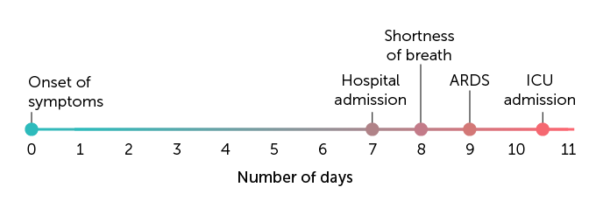
Disease progress
When a virus infects human cells its normal cell processes stop & the cell makes more virus then bursts open releasing them. In response the body makes cytokines which alert the immune system and neighbouring cells of infection and puts cells into a lock-down state so they are harder to infect. A lot of cytokine can cause high temperature, shakes, muscle aches - a severe response can damage lung tissue & the patient can sometimes die.
Figure 3. How fast a new coronavirus can sicken. C. Huang et al

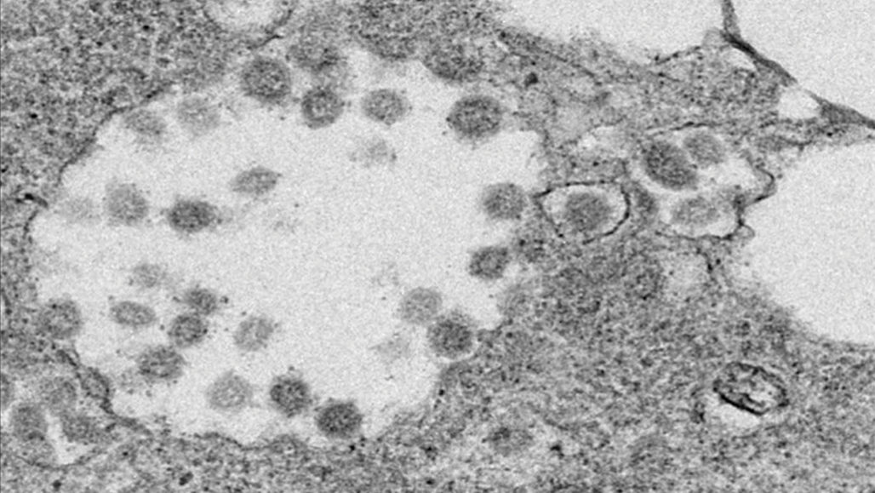
An infection with this new coronavirus causes an onset of symptoms 2-14 days after exposure. These symptoms typically include fever, cough and fatigue and sometimes headache & shortness of breath. Unlike SARS and MERS 2019-nCoV rarely causes runny noses. Some patients develop pneumonia and lung damage can be deadly. Those symptoms can then intensify fairly quickly, resulting in hospital admission and acute respiratory disease syndrome, or ARDS (median time from onset of symptoms, shown in Figure 3). Some infected with 2019 n-CoV subsequently died from multiple organ failure. Researchers now know that people infected with 2019-nCoV can transmit the virus to others even when not showing symptoms.

Prevention
We can best protect ourselves from coronavirus or flu by cleaning our hands, covering coughs and sneezes, not touching our eyes, nose and mouth and staying at home when sick.

What about masks? While no cases of the deadly virus have been confirmed in NZ, some residents have been rushing to the chemist to get hold of surgical mouth-covering masks as a precaution. In many crowded Asian countries, people see it as polite to wear these same masks to prevent the spread of germs by coughing or sneezing.
Figure 4. New virus particles being made in an infected human cell. P Zhou.

In hospitals, these loose surgical masks are used for short periods by trained professionals, changed frequently and properly disposed of. Those staff are also adopting good personal hygiene. The purpose of a surgical mask is to stop droplets in the breath or facial skin cells being dropped onto patients while they operate.

Surgical masks worn by the general public do absolutely nothing to protect them from the disease because:-
- they do not seal around the face so viruses and bacteria could easily get breathed in round the sides
- the holes in the fabric/paper are larger than a coronavirus particle (0.1 micron)
- the masks are often reused, allowing microbes to build up on the outside
- the mask may absorb moisture and provide a breeding ground for bacteria and viruses
- when removed, the wearer usually touches the front of the mask, getting the germs on their fingers.
However, infected people wearing a mask shed less droplets containing viruses into the air around them.

Treatments
There are no specific treatments for coronavirus infections and most people will recover on their own. For now, all doctors can do is treat symptoms of the new disease. As this pathogen is a virus, antibiotics, which treat bacterial infections, are not effective (same for colds and flu). There is minimal evidence for the effectiveness of other touted treatments such as vitamin C, garlic and honey. Tamiflu, an antiviral medicine used to treat influenza A & B in some people. did not work on SARS coronavirus, so is unlikely to be effective here either.

Short-term solutions include: -
- using samples of the new virus to develop “monoclonal” antibodies
- taking immune B cells from infection survivors to produce antibodies
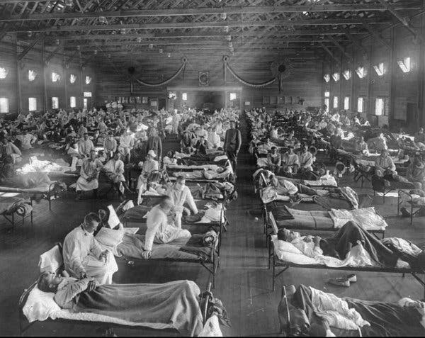
- stop the virus spreading – identify and isolate those infected

Vaccines can build up our immunity for some viral infections, but development of a vaccine ready to be used in sufferers normally takes years. Scientists could theoretically have a vaccine ready for phase 1 safety trials in a year but no sooner. A MERS vaccine was going into phase II trials last year, 7 years after 1st case.

Scientists
Figure 5. Patients in a USA hospital ward during the 1918 Spanish flu pandemic. National Museum of Health
Starting with SARS and then MERS and Swine flu, scientists have learnt to collaborate on a far wider scale to solve global health issues. For this outbreak, WHO has convened a Scientific Advisory Group to review emerging data on the disease epidemiology and identify research priorities & collaborative processes. Due to WHO’s R&D Blueprint scientists are now
- sharing online results of public health importance before publication in scientific journals
- co-ordinating investigations of therapeutics and vaccines to ensure transparent selection of candidates for further evaluation
This ensures protocols in use at the front-line for collecting and analysing clinical data, diagnosis, treatment and limitation of onward progression of the disease are evidence-based and standardised across the world. For example a confirmed case is declared from different samples of the same patient being positive for at least 2 gene targets.

Statistics

Date | All Deaths | All Confirmed Cases | Countries outside China  - cases, (no. of countries), deaths
12 Jan | 2 | 44 | 0
20 Jan | 6 | 282 | 4 (3 - Thailand, Japan, S Korea)
21 Jan | 6 | 314 | 5 (3)
23 Jan | 17 | 581 | 10 (4 - also USA)
24 Jan | 25 | 846 | 11 (6 - also Vietnam, Singapore)
25 Jan | 41 | 1320 | 23 (9 - also Australia, Nepal, France)
26 Jan | 56 | 2014 | 29 (10 - also Malaysia)
27 Jan | 80 | 2798 | 37 (11 - also Canada)
28 Jan | 106 | 4593 | 56 (14 - also Cambodia, Sri Lanka, Germany)
29 Jan | 132 | 6065 | 68 (15 - also UAE)
30 Jan | 170 | 7818 | 82 (18 - also Philippines, India, Finland)
31 Jan | 213 | 9826 | 106 (19 - also Italy)
1 Feb | 259 | 11,953 | 132 (23 -also Russia, Spain, Sweden, UK)
2 Feb | 304 | 14,557 | 146 (23) 1st death outside China in Philippines
3 Feb | 361 | 17,391 | 153 (23) 1 death
4 Feb | 425 | 20,630 | 159 (23) 1 death
5 Feb | 491 | 24,554 | 191 (24 - also Belgium) 1 death
6 Feb | 564 | 28,276 | 216 (24) 1 death
7 Feb | 637 | 31,481 | 270 (24) 1 death
8 Feb | 724 | 34,598 | 288 (24) 1 death
9 Feb | 813 | 37,558 | 307 (24) 1 death

References

CDC - FAQs, Index,
Compound Chem – 22 Jan,
IFLScience – 7 Feb,
LiveScience – FAQs,
NY Times – 5 Feb
NZ Herald – 28 Jan,
RadioNZ – 25 Jan,
SciBlogs – 21 Jan, 22 Jan,
Science News – 24 Jan, 29 Jan, Feb 3,
StatNews – Feb 6,
WHO – R&D, stats reports
John Hopkins dashboard https://www.medpagetoday.com/infectiousdisease/publichealth/84698

