MYCOPLASMA BOVIS

Mycoplasma bovis is a bacterium causing a disease in cattle in NZ at present, the results of which are being managed by the Ministry for Primary Industries (MPI).

Mycoplasmids are primitive types of bacteria. They are smaller and do not have a cell wall, their outer layer is a cell membrane. This means they have a much greater variety of shapes. It also means they are resistant to some antibiotics, those that work by damaging the bacterial cell wall, e.g. penicillin; however mycoplasmids can be treated with other antibiotics such as tetracyclines. Mycoplasmids are anaerobic.
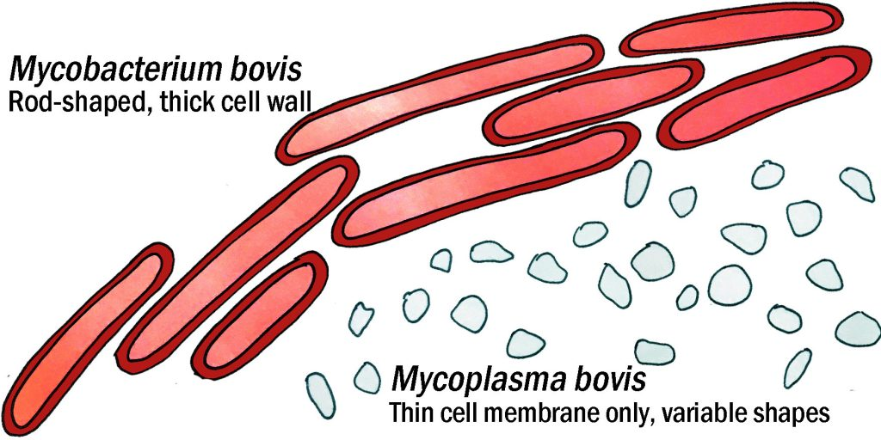
Mycobacterium bovis is a rod-shaped bacteria with a thick cell wall that helps it survive being attacked by the body’s white blood cells. This bacterium infects cattle with bovine TB (which can also infect people). Mycoplasma bovis is smaller with a more variable shape and no cell wall. It also infects cattle but cannot readily infect people. The disease it causes is also called mycoplasma bovis.
Mycoplasma bovis infects cattle but there is no health risk to other species. It is transmitted between cattle by contact and by contaminated milk. This mycoplasmid does not survive in the soil to cause re-infection. It does not infect humans and presents no food safety risk - there is no concern about eating meat, milk and milk products
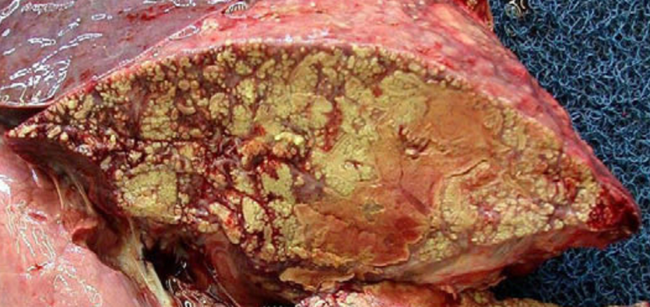
There is only one strain of Mycoplasma bovis in New Zealand and evidence shows it arrived in late 2015-early 2016.
Farmers look for these signs of infection: arthritis, abortions, untreatable mastitis, swollen joints in cows; pneumonia/coughs, arthritis, ear infections, swollen joints, many deaths in calves. However, many infected cattle never show visible signs of the disease but are able to infect others: affected cattle will always be carriers of the disease
Mycoplasma bovis in calf lung – numerous foci of necrosis cause pneumonia. VetClinics.

Prevention involves limiting contact with other herds – secure fences 2m apart – disinfecting equipment and boots/gear and testing herds in areas with infected cattle..

MPI is working to eradicate this disease by tracing all potentially affected cattle, testing them and then culling those herds that include infected animals. Some compensation is available to affected farmers for loss of income and stock value.

References
https://www.thevetgroup.com.au/m-bovis-and-m-bovis-same-same-but-different/
https://en.wikipedia.org/wiki/Mycoplasma_bovis https://beeflambnz.com/mycoplasma-bovis
https://www.dairynz.co.nz/animal/cow-health/mycoplasma-bovis/
https://www.biosecurity.govt.nz/dmsdocument/20894-poster-of-mycoplasma-bovis-what-to-look-out-for
https://www.biosecurity.govt.nz/dmsdocument/31614-mycoplasma-bovis-myth-busting

