Interpreting Representations of COVID-19 data https://twitter.com/PopSci/status/1235228710409834500/photo/1

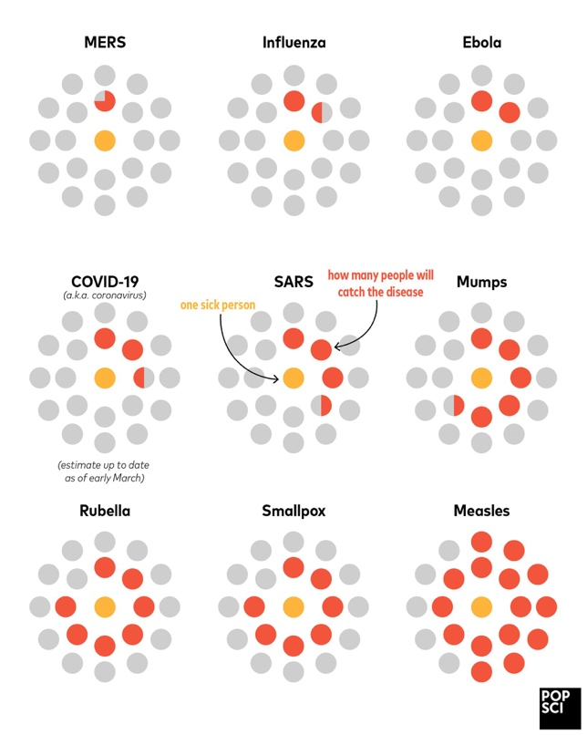 Alayna Amy 2020
Question 1
- Which of the following diseases are likely to be passed on to the most people: COVID-19, Influenza or Mumps?

- What message is the artist wanting to get across?

- Why do you think they represented the data this way?
Question 2

- Which is the deadliest viral disease?
- Which is the most contagious viral disease?
- What percentage of those who become infected with polio die?
- On average, how many people are infected by someone with mumps?
- How is ebola transmitted?
- How is smallpox transmitted?
- Describe the deadliness and contagiousness of coronavirus and describe how it is transmitted.
- What would be a suitable title for this graph?
- Why do you think the information was presented this way?
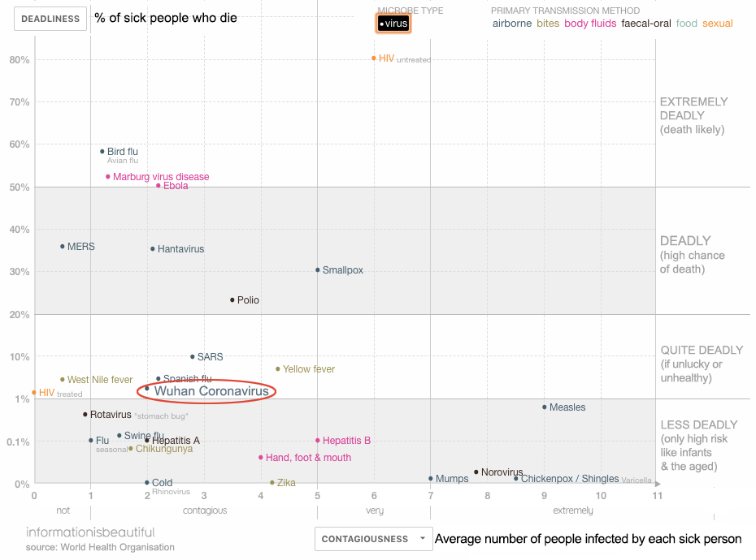

Mike Stone

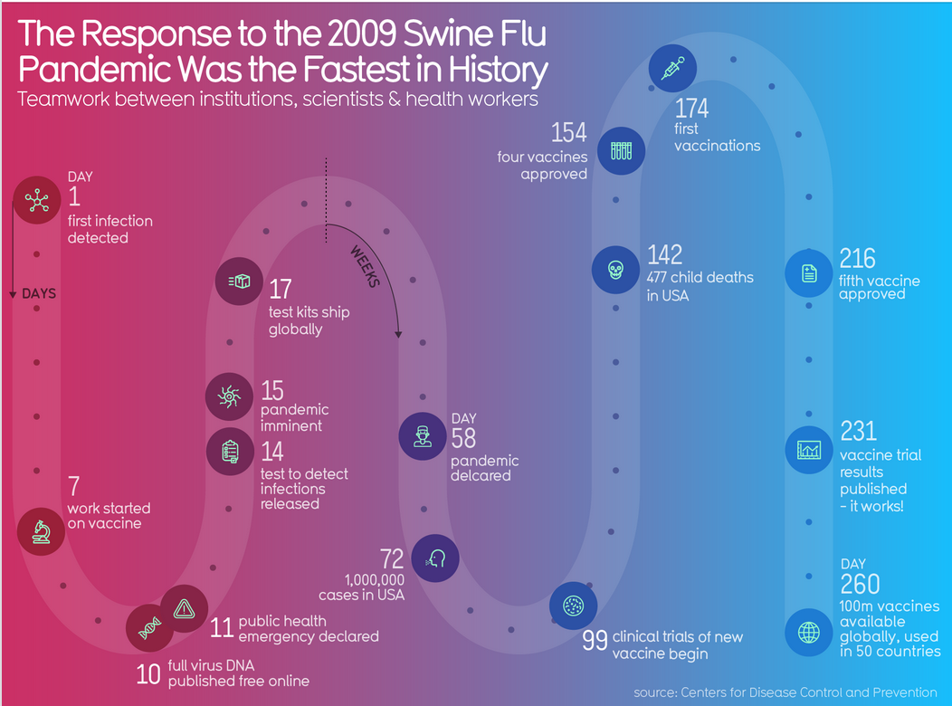
Question 3

- What does this representation tell us?
- What is left out?
- How does this representation get the message across?
- Why is it presented in this particular way?
- If we take Dec 1 2019 as day 1, how does this response compare to that for COVID-19, so far?
- The source of this graphic took Jan 1 as Day 1 for COVID-19 in its comparison. Why might they have done that?
- What is the earliest we could expect to see a vaccine for COVID-19?

https://informationisbeautiful.net/beautifulnews/200-H1N1-response/

Mike Stone

Coronavirus Discussion Questions
- Essential question: Why is it important to get the facts and ask questions about the coronavirus?

- What do you know about the coronavirus?

- A. What are organizations like the World Health Organization (WHO) and the Ministry of Health doing to help address the coronavirus?

B. What are some of the challenges related to studying and preventing the spread of infectious diseases?

- In general, what are some health and hygiene practices you should use in order to help prevent the spread of germs?

- A. Media literacy: Why is it sometimes a good idea to limit the amount of news you watch on issues like the coronavirus?

B. If you’re feeling worried about the virus, who could you talk with at home and in school?

C. How are science-based websites like the World Health Organization, STAT news and Science News different from general news websites?

https://sharemylesson.com/todays-news-tomorrows-lesson/coronavirus-student-guide?utm_source=SilverpopMailing&utm_medium=email&utm_campaign=enews_030120_womenshistory%20(1)%20remainder&utm_content=&spMailingID=41906526&spUserID=OTAzMzYyMTIzMDc1S0&spJobID=1720065453&spReportId=MTcyMDA2NTQ1MwS2

