Connected Summaries

For each story, the pdf, a PowerPoint & teacher notes are available online but If you wish to order a paper copy ring 0800 660 662 & quote the item no.

Connected 2013
The focus of Connected this year is on the science capability: gather and interpret data

Level 2: I spy. Item no. 40667

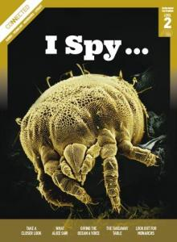Take a Closer Look Scientists are detectives who try to solve the mysteries of nature, using their senses to find out what life, the world & the universe are up to.

What Alice Saw In 1880, when Alice McKenzie was 7 years old, she saw a large, blue bird. She thought the bird was a takahē. What if it wasn’t?

Giving the Ocean a Voice How is the health of the Pacific Ocean? The crews of seven voyaging canoes have been finding out. What did they observe?

The Takeaway Table Room 3 has its own bird “takeaway table”, stocked with delicious bird food. They study & report on visits from different bird species.

Look out for Monarchs In NZ, scientists are gathering data about monarch butterflies. They want to find out where the butterflies fly to and from – and where they go in winter.

Level 3: Food for Thought Item no. 40669

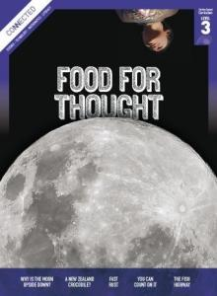Why Is the Moon Upside Down? The Moon looks weird up here. There’s something wrong with it.

A New Zealand Crocodile? Scientists digging in Southland soil in 1989 found something that would change our ideas about animals that have lived in Aotearoa.

Fast Rust What doesn’t breathe but can’t live without air, doesn’t drink but needs water near, never sleeps & won’t rest much, is stronger than steel, but crumbles at a touch?

You Can Count on It Fa‘aea’s mum, a meteorologist, talked to Fa‘aea’s class about sorting & displaying data in different ways.

The Fish Highway There is a maze of water & sewage pipes under Wellington’s pavements, beneath manhole covers & bundles of cables. The oldest pipes are lined with bricks. They snake under the streets.

Level 4: Are you sure? Item no. 40671

After the Spill If an oil spill occurred on your local beach, how would it affect you now and in the future?

An Ecologist on Ice An interview with ecologist Phil Lyver about Adelie penguin population dynamics and the marine ecosystem in the Ross Sea.

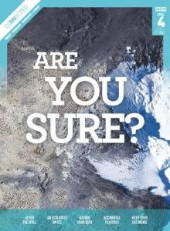Gather Your Data In the past, ecologists wished there was an easy way to record data in difficult alpine environments. Now ecologists use data loggers.

Accidental Plastics From your toothbrush to your television, plastic products are just everywhere. It’s difficult to imagine life without these synthetic compounds.

Keep Your Cat Inside We had a cat once that killed rats, mice, a stoat, skinks, wētā, & birds (I saw them!). Perhaps pet cats should be kept inside.
Connected 2014
The focus of Connected this year is on the science capability: use evidence to support ideas

Level 2: How do you know? Item no. 43957

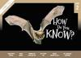Garden with Science To grow healthy plants, gardeners use scientific knowledge and skills, including observing the world around them and experimenting to find evidence to support their ideas.

Super Senses Scientists gather & use evidence about animals’ super navigational senses to support their ideas.

Winning the Bledisloe Cup Two market gardeners use science to develop innovations that have changed the ways veges are grown in NZ.

Pop! Froth! Fizz! A class makes predictions, observes what happens & suggests a possible explanation for acid-carbonate reactions.

Making Amazing Places A group of year 4 Christchurch students designed the winning playground by gathering survey data and research evidence about the popularity of their idea.

The Cardboard Cathedral During the Christchurch earthquake, the cathedral was so badly damaged it couldn’t be used. Therefore, the people in charge of the cathedral worked with architects, engineers, and builders to build an innovative new temporary cathedral.

Level 3: Rising seas Item no. 43967
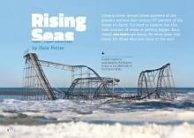Rising Seas While we know that global warming is raising sea levels, the rate of change & its likely impact are unclear. Scientists investigate what is happening & use evidence to suggest how we might adapt to the changes.

Counting Kākahi Scientist Hannah Rainforth investigated kākahi in the Whanganui River to find whether the evidence supports claims by local kaumātua that kākahi have nearly disappeared.

Rebuilding Christchurch with Amazing Ideas Christchurch students design an amazing place, testing their ideas & used evidence to show that the ideas could really work.

Elephant Toothpaste After the zoo asks students to invent a recipe for elephant toothpaste. Are they successful? And what do the elephants think of their new toothpaste?

The Tsunami That Washed Time Away Geologists James Goff & Scott Nichol think the landscape at Henderson Bay was changed by a huge tsunami hundreds of years ago. Can they find evidence of this?

Level 4: What’s the evidence? Item no. 43977

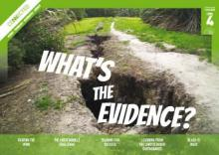Beating the Wind Scientist Lindsey Underwood uses evidence to explain how aerodynamics can improve the performance of racing cyclists.

The Great Marble Challenge A class is challenged to design a ramp that will get a marble to stop 500 mm - 2 m from the end of the ramp.

Training for Success Top athlete Phoebe Edwards and her coach, Mike Ritchie, constantly observe and measure her performance and work on improving technique, to help her train for success.

Learning from the Christchurch Earthquakes New learning has come out of the devastation of the Christchurch earthquakes. How has data & research from the earthquakes changed what geologists think?

Black is Back Te Papa conservator Rangi Te Kanawa uses her knowledge of traditional dyeing practices & science to preserve fibres in textiles that have been dyed using iron-tannate black dyes.
Connected 2015
The focus of Connected this year is on the science capability: critique evidence

Level 2: have You checked? Item no 16393
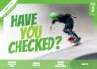Why Do Our Muscles Get Tired? Moana & Oscar carry out a simple investigation to discover more about muscle fatigue (muscles using oxygen faster than our body can supply it)

Operation Duck Pond Nathan Burkepile, a scientist who wants to know what kind of pond ducks like best, works with the citizen scientists to make sure that the data they collect is reliable.

Learning from the Tangata Whenua As a scientist, James Ataria thinks carefully about how evidence should be collected and critiqued. But, unlike many other scientists, he also uses Māori cultural knowledge to help his work.

Heat It Up Students design an experiment to test whether their solar oven would work better if they paint it black on the inside. They change their design to improve the quality & reliability of their data.

Level 3: Fact or Fiction? Item no 16421

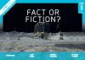Pseudoscience Advertisements can mislead by using pseudoscience (pseudoscience sounds scientific but is not based on solid evidence). We need to think like scientists to be able to tell the difference between real science & pseudoscience, We can use our knowledge of what makes an investigation scientific to ask whether the info is trustworthy.

Sleep Sleuths Jeremy & Marama investigate to find out how much sleep their classmates are getting. They discover that sometimes, a good investigation can raise more questions than it answers!

Catching a Space Duck After 10 years flight the spacecraft Rosetta caught up with Comet 67P and sent a lander down to its surface. Scientists use the info sent back to find out more about our solar system.

The Science of Rongoā Māori use kawakawa as rongoā (traditional medicine). But when scientists tested the kawakawa leaves they said there was no scientific evidence to support the plant’s medicinal properties. Chris Ryan took a closer look at the scientists’ investigations and noticed that they had not used traditional methods to prepare the kawakawa. He wondered if this might have affected their results. So Chris decided to carry out his own investigation.

Level 4: Is that so? Item no16407

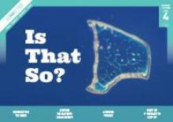Reconnecting the Brain Dr Melanie Cheung, a neurobiologist, studies the roro (brain), collecting and analysing data about how it works and what can go wrong. She also studies the use of tikanga (Māori customary practices) in the modern science world.

Lighting the Way with Solar Energy Tokelau decided to switch to renewable energy. After thinking critically about all the options. They decided that solar energy was the best option suited to their sunny climate.

A Sinking Feeling Mr Tuala’s class learn about density (and how it relates to floating a boat), critique and improve their original boat design.

Don’t Sit If You Want to Keep Fit Scientific evidence suggests that sitting for long periods of time can cause health problems and that standing and moving around is better for us. But as with any scientific evidence, we need to ask questions about the evidence to determine if it can be trusted.

Connected 2016
The focus of Connected this year is on the science capability: interpret representations

Level 2: Show and tell. Item no 1672

An Invasion of Yellow Crazies. The islands of Tokelau have been invaded by yellow crazy ants. Scientists are investigating where they are & what can be done about them. By collecting and recording data, they can identify the extent of the problem and figure out the best course of action.

What’s Inside? The vets at Wellington zoo encounter a lot of interesting patients. Luckily, they have a range of amazing technologies that harness light and sound to help them see inside sick and injured animals.

Sun, Wind or Rain? People in Aotearoa NZ have been predicting the weather for years. From violent storms to warm breezes, by observing patterns in nature people can tell what tomorrow will bring.

I Am Alice Alice is a tunnel-boring machine used to build two tunnels for Auckland’s Western Ring motorway. Hear about the experience from Alice herself as she provides a first person account of the impact of new technology on our land and infrastructures.

Level 3: Picture this Item no. 16735

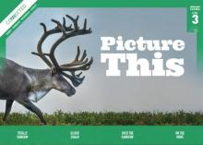Totally Random? Miranda is going to explode if Hugh rolls another six. Three in a row just isn’t fair. Isn’t rolling a dice meant to be random? Take a deeper look into the mathematical concept of randomness and find out if Miranda stands a chance against Hugh.

Blood Sugar Sarah Cook is a busy year 10 student living with type 1 diabetes. Find out what Sarah does to manage her diabetes and make sure it doesn’t prevent her full and active lifestyle.

Over the Rainbow Ms Maxwell’s students must use their prior knowledge of the electromagnetic spectrum on a treasure hunt to find out how different types of energy can be used in their everyday lives.

On the Move Some animals migrate thousands of kilometres every year - so how do scientists keep track of them? Take a look at the different technologies scientists use to study migration patterns, and discover what they have learnt about great migrations.

Level 4: Getting the Message. Item no 16749

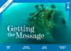Winning Ways: Presenting Scientific Data Grace is on a mission to win the science fair – but to do so she must structure & present her investigation in the most informative and thought-provoking way possible. Grace uses diagrams, photographs, tables, graphs, info-graphics & clear science writing to present her data & blow the judges away!

Driving Us into the Future Electric cars are often seen as the vehicles of the future – but are they? Read about the development of electric cars & see how the technology they use contrasts with that used by fuel-powered cars.

Can You Hear That? Sounds are all around us, even if we can’t hear them. Human ears are designed to pick up sound waves of a range of different frequencies, but ultrasonic and infrasonic sounds have frequencies that only certain animals can hear.

What Now for the Rena? In 2011 MV Rena struck Astolabe Reef causing an environmental disaster. The clean-up operation has removed lots of debris from the wreck – but large parts Rena still remain on the ocean floor. What factors were considered when making the decision on the future of the Rena wreck?
Connected 2017
The focus of Connected this year is on the science capability: engage with science

Level 2: Taking Action. Item no. 69103
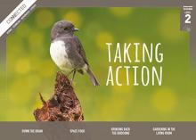Space Food A group of students investigate how to stop food rotting on a journey to Mars. They share what they know about the different methods of food preservation to come up with a plan.

Gardening in the Living Room Balaclava School has a new greenhouse called the Living Room. The students find out how the environment inside the Living Room helps plants grow during the cold Dunedin winters and investigate which vegetables grow best inside and outside its unique climate.

Down the Drain Students at Wilford School in Petone were shocked to discover the amount of rubbish finding its way onto their local beach. Find out how they investigated the issue by using traps to collect the rubbish entering the stormwater system.

Bringing Back the Birdsong For years, introduced predators have been killing birds along the Kepler Track in Fiordland. Students in the Kids Restore the Kepler project are working with the Department of Conservation and the Fiordland Conservation Trust to reduce the number of predators living in the area. Their mission: to bring birdsong back to the Kepler.

Level 3: Mahi Tahi. Item no 69118
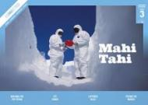Testing the Waters How clean is the water in your river? Scientists are testing the health of the Maitai River. Find out what data they collect and what can be done to make our rivers cleaner and healthier for everyone.

Pet Power Humans and animals have a powerful bond. Some people think that this bond could have a positive effect on human health and behaviour. But what does the science say? Investigate the evidence for yourself.

Captured in Ice Nancy Bertler is a scientist who studies the ice. She’s been examining Antarctic ice cores to discover what Earth’s climate was like in the past – and how it might change in the future

Building for the Future The Samoan village of Sa’anapu is under threat from tsunamis, cyclones, and rising sea levels. To protect their village, the Council of Matai are working with an architect and scientist from NZ. Together, they’re drawing on cultural, scientific, and technological knowledge to build a safer future for Sa’anapu.

Level 4: Where to next? Item no. 69132
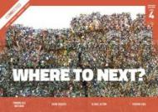Sensing Data Air pollution is a problem in many cities, including Christ-church. After the 2011 earthquake, a team of researchers used technology & big data to help make Christchurch a healthier, smarter city to live in.

Turning Old into New Shoes made from chewing gum? Jackets made from drink bottles? Go beyond the recycling bins and find out how everyday objects and materials can be broken down and made into something new.

Kauri Dieback The future of our kauri forests is at risk from a disease called kauri dieback. Combating the spread of this threat requires expertise from both Western science and mātauranga Māori and calls on everyone to get involved.

Global Action This detailed article looks at the science and politics of climate change. It examines what global warming is, explores how scientists use computer modelling to predict the impact of climate change & explains how scientific innovations in NZ could help reduce our agricultural emissions.
Connected 2018
The focus of Connected this year is on computational thinking for digital technologies and designing and developing digital outcomes. NS = not a science focus

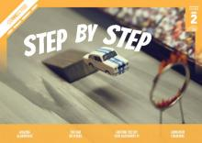
Level 2: Step by step

Amazing Algorithms - This article introduces & explains the concept of algorithms in a simple & engaging way, by providing concrete examples from everyday life, mathematics & computer programming. NS

The War on Weeds - Students at Kaniere School are helping scientists combat the spread of weeds, using simple digital technology to identify the weeds & upload information to a national database.

Lighting the Sky with Raspberry Pi - Students at Fernridge School have created a digital light display for Matariki using Raspberry Pi computers. This article shows how the students created the light display, providing a real-life context for exploring how computers work.

Animation Creations - Ryan Kothe, an animator from Auckland, uses stop-motion animation to make short videos and advertisements. In this article, he explains how to create your own stop-motion animation movie. NS
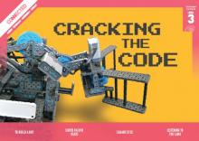

Level 3: Cracking the Code

To Build a Bot - 3 students designed and built a robot that won the New Zealand VEX IQ Challenge. An authentic introduction to programming and computational thinking (& physics & engineering concepts related to energy, weight, & balance).
South Pacific Beats - Designer Rachael Hall has developed a modern version of the traditional Tongan lali. Called Patō, Rachael’s drum keeps the traditional sound of a lali but incorporates digital capabilities.

Square Eyes - Siali is selected to trial a new augmented reality device called SquareEye but find it is affecting his experiences in ways he doesn’t necessarily consent to. NS

Listening to the Land - Pauline Harris, a scientist of Rongomaiwahine and Ngāti Kahungunu descent, is collecting and recording mātauranga from iwi and hapū about plants & animals in Aotearoa. The team is using a computer program to record the mātauranga and connect it to particular times and places in history. They hope this info will help us understand how climate change is affecting Aotearoa’s wildlife.

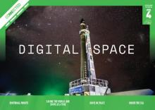
Level 4: Digital Space

Emotional Robots - Consider the development of artificial intelligence (AI) from a social & ethical perspective: the ethical implications of building AI that act like humans, and what would happen if AI became more intelligent than us. NS

Saving the World, One Swipe at a Time - This article describes how 3 Kiwi companies have used digital technology to help solve health or social problems. NS
Kiwis in Space - In January 2018, NZ became one of only 11 countries that have successfully built and launched a rocket capable of sending satellites into space. This interview with Rocket Lab Avionics Manager Naomi Altman explains the science and technology behind that incredible achievement.
Under the Sea – High school students partnered with scientists, fishers & local iwi to survey a rocky reef 11 km off the Taranaki coast. The article focuses on the survey methods being used and the different technologies involved in each method.
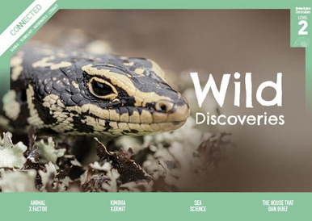
Connected 2019
NS = not a science focus

Level 2: Wild Discoveries
Animal X Factor: All of us have favourite animals – but why do we like some animals more than others?

Kimihia Kermit: Students from the Ngāti Mutunga rohe have been listening out for frogs. They want to find out which frogs, and how many of them, are living in this north Taranaki area.

Sea Science: In 2017, students on Aotea Great Barrier Island became scientists and did something about the rubbish washing up on their shore and learnt about marine debris.

The House that Dan Built: Eco-houses are designed to look after the natural world. Daniel Turinsky,from Nelson Central School entered a competition to design an eco-house using the computer game Minecraft.

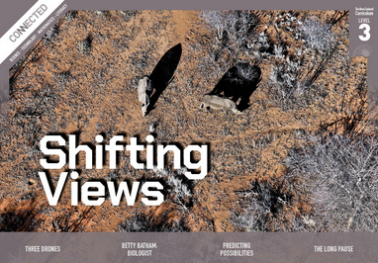
Level 3: Shifting views
Three Drones - Three examples of drones to show how they work, how they are used now, and how they might be used in the future

Betty Batham: Biologist - The story of Betty Batham, a pioneering marine biologist. Born in an era when a woman’s place in society was largely limited to the home, Betty rose to become a noted scientist.

Predicting Possibilities - Mathematics can be used to predict the possible outcomes of a range of human and environmental activities. Mathematical models are created by defining and measuring key variables, designing an equation that shows how the variables interact, and using the equation to make predictions. NS

The Long Pause – Archaeologists find evidence to explain the mystery of the long pause between 2 major periods of Pacific migration.

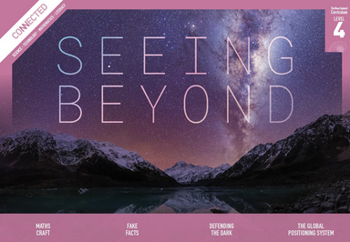
Level 4: Seeing Beyond
Fake Facts - Digital technology exposes us to information that can be false or can do harm. How do we look at information critically and evaluate what is based on facts and worth sharing. NS

Maths Craft - This article takes a playful, creative approach to pure mathematics, exploring craft activities that let students explore the properties of Möbius strips & mathematical knots. NS

Defending the Dark – How the science of astronomy is impacted by the issue of light pollution and practical ways of reducing it

Global Positioning systemu – How does GPS work, its benefits, and the risks of over-reliance.

