Feijoas

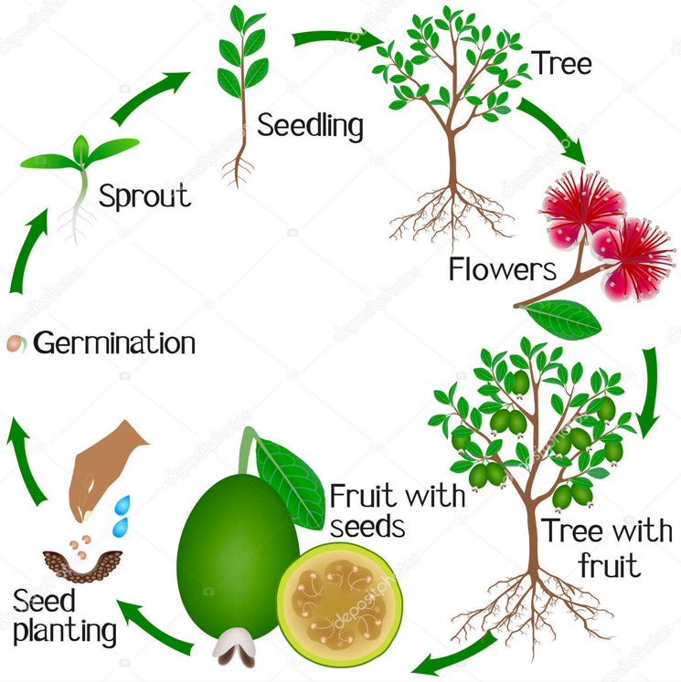The feijoa is a flowering plant in the myrtle family, and is native to South America. It is also called *Acca sellowiana,* named after Friedrich Sellow, a German who first collected specimens of feijoa in Brazil.

**Propagation**: Like many other kinds of fruit trees, feijoas can be grown from seed, but don’t grow true to type and only grow slowly for the first 1-2 years. To extract seeds squeeze out the seedy pulp into a jar and cover with water, letting the liquid stand for 4 days. Strain and dry the seeds before sowing (the seeds will remain viable for a year or more if kept dry). Germination takes place in 3 weeks. Or feijoa can be grown as grafted cultivars – where the roots of one variety are joined with the stem of another. However, feijoa are most successfully propagated as cuttings taken from an established tree that’s fruiting well. Autumn is an ideal time to plant feijoas in most parts of NZ, allowing the roots to establish over winter in preparation for a growth spurt over spring.

**Growing conditions**: Feijoas are one of the easiest fruits to grow in a home garden, as there are usually very few problems and the trees fruit prolifically without much intervention. They will tolerate a range of soil types, but the best harvests come from plants growing in well-drained soil with a pH between 5.5 and 7.0. The shrub has very few insect pests, although guava moth is a problem in northern NZ. This plant prefers warm-temperate or sub-tropical conditions, requires at least 50 hours of winter chilling to fruit, and is frost-tolerant. Feijoas need fertilisers regularly from spring to harvest - a balance of nitrogen (for leafy growth), phosphorus (for root development) and potassium (for flowering and fruit production). Feijoas need to be watered deeply and regularly from mid to late summer when the fruit is developing and ripening. A light pruning in the summer after fruit is harvested will encourage new growth and increase yields the following year

**Flowers: Their brightly coloured red flowers, appear at Christmas – long** bright red stamens topped with large grains of yellow pollen**.** The bisexual flowers may be borne singly or in a cluster. Feijoa flowers are similar to those of pōhutukawa and southern rata, other members of the myrtle family.

## **Pollination** of feijoas can vary. Some cultivars are self-pollinating, but most need cross-pollinating (from another plant nearby). If feijoa trees are not fruiting then planting another cultivar nearby and/or pruning to open up the canopy and to allow space for pollinators may help. In NZ the pollinators of this plant are bees, bumblebees, and medium-sized birds - silvereye, blackbird and myna. Flowers pollinated with compatible pollen show 60 to 90% fruit set.

**Fruit:** Feijoa fruit season is March to June, autumn in NZ. The fruit falls to the ground when ripe and at its fullest flavour, but it may be picked from the tree prior to falling to prevent bruising. The raw fruit is an excellent source of vitamin C and fibre.

Questions

1. Using your own knowledge and the context here, give the meaning of these terms: propagate, cultivar, stamen, self-pollination, cross-pollination, pollinator, fruit set.
2. What might happen to feijoa if:
   1. NZ had a very dry summer with watering restrictions in place?
   2. Winter was not as cold as usual?
3. Look at this picture of a feijoa flower and identify the parts.

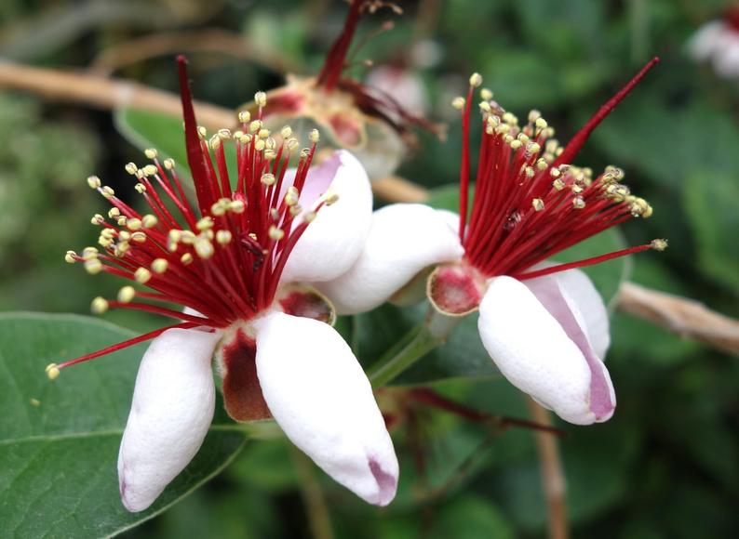

A

B

C

D

E

F

1. Describe what happens when this flower is pollinated and fertilised. Use the terms pollen, stigma, pollen tube, style, ovary, fertilise, egg.
2. Name the parts seen in the feijoa fruit below (if you think carefully you can figure out what H is):

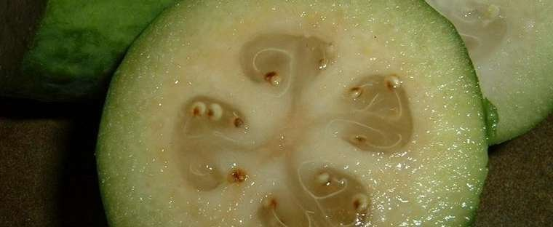

G

H

1. Find pictures of the flowers of pohutukawa & southern rata. Compare and contrast these with feijoa.
2. What more information does this video add? <https://www.youtube.com/watch?v=Y3CBqHoQFjw>

<https://www.tuigarden.co.nz/ideas-and-inspiration/feijoa-variety-favourites/> <https://en.wikipedia.org/wiki/Acca_sellowiana>

<https://www.milkwood.net/2018/05/10/all-about-feijoas-growing-harvesting-recipes/> <http://www.crfg.org/pubs/ff/feijoa.html>

<https://depositphotos.com/275911072/stock-illustration-growth-cycle-feijoa-tree-white.html>