NZ Seed Dispersal

During autumn (April-June) in NZ we can see fruit, seeds and seed pods like these in the environment around us – bush, beach, home garden, mudflat, stream. This video explains how plants disperse their seeds https://www.youtube.com/watch?v=xY4JFOSuqvY

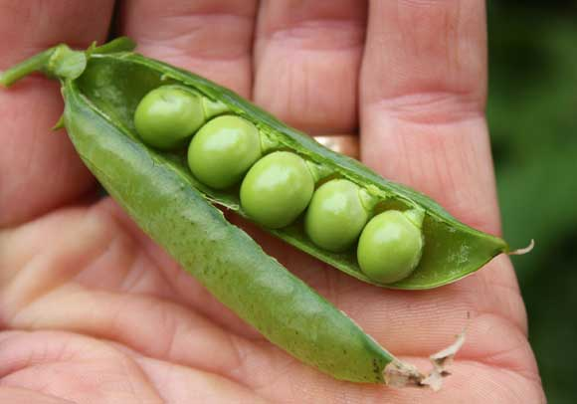  A | 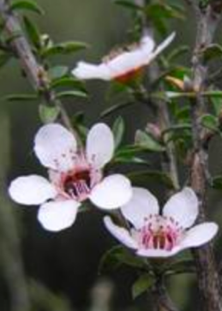  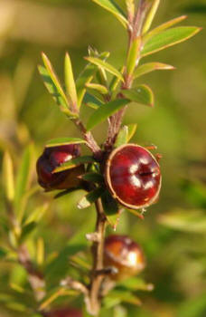  B | 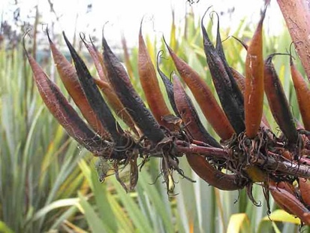  C
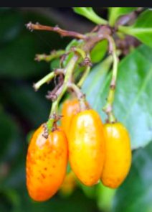  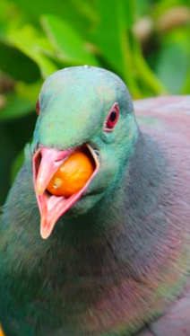  D | 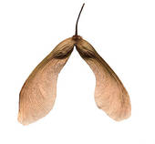  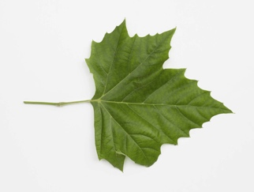  E | 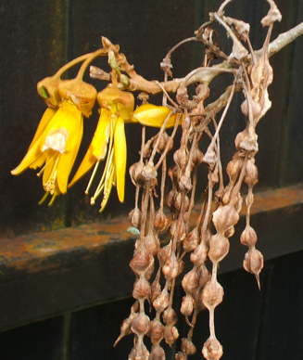  F
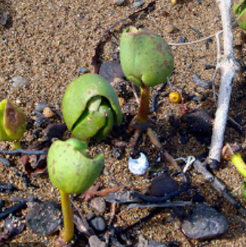  G | 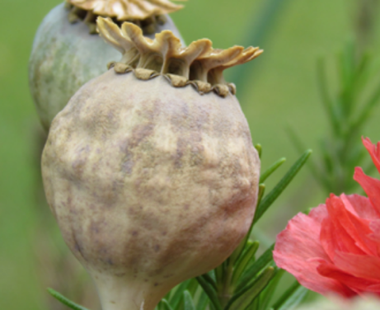  H | 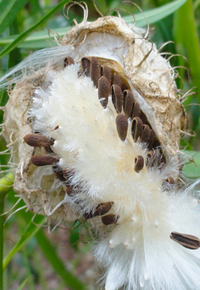  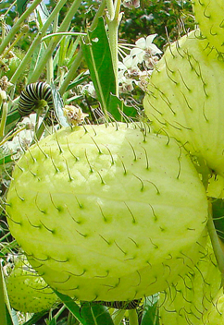  I

- Try to identify these 9 seed pods and seeds. Look for clues in the picture(s).
- Seeds need to travel away from their parent plant so they have a better chance of growing. They can be spread by wind, water, bursting, and animals.
  - Name the method by which each seed is spread (again, clues in pictures)
  - Describe 1 adaptation that helps each seed disperse in the way it does.
- Find out more about 1 of these plants – e.g. where does it normally grow, how exactly do the seeds get out of the pod, 1 interesting fact about its seed dispersal etc – and write a paragraph about what you find.
- From the video
  - What other method of dispersal does the narrator talk about?
  - In NZ rimu trees mast every few years.
    - What is masting?
    - Find a picture of rimu seeds and include it in your work.
    - How do you think these seeds are dispersed?

Note: 4bii. Not copied an image before? Some you can copy and paste. Some you need to take a screen shot – google to find how for your device [Mac is shift-command-4]. Then insert pic.

If you need clues for Q1 then look at this list:
Flax Karaka Kowhai Mangrove Manuka Pea Poppy Swan Plant Sycamore

When can we collect native seeds? https://www.doc.govt.nz/get-involved/run-a-project/restoration-advice/native-plant-restoration/ecosource-seeds/collection-and-propagation-guide-trees/calendar-for-seed-collecting/

