How Does Evaporation Cause Cooling?

Donald Miller, Sciencing 10 April 2018

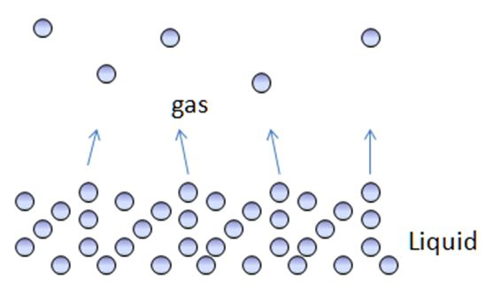
Evaporation causes cooling because the process requires heat energy. The energy is taken away by the molecules when they convert from liquid into gas, and this causes cooling on the original surface.
So, liquid evaporating from a surface has a cooling effect. And different liquids have this effect to different degrees. For example, rubbing alcohol has more of an evaporative cooling effect than water. Alcohol evaporates more quickly compared to water, so scientists class it as a "volatile" liquid. But all liquids follow the same principle of evaporative cooling – as liquid changes to vapor it absorbs heat energy, cooling the liquid left behind.

Heat and Evaporation
When a liquid evaporates, its molecules convert from the liquid phase to the vapor phase and escape from the surface. Heat drives this process. In order for the molecule to leave the liquid surface and escape as a vapor, it must take heat energy with it. This heat comes from the liquid surface. Since the molecule is taking heat with it as it’s leaving, this has a cooling effect on the surface left behind. We call this evaporative cooling.

Evaporation and Human Perspiration
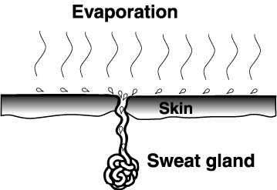
Human perspiration is an example of evaporated cooling. Pores in our skin allow liquid water inside our body to escape and convert to water vapor in the air. As this happens, it cools down our skin surface. This happens almost constantly. When we are in a hotter environment the rate of perspiration or evaporation increases, so the cooling effect increases. Again, this is because the liquid molecules, as they escape and become vapor, require heat and they take it with them.

Evaporation and Plant Transpiration
Plants do something similar, through a process called transpiration. Plant roots absorb water from the soil and transport it up through the stem to the leaves. Plant leaves have stomata, pores comparable to the pores in our skin. As water is evaporated out the stomata that draws water up the stem – transpiration

Function of Transpiration
Evaporation of water from the leaves (transpiration) is important in plants to transport water from the roots to other plant tissues. This evaporative cooling keeps the plant—which might very well be exposed to direct, intense sunlight—from overheating. And this also explains why, on a hot day, if we enter a forested area, we feel considerably cooler. Part of that is due to the shade, but part is also due to the evaporative cooling effect from the trees through this process of transpiration.

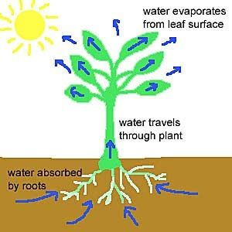
Wind Increases Evaporation
Wind increases the effect of evaporative cooling. We feel this when we’ve been swimming and come out of the water – a windy environment, feels much colder than a calm environment. The wind increases the evaporation rate of the liquid water from our skin surface – more is converted to vapor.

Wind-Chill Factor
Incidentally, this process also causes so-called wind chill. Even in colder conditions, when we're outside and our skin is exposed to the elements, a certain amount of perspiration occurs. When it's windy, more evaporative cooling takes place from exposed skin – the basics behind the wind-chill factor.

https://sciencing.com/evaporation-cause-cooling-5315235.html

