https://www.newsroom.co.nz/the-latest-science-behind-universal-face-masks
AUGUST 13, 2020. Updated August 16, 2020

Farah Hancock
The latest science behind universal face masks

What’s the science behind the changed position on mask use? Farah Hancock reports.
Auckland’s Level 3 lockdown will look different to the last lockdown. This time there will be masks.
They’re mandatory for people on domestic flights leaving Auckland and “strongly urged” for everyone else when in public.
The Government has distributed one million masks to Countdown supermarkets and another three million will be distributed by social services.
Prime Minister Jacinda Ardern suggested people adopt their use “as a duty to one another” telling people to “please use whatever you have at hand” such as a scarf or bandana rather than venture out unmasked.
It’s a departure from the last lockdown partly because most of the latest cases are community transmission, and partly because there’s more scientific evidence available. Previously the evidence was mixed. It tilted in favour of general masking, but not dramatically so.
With worries about ensuring health care workers had adequate masks, and concern mask use would embolden people to relax physical distancing, the World Health Organisation (WHO) held back on endorsing widespread use.
Other countries ignored the WHO stance. In some countries such as China, Hong Kong and Taiwan, wearing a face mask was already common practice. In March, Venezuela, Vietnam, the Czech Republic, Slovakia, and Bosnia and Herzegovina mandated masks in public places. By April a slew of other countries followed suit.
When the CDC in the United States suggested face coverings in public on April 3, New Zealand held back. At that point community transmission in New Zealand was 1 percent of cases.
Director-General of Health Ashley Bloomfield said at the time: "They [the US] have clearly widespread infections and widespread community transmission."
Director of Public Health Caroline McElnay said mask wearing was at the bottom of its list of strategies to control the virus. The advice of the WHO was being followed.
On June 5, WHO changed its stance.
WHO Director-General Dr Tedros Adhanom Ghebreyesus said: "In light of evolving evidence, the WHO advises that governments should encourage the general public to wear masks where there is widespread transmission and physical distancing is difficult, such as on public transport, in shops or in other confined or crowded environments".
New evidence
There are still gaps in knowledge about the effectiveness of masks and face coverings, but current studies further tilt scales in their favour.
One of the key benefits of face masks is what's referred to as 'source control' - reducing droplets from infected people.
One study looked at how a mouth covering blocks droplets. A person spoke the same phrase a number of times with and without a face covering and a camera picked up the number of droplets. Initially done with a damp washcloth instead of a mask this has now been redone with a variety of different masks.

It found N95 masks to be the most effective and a fleece neck gaiter to be the worst performer, saying it “seemed to disperse the largest droplets into a multitude of smaller droplets”, making more total droplets than no mask at all.
Counting droplets is only one part of the picture. Other concerns have been raised about the general public wearing masks. There are worries they might be worn incorrectly, could lead to a false sense of security which may make people lax about other important measures such as hand washing.
Droplet counts aside, does mask wearing reduce the number of Covid-19 infections?
A study published in Health Affairs looked at infection rates in different US states between March 31 and May 22, 2020. It found mandated wearing of masks reduced infection rates and concluded: “The study provides evidence that US states mandating the use of face masks in public had a greater decline in daily Covid-19 growth rates after issuing these mandates compared with states that did not issue mandates.”

The study estimated that because of the mandates more than 200,000 Covid-19 cases were averted by May 22, 2020 - although it also cautioned the figure was a general approximation.
Germany’s local and regional mask mandates were found to reduce the daily growth rate of reported infections by around 40 percent. It reduced the cumulative number of registered Covid-19 cases between 2.3 percent and 13 percent over a period of 10 days after they became compulsory.

Another study based on the USS Theodore Roosevelt, where a Covid-19 outbreak occurred, found those wearing masks were less likely to get infected.

Case reports also provide some evidence. An infected man on a flight to Canada was coughing throughout the 15-hour flight, but wore a mask. None of the 25 passengers sitting close to him got infected.

In Missouri, two infected hairdressers wore masks while working. Both saw customers while experiencing symptoms of Covid-19 but none of the 139 customers they saw prior to their diagnosis got sick. Ninety-eight percent of their customers wore masks as well.
One modelling study, yet to be peer-reviewed, suggests when 80 percent of the population wear masks, and does this from the early stages of an outbreak, it could eliminate the virus.

The WHO home-made mask recommendations
The WHO suggests at least three layers of material for home-made masks and suggests avoiding elastic material as it can stretch over time.
The type of material can make a difference, a cotton handkerchief mask would need at least four layers and would only be 13 percent effective in blocking droplets.
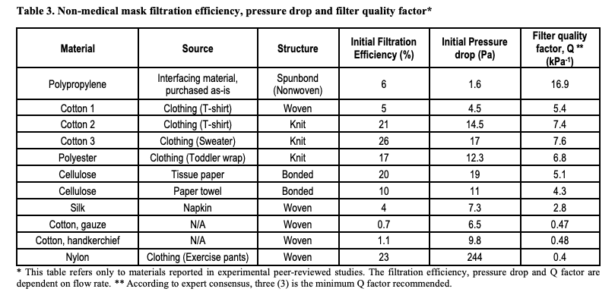
It's suggested a mix of materials be used with an absorbent material as the innermost layer and a non-absorbent material as the outermost layer. Coatings such as wax are advised against as they can make the mask hard to breathe through and increase the risk of air escaping from the sides.
A mask should only be worn by one person and cloth masks should be washed frequently.Face shields are considered inferior to masks for stopping droplet spread.
QUESTIONS TO CONSIDER

- What are the current rules about face mask use in New Zealand?

- How is this different from last month?

- Why has New Zealand changed its stance on facemasks?

- What is the WHO? What is their role in the pandemic?

- Provide 3 scientific examples for why the WHO and New Zealand have changed their stance?

- What does it mean to be peer-reviewed for science findings? Why is this standard scientific practice?

- In the table above, which 3 fabrics are most effective at filtering out germs? Explain your reasoning.

- What is the current recommendation for a fabric mask – according to the WHO?

