Tuatara genome explains some of its unique features

The tuatara, *Sphenodon punctatus,* is an iconic species that is endemic to New Zealand. Māori regard tuatara as taonga and guardians of special places. The species is internationally recognized as being vulnerable to extinction owing mainly to habitat loss, predation, disease and especially global warming. Once widespread across NZ, its population now numbers 60-100,000.

With no close relatives, the classification of tuatara has long been contentious. Some argue tuatara are more closely related to birds, crocodiles and turtles, but this study shows they stem from a common ancestor shared with lizards and snakes. This study also clarifies the timing of the split of tuatara from its relatives, the rate of evolution and the number of species.

It is the only living member of an ancient reptilian order once widespread across Gondwana, and its genome provides key insights into the evolution of birds, reptiles and mammals. Tuatara appear to have split off from a lepidosauran common ancestor 250 Ma – a massive length of time when we consider primates only originated around 65 million years ago, and hominids approximately six million years ago.

[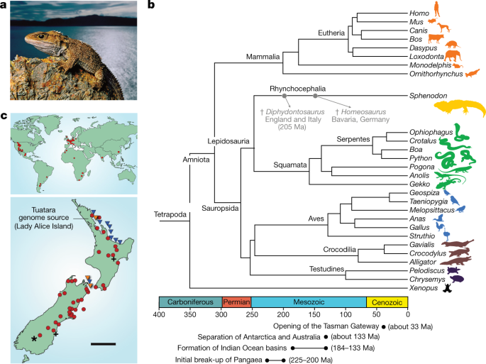](https://www.nature.com/articles/s41586-020-2561-9/figures/1)

**a**. The tuatara, (*S. punctatus*) is the sole survivor of the order Rhynchocephalia. **b**. The rhynchocephalians appear to have originated in the early Mesozoic period (about 250–240 million years ago [Ma]) and were common, with many species globally distributed. **c**. Rhynchocephalian and tuatara fossil localities. Top global distribution. Bottom - NZ distribution. * = Miocene; + = Pleistocene; = Holocene;   = extant population; and = population investigated in this study. Scale bar, 200 km. Photograph by F. Lanting.

"Proving the phylogenetic position of tuatara in a robust way is exciting," said the study's leader, and Otago University geneticist Professor Neil Gemmell. "But we see the biggest discovery in this research as uncovering the genetic code and beginning to explore aspects of the biology that makes this species so unique, while also developing new information that will help us better conserve this treasure."

One area of particular interest was to understand how tuatara can live to be more than 100 years old. The tuatara is found to have genes that code for seleno-proteins, antioxidants that protect the body from the ravages of age, in greater numbers than any other vertebrate. These genes may also have been selected for in response to the low levels of selenium in New Zealand soil.

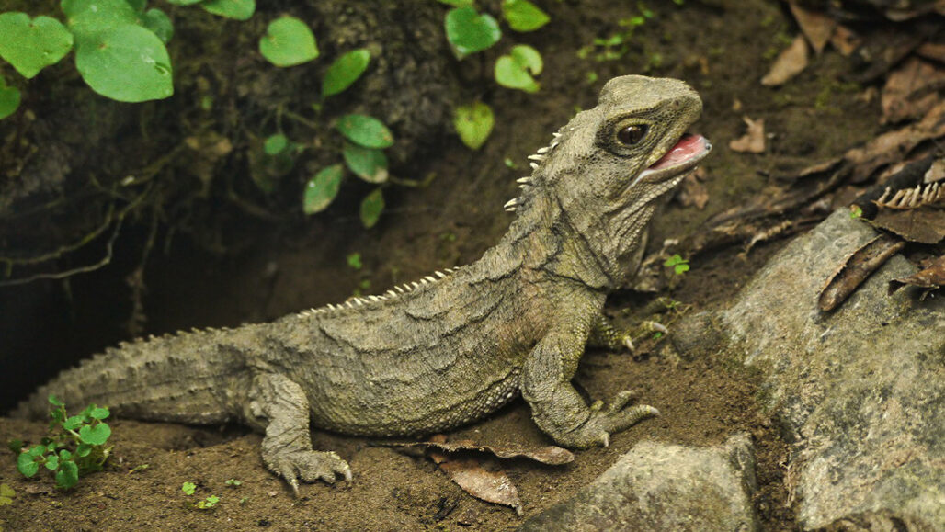The tuatara’s vision is adapted to hunting for prey under conditions of extremely low light but its eye structure and now its genes suggests its ancestors hunted diurnally. The genome also suggests tuatara can see colour well, potentially at low light levels.

Tuatara have the genes for many proteins that detect odour, supporting evidence that a sense of smell is important in detecting prey and mates.

The tuatara regulates its body temperature by changing its behaviour (out in the sun to warm, in burrows to cool etc). This. Study found tuatara have more genes for sensing heat than other vertebrates and this is probably associated with the evolution of its thermoregulation.

Tuatara sex is dependent on temperature - females are produced if the eggs incubate below 22oC and males if above. Genome analysis showed many genes similar to those that promote testicular or ovarian development in other species, and others similar to genes recently implicated in temperature-dependent sex determination. But scientists did not find significant sex-specific differences. There is still more work to be done to find the genes underpinning this characteristic.

The evolution of birds, mammals & reptiles (amniotes, see diagram) was slow for much of their history, but considerable genomic change was seen when these species diversified more widely. As there was little diversity in the rhynchocepalia, the tuatara genome accumulated mutations at a slow rate. In fact, this analysis showed the tuatara is the slowest-evolving lepidosaur yet analysed.

Separate populations of tuatara show relatively low genetic diversity, suggesting that the modern island populations were isolated from each other sometime during the last ice age about 18,000 years ago. The tuatara on North Brother Island are highly inbred and show evidence of a severe bottleneck, which most probably reflects a founder event around the time of the last glaciation. This population is an important source of genetic diversity in tuatara, so keeping this species separate will be important in the conservation of the species.

The tuatara genome was sequenced in partnership with Ngātiwai, the *iwi* who hold *kaitiakitanga* (guardianship) over the tuatara populations located on islands in the far north of New Zealand. This partnership is unique among the genome projects undertaken to date.

Tuatara cells have 36 (2n) chromosomes that carry the DNA sequenced. At 5 Gb (n) the genome is among the largest known for vertebrates (c.f. 3.3 Gb humans, 2Gb lizards). This is due to an extraordinary number and variety of repetitive sequences, both transposable elements and small-segment duplications.

These analyses of the tuatara genome, along with comparisons with other vertebrate genomes, reinforce the uniqueness of the tuatara.

Gemmell, N.J., Rutherford, K., Prost, S. *et al.* The tuatara genome reveals ancient features of amniote evolution. *Nature* (2020). <https://doi.org/10.1038/s41586-020-2561-9>

<https://www.nzherald.co.nz/nz/news/article.cfm?c_id=1&objectid=12353993>

<https://www.sciencenews.org/article/tuataras-rare-reptiles-genes-longevity-cool-weather>