2020 BEANZ Workshop:
What does the Review of Achievement standards mean for my teaching?

Region: Auckland Date: Mon 23 Nov Time: 9-3 pm
Venue: Yr 1 Bio Lab (3.07), Old Biology Building, University of Auckland, 5 Symonds St
Parking: Public transport is an easy and cheap option. You could park on a suburban street near the city fringe & bus in. The AT app is useful to find your bus & its route. Or Campus parking.

BEANZ Regional Reps have developed a workshop for our Biology colleagues aiming to
- understand how to use the draft assessments, and what this means for teaching and learning
- better understand what mātauranga Māori is and what it might look like in the classroom
- start the process of developing some programs or classroom resources

This workshop is part of BEANZ’s professional learning support for all Biology educators so there is no cost to attend.

We will send out two mātauranga Māori readings and a copy of the draft MoE materials. Please read through at least 1 of the readings before the workshop

Please bring
- your lunch or $ to buy some. A small morning tea is provided
- your printed copy of the draft MoE materials
- one resource or idea to share (the more people who do this the more each participant will get out of the session). Please don’t think it’s not good enough. If it worked well for your students, chances are high that it will be useful for others. Especially think about resources you think may be useful in the context we are using – genetics or ecology or mātauranga Māori
- your ideas on what you want next from your local BEANZ Biology cluster. Please have a think about this as we can run 4 clusters in Auckland.
- laptop is not essential but you may want to bring it.

A small morning tea will be provided, but please bring your own lunch. All resources from the workshop will be made available to registered participants via a shared Google Drive (so please give us an email that will allow you to access that).

Please register by emailing Heidi hrg@northcote.school.nz prior to 18 Nov (to allow enough time for photocopying & food prep). Please do not wait till you get permission (we can pencil you in & adjust when you confirm/decline later) as it gives us a better forecast of numbers.

Your local BEANZ Regional Representatives,
Chandar Dewan Heidi Haringa
Linda Haycock Anumeet Kaur
Barbara McGowan Mike Stone

Venue:

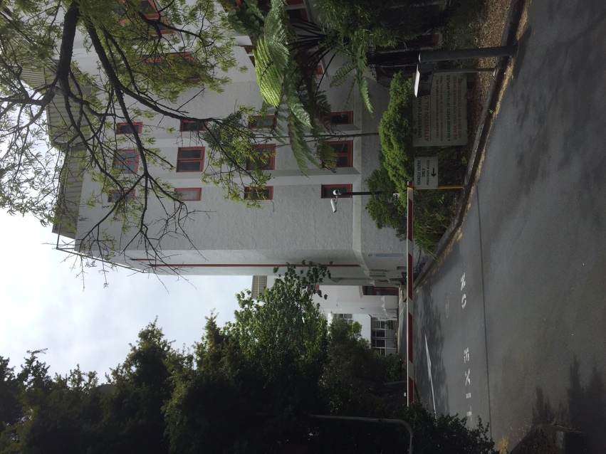
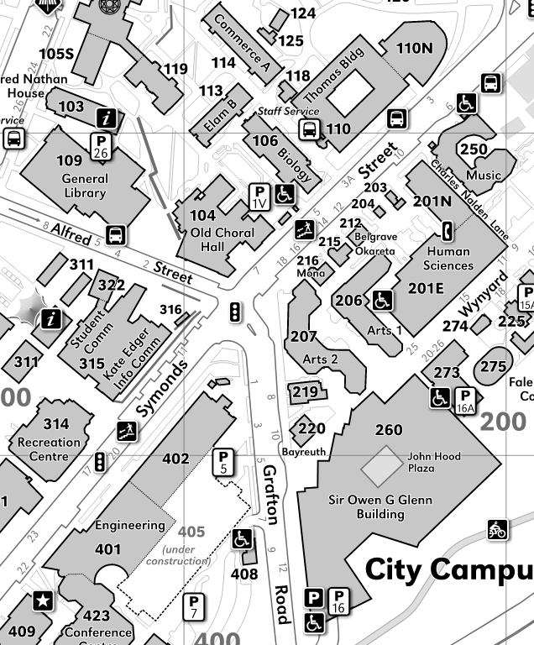

The Old Biology building is 106 on this map of the city campus of the University of Auckland. Walk past the car barrier up the drive a bit and you will see an entrance to the building on your right. Come through the door, up a few stairs and straight ahead into the entrance foyer. We will meet here (& morning tea will be here later), on the first floor. The lab is on the 3rd floor, please be at the lab & ready to start by 10.00 am. Those whose mobility is such they cannot manage the stairs, contact Mike 027 8871 664 and we will get a Ak uni person with a pass card to come down in the lift for you.

