CLIMATE SCIENCE: Spot the difference

Welcome to our new climate science resource - spot the difference. The activities are designed to encourage the use of observation and visual literacy skills using images that show either the effects of climate change or a related solution. Our approach is that it is important to be honest with children about what is happening to our world in an age-appropriate manner, and to focus on sharing solutions with them as well as talking about problems.

In the activities, the teacher guides the children to compare the two images and spot the differences between them. Through scaffolded questioning, the teacher can support the children to explore and discuss what is happening, why it is happening and the possible impact.

HOW TO RUN THE ACTIVITY:
- Display the pairs of images to the children.
- Provide any brief context that is required. The teacher notes will be useful for this. Take care not to explain what has happened between image 1 and image 2 as this is the focus for the children.
- Invite the children to describe what they can see in image 1, what they can see in image 2 and what the differences between the two images are. Partner talk is effective here.
- Use the suggested questions (or your own) to prompt children’s reasoning and deeper thinking

https://pstt.org.uk/application/files/1716/2186/6517/Summer_2021_Trust_Newsletter.pdf

Activity 1 Melting glaciers - The Pedersen Glacier

TEACHER NOTES TO SET THE CONTEXT:
A glacier is a large area of thick ice formed on land by many years of snowfall which has not melted and instead forms ice. Glaciers remain frozen from one year to the next and they flow slowly over the land due to their weight. If they reach the sea, pieces can break off and become Icebergs. The images below show the Pedersen Glacier that sits on the western side of Alaska in Kenai Fjords National Park. The glacier was formed in the little ice-age (1350 - 1850), a geological period when mountain glaciers in a number of locations expanded.

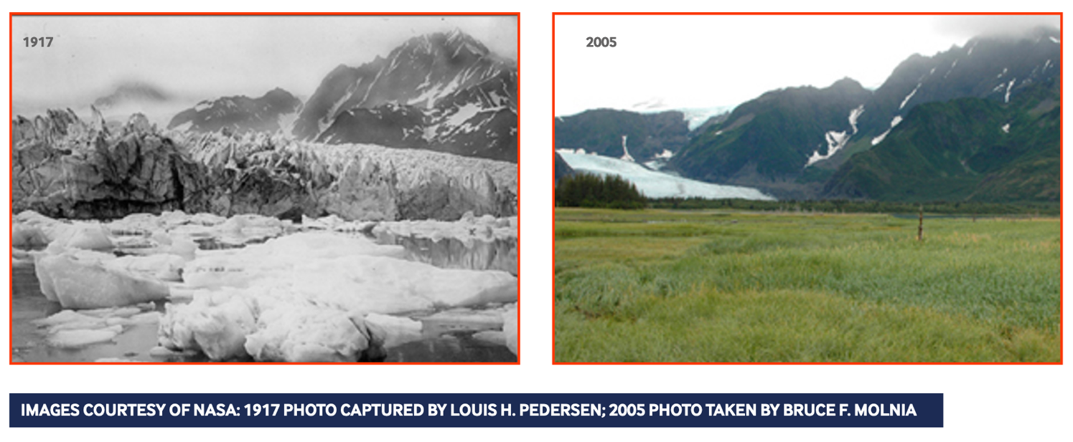

QUESTIONS TO SUPPORT THE CHILDREN TO MAKE COMPARISONS:
- How do you know this is the same view?
- What features can you see that identify it as the same view?
- What are the differences that you notice in the pictures of Pedersen Glacier in 1917 and 2005?
- What causes ice to melt?
- What conditions does grass need to grow?
- What do you think caused the change in the glacier and the surrounding landscape over this time?
- What could the effects of this be?
- What problems might melting glaciers cause?

FURTHER BACKGROUND INFORMATION FOR TEACHERS:
Glaciers are melting due to climate change leading to global heating. Sometimes melting ice forms a glacial lake. If melting increases and these lakes overflow, they can release huge volumes of water and cause catastrophic flooding. Glaciers store around three quarters of the world’s fresh water. When a glacier disappears completely this can mean a loss of freshwater supplies to communities. From 1951 to 1986 the Pederson Glacier retreated steadily but slowly at 20 metres per annum (m/a) (706 m in total) and from 1986 to 2005 at a speed of 23 m/a (434 m in total). By 2015 the glacier had retreated 2600 m since 1994. This is a speed of 125 m/a which is much faster than before.

ADDITIONAL RESOURCES AND INFORMATION
https://www.theguardian.com/environment/ng-interactive/2021/apr/29/visualised-glaciers-now-and-then
https://www.stem.org.uk/polar-explorer-educational-resources
https://www.theguardian.com/environment/2021/may/01/as-glaciers-disappear-in-alaska-the-rest-of-the-worlds-ice-follows
https://www.theguardian.com/environment/ng-interactive/2021/apr/29/end-of-the-ice-new-zealands-vanishing-glaciers
Activity 2 Melting sea ice: why is this a problem? - Polar bears

Please note: these images may cause children to feel distressed and teachers should exercise their own judgment about whether or not it is appropriate to show them to the children they are teaching.

TEACHER NOTES TO SET THE CONTEXT:
Polar bears mainly inhabit the Arctic Circle, subsisting on a diet of seals and other prey. Polar bears spend most of their time on sea ice and it is from the ice that they hunt for seals. When seals come to the surface at holes in the ice, they become prey to the polar bears. With their sensitive sense of smell, polar bears are able to detect the smell of a seal’s breath when they exhale. This enables them to catch the seals. Polar bears also stalk seals that are resting on the sea ice. Both methods involve sea ice.

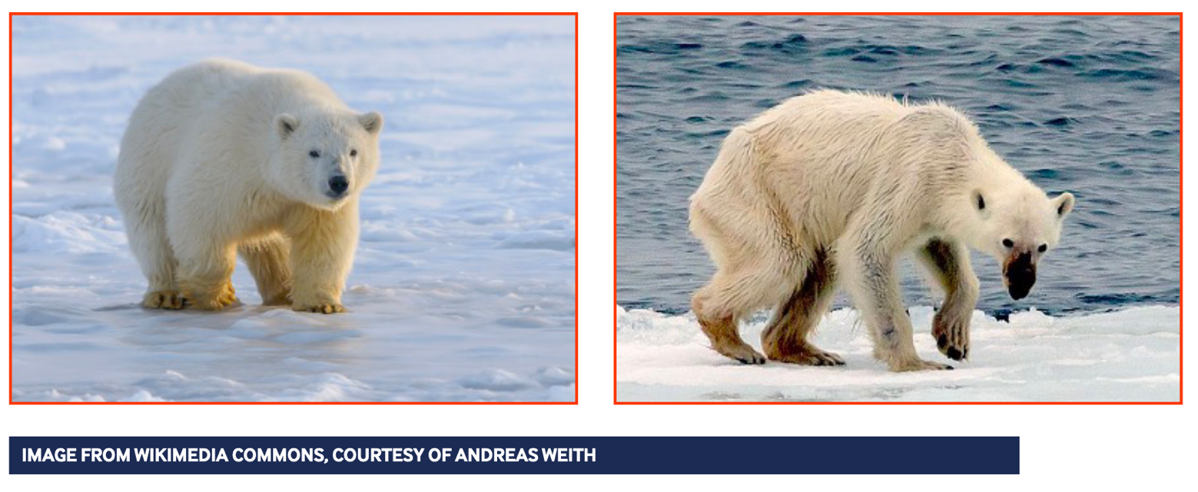

QUESTIONS TO SUPPORT THE CHILDREN TO MAKE COMPARISONS:
- What are the differences you can see between the two polar bears?
- What do polar bears need to be healthy?
- Which polar bear do you think looks healthy and why?
- What do you think the unhealthy polar bear is missing?
- What might have caused this?
- Is there a solution for the unhealthy polar bear?
- How is the health of polar bears related to the melting of polar ice?
- What are ways that polar bears could adapt to the melting of sea ice to survive?

FURTHER BACKGROUND INFORMATION FOR TEACHERS:
Arctic sea ice keeps the polar regions cool. The ice melts and forms with the seasons; however, global heating has upset this balance and the thickness and extent of the sea ice is decreasing. Polar bears depend on ice to hunt for their food. As a result of habitat loss caused by climate change, polar bears are unable to find enough food and are now classified as a vulnerable species. To date, the impact of global heating has impacted the Arctic most. Polar bears’ dependency on sea ice makes them highly vulnerable and we are yet to see how they adapt to their changing environment. Some studies suggest that the Arctic could be ice free in the summer by 2050

ADDITIONAL RESOURCES AND INFORMATION
https://www.worldwildlife.org/teaching-resources/toolkits/polar-bear-toolkit
https://www.worldwildlife.org/pages/polar-bears-and-climate-change
https://polarbearsinternational.org/education-center/
Activity 3 What can we do to help the planet? – Reforesting

TEACHER NOTES TO SET THE CONTEXT:
The images that follow show the same view at Coille Ruigh, Glen Affric in Scotland. This was home to red deer who were overgrazing the Scottish Pine seedlings (95% of the seedlings had grazing damage) which was preventing them from reaching mature growth. In both images, Scots Pine snags are visible. Snags are standing dead or dying trees. For example, 9 year old trees were on average just 8.5 m high. By building a fence around the area to prevent red deer from entering, the Scottish Pines were allowed to naturally regenerate. This project is a partnership between the charity Trees for Life and Forestry Commission Scotland.

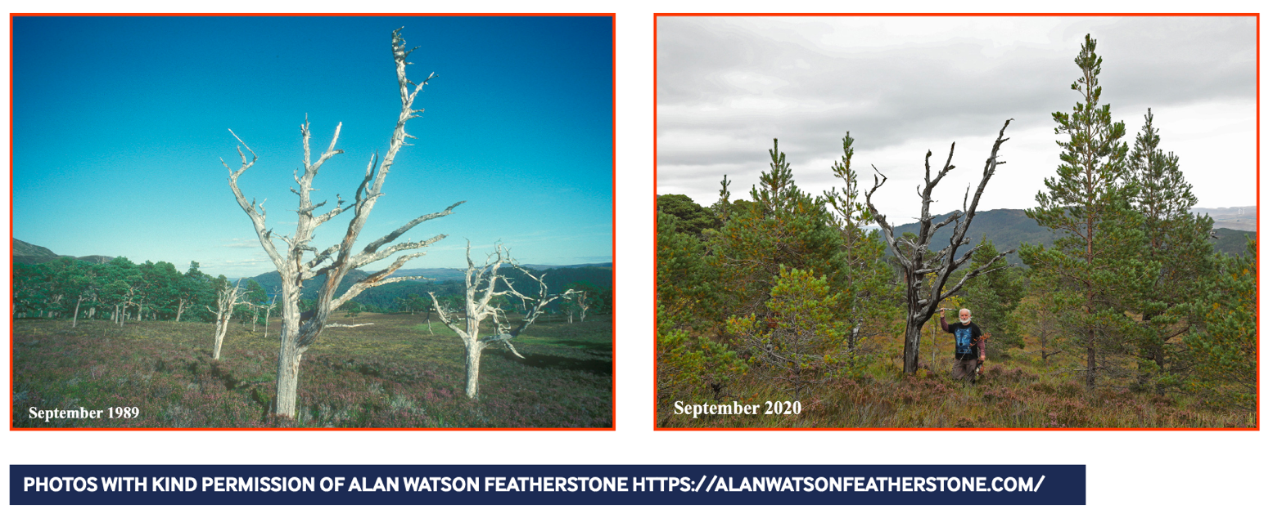

QUESTIONS TO SUPPORT THE CHILDREN TO MAKE COMPARISONS:
- How do you know this is the same view?
- What features can you see that identify it as the same view?
- What are the differences that you can see between Coille Ruigh in 1989 and 2020?
- Why do you think there are so few trees in the photograph from 1989?
- What do you think has happened in the years in between?
- What impact do you think the differences have on wildlife?

FURTHER BACKGROUND INFORMATION FOR TEACHERS:
Much of Scotland, like most of Britain, was once densely forested. Caledonian Forest was the temperate rainforest which once covered much of Scotland. The mission of the charity Trees for Life is to rewild the Scottish Highlands by enabling the restoration of the Caledonian Forest. Some of this work involves planting trees or, as in the case of Coille Ruigh, allowing an area to naturally regenerate. Amongst other aspects of their work is the introduction of red squirrels to new forests and studying the feasibility or reintroducing lynx to the Scotland Highlands.

ADDITIONAL RESOURCES AND INFORMATION
https://treesforlife.org.uk/coille-ruigh-25-years-of-regeneration/
https://www.woodlandtrust.org.uk/support-us/act/your-school/resources/
https://practicalaction.org/schools/regreen-the-desert/
https://alanwatsonfeatherstone.com/

Eco-anxiety https://www.climatepsychologyalliance.org/news/haveyouseen/546-new-youth-point

Franz Joseph glacier 2007 and 2021
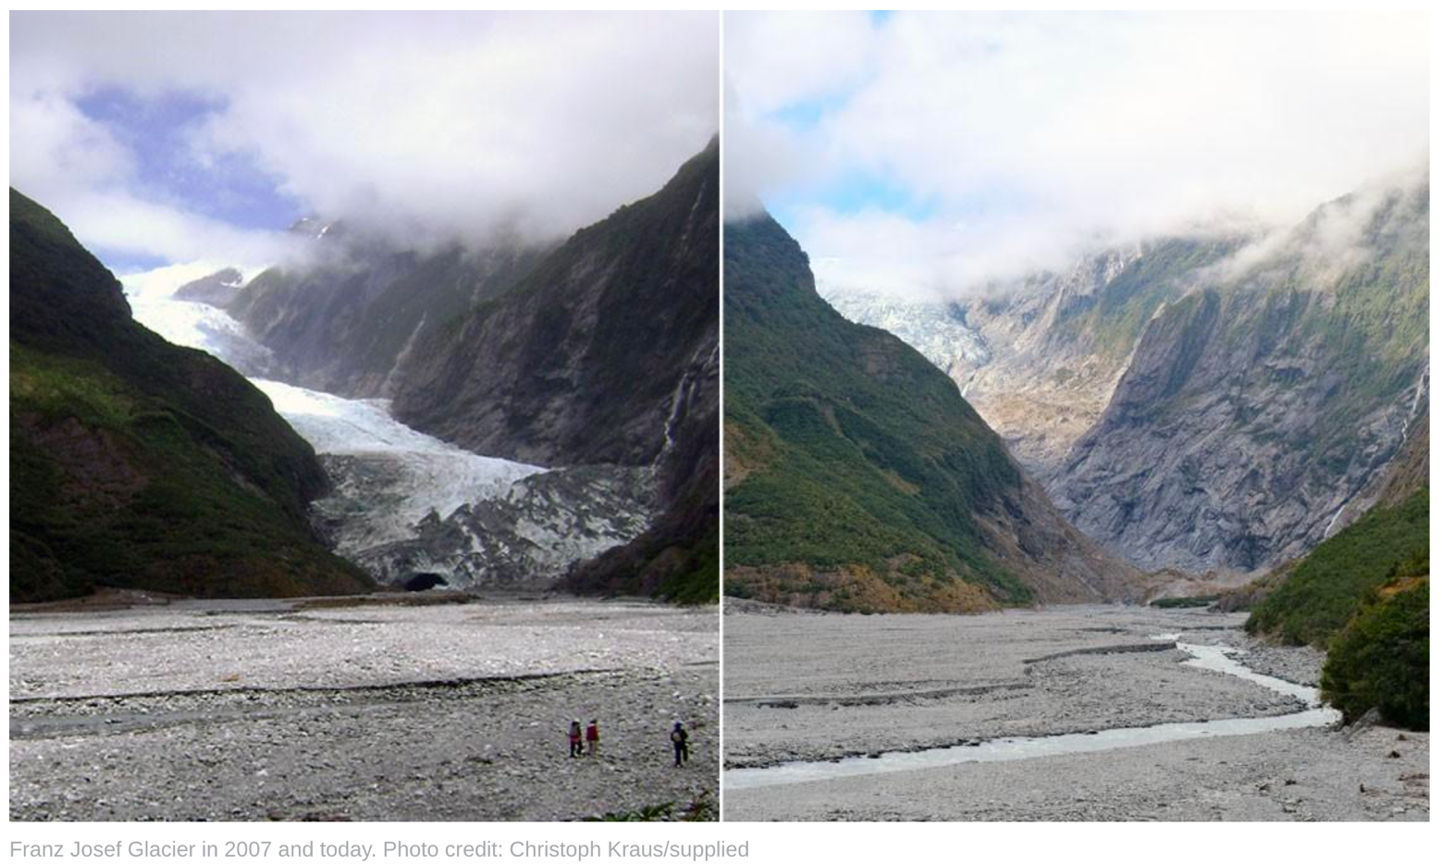

Extra for those who want a NZ link

