Diagram A  
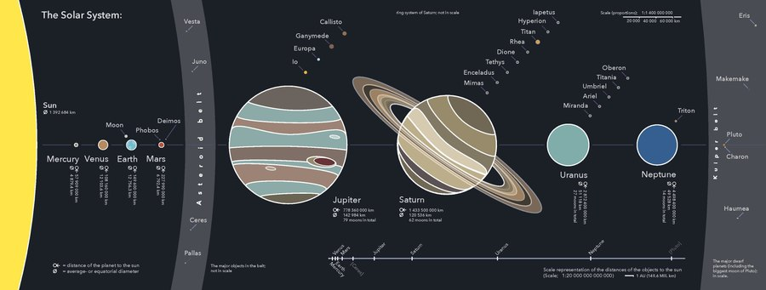

Here are some diagrams supposedly explain the solar system. Rank the diagrams from least useful to most useful, and explain why.

Answer these questions about each diagram:

* What does the representation tell us?
* What is left out
* How does this representation get the message across?
* Why is it presented in that particular way?

Diagram B

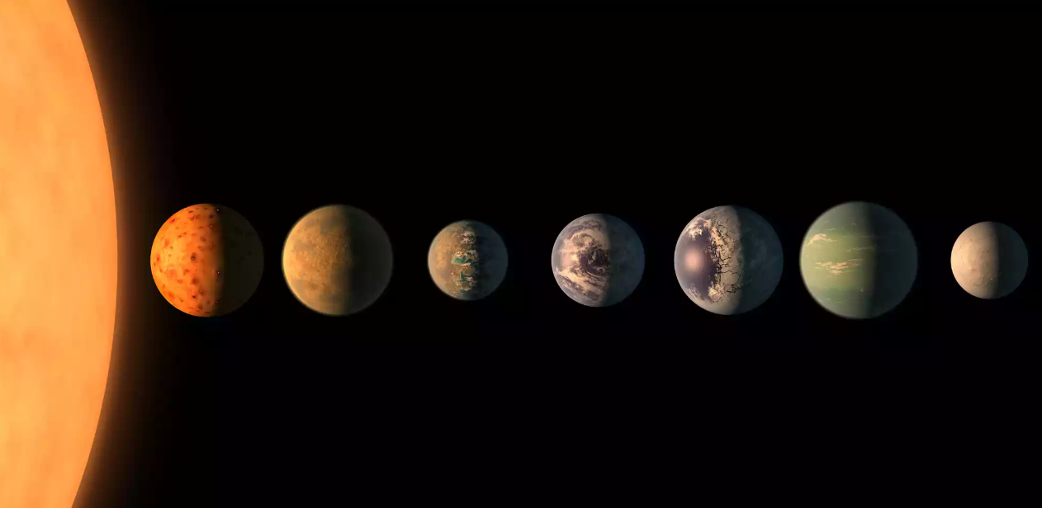

Diagram c

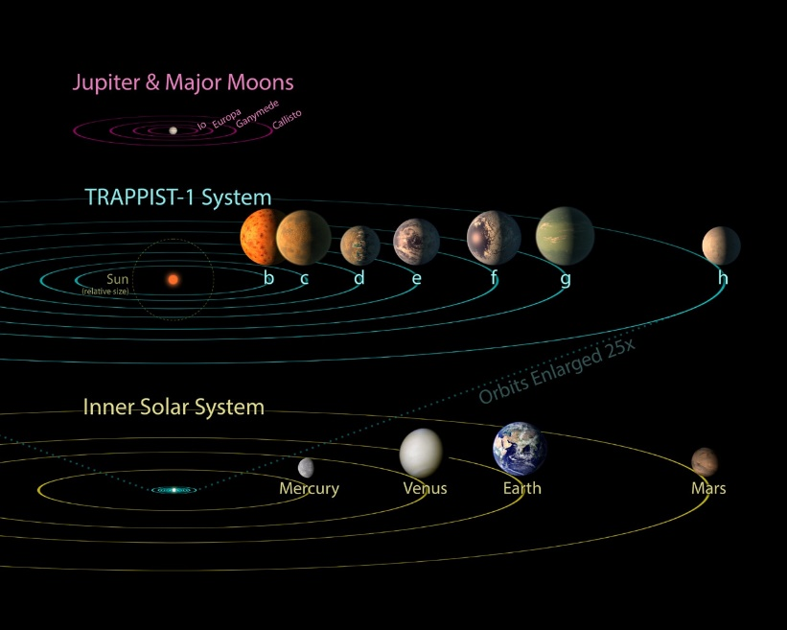

Diagram D Diagram G

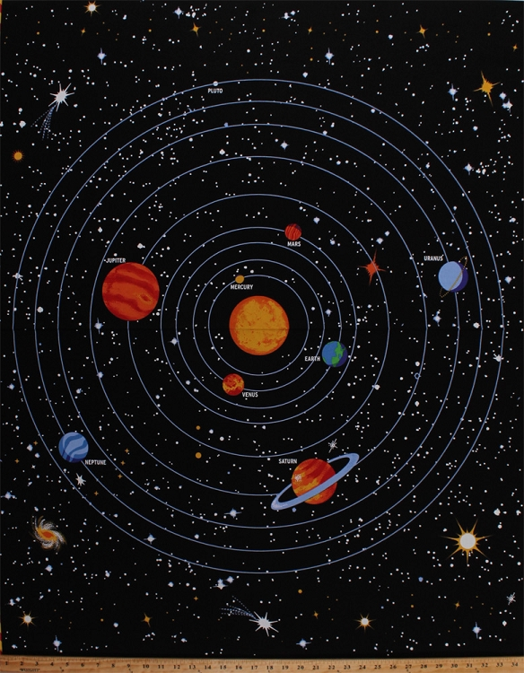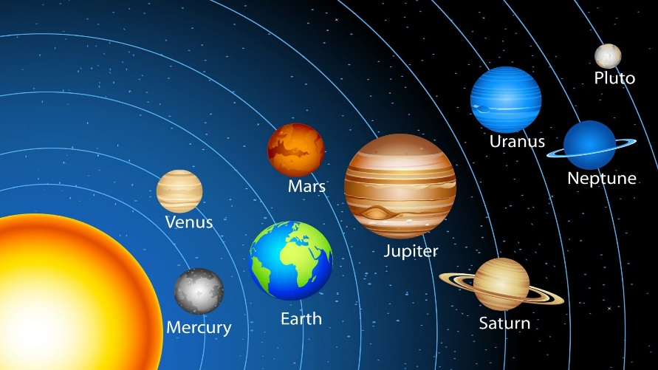

Diagram E

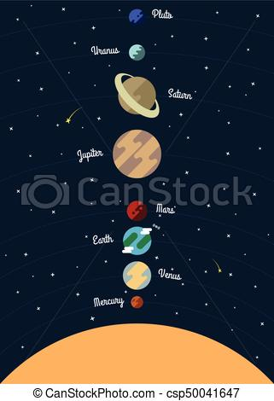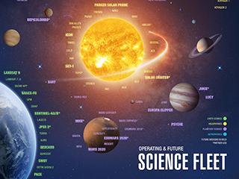

Diagram F

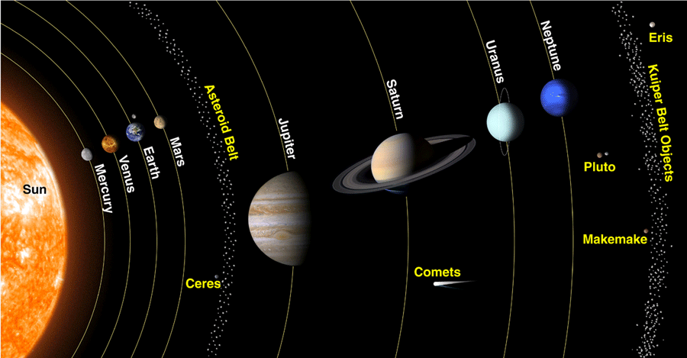

Diagram H