UoA scientists dismiss mātauranga Māori as not science

In the 31 Jul (issue 31) Listener:
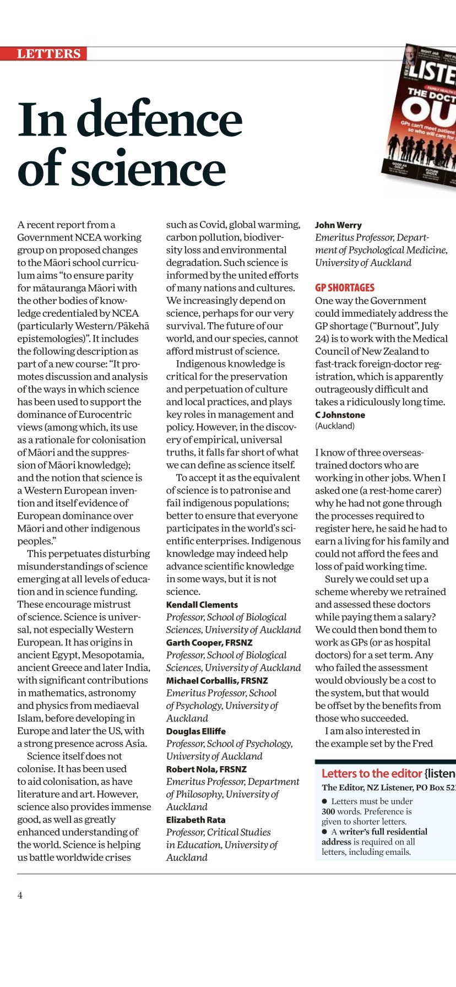

Response from NZ Association of Scientists https://scientists.org.nz/resources/Documents/PressReleases/NZAS-M%C4%81tauranga%20and%20Science.pdf

Not just myths and legends NZH article by Te Taru White
https://www.nzherald.co.nz/rotorua-daily-post/news/opinion-myths-and-legends-much-more-than-that/USO2VFCKXRVKWFWUWC5ULKKBHE/

Response from the Royal Society
https://www.royalsociety.org.nz/news/joint-statement-from-president-and-chair-of-academy-executive-committee/

Response from the Vice-Chancellor of Ak uni
https://www.auckland.ac.nz/en/news/2021/07/26/vice-chancellor-comments.html

Acting Dean of Science steps down
https://www.nzherald.co.nz/nz/auckland-university-professor-resigns-over-letter-claiming-maori-knowledge-isnt-science/NF4CMOCYRJZGI5Y4DXACKKJU54

Response from Dr. Kiri Mamai Dell, UoA
https://kupumamae.com/2021/07/27/just-what-is-matauranga-maori/

Kath Haines’s students at WEGC respond
https://www.rnz.co.nz/news/te-manu-korihi/448109/matauranga-maori-in-science-it-sparks-more-interest-in-learning

Defence of Colonial Racism by Tina Ngata
https://tinangata.com/2021/07/25/defending-colonial-racism/

