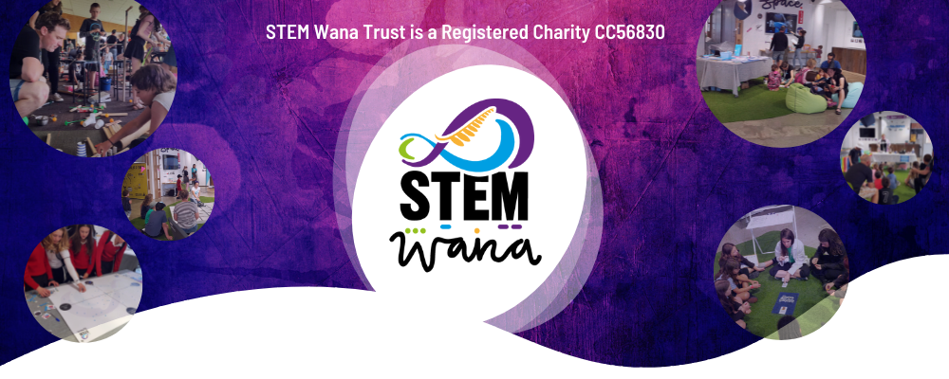

|  |  |
| --- | --- |
| |  | | --- | | October School Holiday STEM Activities  Introducing STEM in the Community for 8-12 year olds  STEM in the Community is our outreach project held in locations across the Bay of Plenty, where we bring together amazing STEM content providers, smart venues and enthusiastic children and tamariki. Each location is run as a unique event.  Please find below all information about Tauranga's session and book your free ticket now! Get in quick as spaces are limited and filling fast!  **Saturday 2nd October 2021.** Tauranga. Biomimicry interactive workshop - Invented by plants and animals - an introduction to biomimicry. [Book ($20 family) tickets here](https://lists.stemwana.nz/lt.php?tid=ekwABVVQAgxTUx8EVlwGHAJXUgAbUgAEBxQABVJVWgEGUgBRXFYdXAMCBgYBXgUcAQJSBBsEVlMDFFICVwBOBAMFDgoDUVlaBAhQS1UNVwABAVQHG1IEDFYUBAIEAE5RUAkIHgFXB11SVQZWWwsAVA).  **Thursday 7th October 2021. Rotorua**. Science at home - learn how to do your own science experiments using simple household items. [Book FREE tickets here](https://lists.stemwana.nz/lt.php?tid=ekwJUVEAVg1UUh9SB1lWHAJUBVAbCFZQBRQGB1oFWggKBA4AB1cdXAMCBgYBXgUcAQJSBBsEVlMDFFICVwBOBAMFDgoDUVlaBAhQS1UNVwABAVQHG1IEDFYUBAIEAE5RUAkIHgFXB11SVQZWWwsAVA).  **(ALL AGES) Friday 8th October 2021.**Tauranga. Come and make your own art-bot and create art using robotics. [Book FREE tickets here](https://lists.stemwana.nz/lt.php?tid=ekxZBF0EV1wEVR9SBQ1THAJTVgIbUQRTAhQAV1YBVgMKBApRUAQdXAMCBgYBXgUcAQJSBBsEVlMDFFICVwBOBAMFDgoDUVlaBAhQS1UNVwABAVQHG1IEDFYUBAIEAE5RUAkIHgFXB11SVQZWWwsAVA).  **Friday 15th October 2021.**Katikati. Come have a go at robotics and coding and take part in an interactive egg drop challenge! [Book FREE tickets here](https://lists.stemwana.nz/lt.php?tid=ekxZV1VZVQkEVB8BAVoLHAICVQsbCQNUBRQCAQAFVggHAQhVAQUdXAMCBgYBXgUcAQJSBBsEVlMDFFICVwBOBAMFDgoDUVlaBAhQS1UNVwABAVQHG1IEDFYUBAIEAE5RUAkIHgFXB11SVQZWWwsAVA).  **Saturday 16th October 2021.** TCC Water Education workshop - Get hands on with interactive Pumps, Pipes and Wipes model to see where our water goes once it’s been used. [Book FREE tickets here](https://lists.stemwana.nz/lt.php?tid=ekxaBVRRUwgAAB9WUw4FHAJSA1UbCVUMBRQIB1pcV1QABwgEAVcdXAMCBgYBXgUcAQJSBBsEVlMDFFICVwBOBAMFDgoDUVlaBAhQS1UNVwABAVQHG1IEDFYUBAIEAE5RUAkIHgFXB11SVQZWWwsAVA).  **Saturday 16th October 2021.**"Astronomy 101" workshop by Tauranga Astronomical Society - a fun, interactive demonstration of the basics of astronomy.[Book FREE tickets here](https://lists.stemwana.nz/lt.php?tid=ekwOUgQDBAFTBR8CB11XHAJXA1EbCQlRWRQAB1FdUwBRVVpSVFYdXAMCBgYBXgUcAQJSBBsEVlMDFFICVwBOBAMFDgoDUVlaBAhQS1UNVwABAVQHG1IEDFYUBAIEAE5RUAkIHgFXB11SVQZWWwsAVA).  Other events to be confirmed at Te Puke and Whakatane locations...    *STEM Wana Trust proudly presents...*  Tauranga STEM Festival 2021 - NEW DATE!!! - Sunday 5th December 2021  [Click here to get your exclusive Early Bird tickets now!](https://lists.stemwana.nz/lt.php?tid=ekwBB1ECV1xQVR8BBwxUHAJQBgAbCAZWABQGXQFXW1FWAVsKUFkdXAMCBgYBXgUcAQJSBBsEVlMDFFICVwBOBAMFDgoDUVlaBAhQS1UNVwABAVQHG1IEDFYUBAIEAE5RUAkIHgFXB11SVQZWWwsAVA)        Tinkd Makerspace - NOW OPEN!  Basestation, 148 Durham Street, Tauranaga, Bay of Plenty    Tinkd Makerspace is a STEM Wana Trust project. Tinkd is built to provide the location, tools, techniques (education), support and encouragement for innovative and creative work with a focus on STEM.  Come and have a go at 3D printing, vinyl cutting, robotics, electronics, textiles design, sewing and so much more! Check out the website and contact us for a free tour! Suitable for children over 8 years old. [www.tinkd.nz](https://lists.stemwana.nz/lt.php?tid=ekxcAVdVBF9XAx9TBQ9THAIIVgcbCVQHAxQDXFtQVQAAAg5SXVkdXAMCBgYBXgUcAQJSBBsEVlMDFFICVwBOBAMFDgoDUVlaBAhQS1UNVwABAVQHG1IEDFYUBAIEAE5RUAkIHgFXB11SVQZWWwsAVA)    Morning Tea with STEM Heroes - This is a free event suitable for high school students and adults.  Hosted at University of Waikato, Tauranga Campus. Tuesday 5th October from 8:30am to 10:30am  Is your child still figuring out which subjects to choose at school or which career path to take? We want to help you support them to make the right decision. We invite you to converse with a panel of STEM heroes who will be sharing with you their own STEM experiences.  Introducing our panel:  **Suki Xiao** - Career Coach & Entrepreneur  **Victoria Clark** - Senior Environmental Engineer Specialist at Beca  **Natalie Prinz** - Marine Biologist, doing a PhD in Marine Ecology at the Waikato University and STEMFest Ambassador  **Vithya Yogarajan** - Master of Science in Machine Learning and Applied Mathematics at University of Waikato.  Light refreshments will be provided. We look forward to seeing you there!  [Get your FREE tickets here.](https://lists.stemwana.nz/lt.php?tid=ekwKBVxSVQhaBB8BW10CHAIDUQEbUQQGBBRRXFEGWwQFAQtVXVkdXAMCBgYBXgUcAQJSBBsEVlMDFFICVwBOBAMFDgoDUVlaBAhQS1UNVwABAVQHG1IEDFYUBAIEAE5RUAkIHgFXB11SVQZWWwsAVA) | |