LEARNZ Ideas for Māori Language Week
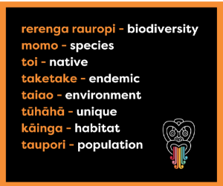
Teaching and learning about te reo Māori and mātauranga Māori is embedded in our LEARNZ online field trip resources.
Ahead of Te Wiki o te Reo Māori next week, we wanted to share with you some awesome distance learning resources from past field trips to make it easy for you to include Māori language moments in everyday learning.

Keywords with pronunciation prompts are included in every field trip’s ‘Discover more’ readings and quiz section, making it easy for ākonga to expand their vocabulary and kōrero about the field trip with new words learnt. Start with trying to learn these new words from our upcoming Backyard Biodiversity online field trip.

Resources to support mātauranga Māori learning
In our conservation field trips LEARNZ builds closer relationships with iwi to include perspectives and mana whenua tikanga in regards to their role as kaitiaki (guardians) of the natural environment. Check out these resources from past online field trips for inspirational and informative learning with your ākonga.
Raranga tuku iho, tohatoha whiwhi ōrite - dual heritage, shared future >
This online field trip is in te reo Māori and English, you can start with these ‘Discover more’ readings which share the stories of Kupe and the first Polynesian settlers.
Map my Waahi - Tikanga for Hīkoi >
Watch this video from the Map my Waahi field trip, where Te Poihi Campbell explains tikanga Māori hei aratakitaki i ngā kaupapa – a Māori cultural approach to activities. Use this video to kōrero with ākonga about how to be respectful when visiting new places.
Map my waahi - The importance of pepeha >
Watch this video of ākonga from Te Kura Māori o Porirua, Andre and Manaia, who explain what their pepeha means to them and visiting places they connect with. Use this video to get ākonga to reflect on places they connect with and share with each other.

