**LEARNZ Virtual Field Trip**

**An Example of a Planning Sequence**

This example of a short-term lesson sequence for primary schools makes use of all field trip components for a 3-day virtual field trip.

However, the flexibility of LEARNZ means that teachers can use as many or as few of the components as they wish. Teachers who are involved for the first time may wish to choose just one or two.

Teachers, visit the [Support Section](http://www.learnz.org.nz/support) of the LEARNZ website for more information on:

* [Getting started with LEARNZ](http://www.learnz.org.nz/support/getting-started)
* [The ambassador programme](http://www.learnz.org.nz/support/ambassador-programme)
* [Taking part in web conferences](http://www.learnz.org.nz/support/audioconferences/introduction)
* [Ask-an-Expert web forum](http://www.learnz.org.nz/support/ask-an-expert)

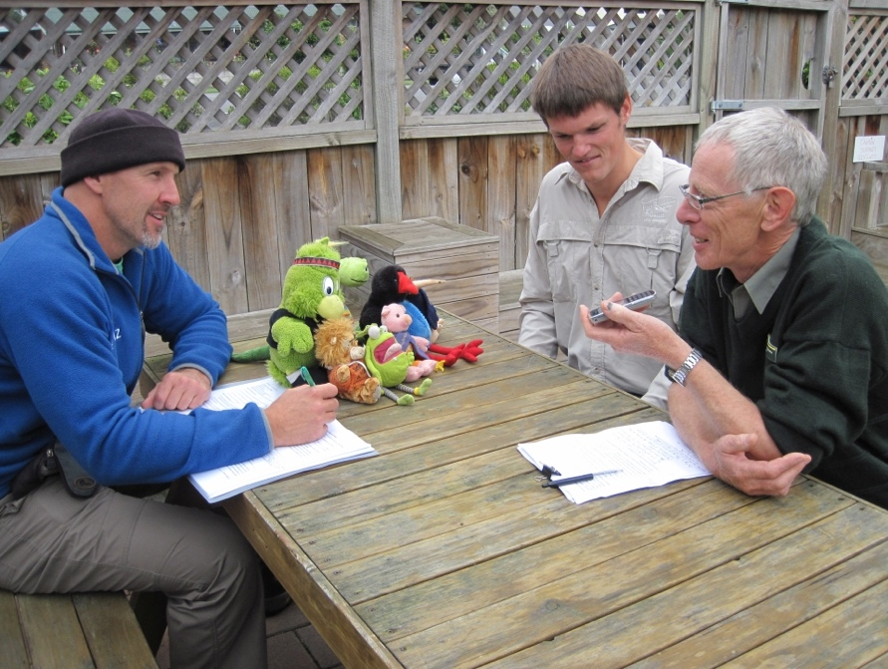

This plan includes the following components of a **LEARNZ Virtual Field Trip.**

* planning using the online curriculum links
* using online and printable background information
* using online interactive self-marking plus other activities
* using daily field trip diaries with photos and inquiry questions
* using daily field trip video clips and inquiry questions
* using Twitter for live updates and information/thought sharing
* putting questions to experts during live web conferences
* listening to web conferences while completing related tasks
* taking part in the LEARNZ Meeting Room during web conferences
* completing web conference summaries
* sending a class ambassador, viewing the ambassador's daily web page updates
* corresponding by email with the LEARNZ teacher and the class ambassador
* completing a field trip evaluation

|  |  |  |  |  |  |  |  |  |  |  |  |  |  |  |  |  |  |  |  |  |  |  |  |  |  |  |  |
| --- | --- | --- | --- | --- | --- | --- | --- | --- | --- | --- | --- | --- | --- | --- | --- | --- | --- | --- | --- | --- | --- | --- | --- | --- | --- | --- | --- |
| **An Example of a Planning Sequence** | | | | | | | | | | | | | | | | | | | | | | | | | | | |
| **Timeline** | **6 weeks before field trip** | **4 weeks prior** | | **2 weeks prior** | | | **Thursday** | | | **Friday** | | **The week prior**  **Monday** | | | **Tuesday** | | | **Wednesday** | | | | **Thursday** | | | **Friday** | | |
| **Suggested teacher and classroom activities** | Decide to take a virtual field trip. Register with LEARNZ  Log onto MyLEARNZ and enrol class(es) in selected field trip(s) | Plan the field trip to fit with class, term and year plan.  Select AOs.  Send class login home with students so parents can follow field trip. | | Plan field trip (3-4 weeks) into your daily timetable  Select background pages and activities for class/group sessions.  Plan to ask questions in web conferences.  Plan to listen to others | | | Set scene with class - "Let's go on a field trip to ... What might we see, what could we find out? ..."  Introduce field trip location and themes, guests, website material.  Create field trip display in classroom. | | | Develop questions about the web conference topics | | Readabout the LEARNZ field trip teacher's ambassador.  Select class ambassador to send on trip**.**  Write up summary of ambassador's life plus hopes and dreams for field trip. | | | Develop and find answers for questions about web conference topic  Add ambassador photo to field trip display in your classroom. | | | Summarise the unanswered questions on the web conference topics into 10 "fat" questions for each | | | | Class prepares short assembly item to share with team, school or principal about their adventures next week.  Teacher checks web conference equipment, and connections. Organise a practice run with the LEARNZ office to check sound quality. | | | Present short assembly item.  Call another school or a parent and have class practise asking questions | | |
| During brainstorming, keep a chart of unanswered questions. Summarise later to form “FAT” questions to ask in your web conference. | | | | | | | | | | | |
| **Teacher contact with LEARNZ team** | Join [LEARNZ group on VLN](http://www.vln.school.nz/groups/profile/785745/learnz) for this field trip, and get ideas from other teachers. | **Receive** newsletter #1 | | **Receive** newsletter #2  **Send** email to book in to web conferences including date, time  **NB:** ONLY speaking schools need to book, as they ask questions live. | | | | | | | | **Sign-up** class ambassador online, include details from class discussion  **Receive** ambassador confirmation email with your ambassador's email address for the field trip.  **Post** ambassador to **address supplied by LEARNZ Teacher in a personal email**. | | | | | | **Email** 10 "fat" questions for each web conference topic to [andrew.penny@core-ed.org](mailto:shelley.hersey@core-ed.org) | | | | | | | **Receive** newsletter #3.  **Receive** confirmed web conference questions to ask.  **Receive** email - ambassador arrived. | | |
| **Online Material available** | Complete **Registration & Enrolment**.  Review field trip **Summary.** | **Web Site** goes live.  Standard and easy background pages. | | **Web conference** timetable confirmed, expert profiles, locations. | | | **Field** trip website | | |  | | **Class ambassador** pages | | | | | | | | | |  | | | **Web conference** questions online | | |
|  |  | **Check home page of field trip for daily additions to the site** | | | | | | | | | | | | | | | | | | | | | | | | | |
| **The LEARNZ Team is available for support, web conference practise and general inquiries.**  **enquiries@learnz.org.nz** | | | | | | | | | | | | | | | | | | | | | | | | | | | |
| **An Example of a Planning Sequence (continued)** | | | | | | | | | | | | | | | | | | | | | | | | | | | |
| **Timeline** | **Field trip week Monday** | | **Tuesday** | | | **Wednesday** | | | **Thursday** | | | | **Friday** | | | **First week after**  **Monday** | | | **Tuesday** | | **Wednesday** | | | **Thursday** | | | **Friday** |
| **Suggested teacher and classroom activities** | Finish off previous week’s field trip tasks and activities. Discuss expectations and hopes for field trip.  Print or bookmark questions for three days of web conferences.  Students write to ambassador - combine into a single email and send.  Get live updates on Twitter – follow @andrewpenny01 | | Read Mon diary.  Read Mon ambassador diary.  Find travel routes to field trip location on LEARNZ Homepage map.  Listen to today's web conference | Take part in LEARNZ meeting room.  Write summary for today's web conference.  Ask questions in your booked web conference (Tue or Wed or Thu). | | | Read Tue diary.  Watch Tue videos, answer questions.  Read Tue ambassador diary.  Write to ambassador.  Listen to today's web conference | Take part in LEARNZ meeting room.  Write summary for today's web conference. | | | Read Wed diary.  Watch Wed videos, answer questions.  Read Wed ambassador diary.  Write to ambassador.  Listen to today's web conference | Take part in LEARNZ meeting room.  Write summary for today's web conference. | | | | Read Thu diary.  Watch Thu videos, answer questions.  Read Thu ambassador diary.  Write to ambassador. | | | Review expectations and hopes for field trip.  Create chart of highlights.  Create individual records of the trip - include images and experiences. | | | Create individual records of the trip - include images and experiences. | | Present individual records of the trip to class, team, assembly or parents.  Summarise trip for assessment. | | | Teacher completes online evaluation of the field trip, including student feedback. | | | Share learning online via blog or wiki or class web site. Publicise in school newsletter and/or BOT report. |
| **Teacher contact with LEARNZ team** |  | |  | | | Send web conference summary to LEARNZ Teacher – [andrew.penny@core-ed.org](mailto:shelley.hersey@core-ed.org) | | | | | | | | | | | | | Receive newsletter #4    Receive thank you for participating email and web conference certificate | | | | | | | | |
| **Send** email to **ambassador**  **Receive** reply from **ambassado**r | | | | | | | | | | | Complete online evaluation form by due date to go into draw for evaluation prize. | | | | | | | | | Receive ambassador back in post with participation certificate. | | | | |
| **Online Material available** |  | | Diary #1 Monday | | Diary #2 Tuesday | | | Diary #3 Wednesday | | | Diary #4 Thursday | | | Review field trip components.  Web conference summaries. | | | Review field trip components.  Web conference summaries. | | | Field trip website.  Web conference summaries. | | | Field trip website.  Web conference summaries. | | | Field trip website.  Web conference summaries. | |
| Ambassador update | | Ambassador update  Web conferences – daily recordings | | | | | | | | |
| **Check home page of field trip for daily additions to the site** | | | | | | | | | | | | | | | | | | | | | | **Fourth week after**  **Receive** newsletter #5.  **Evaluation Prize** winner drawn  **Choose** next field trip, **enrol** class. | | | | |
| **The LEARNZ Team is available for support, web conference practise and general inquires.**  **enquiries@learnz.org.nz** | | | | | | | | | | | | | | | | | | | | | | | | | | | |