Some Science Capability activities

Item 1

The graph shows a river’s water flow over 18 days. The measurements were taken about 45 km from the river’s source (where it begins).

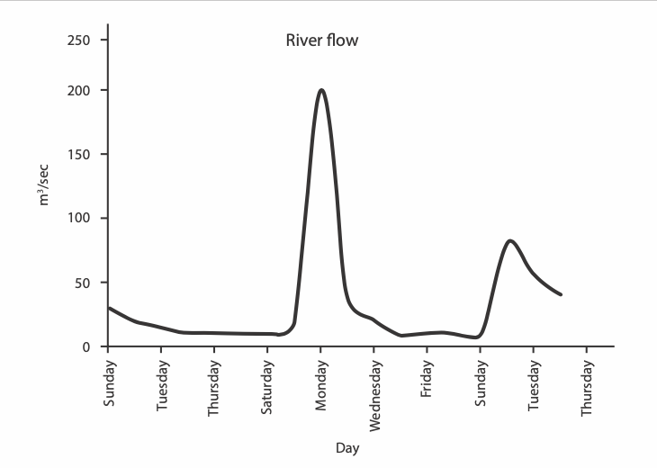
- What was the approximate water flow on the first Sunday?

- Look at the units. Think about what it means. How might scientists measure river flow?

- What story does the graph tell? (Observation)

- What could be causing this? (Inference)

- How could you check that?

Item 2

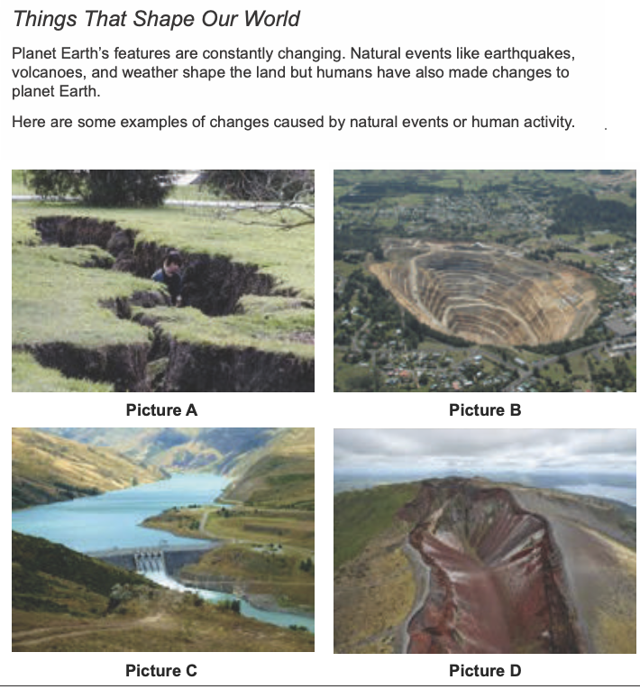

- Which image(s) show change caused by a natural event?

- What is the evidence? (Observation)

- What might have been the cause of the change(s)? (Inference)

- If you are working on your computer, do a reverse image search online to see what more you can find about each image. First save the image as a file. Then:
Google Google Images Search by image Upload the image (Choose file Select a picture from your computer Open or Choose)

Item 3

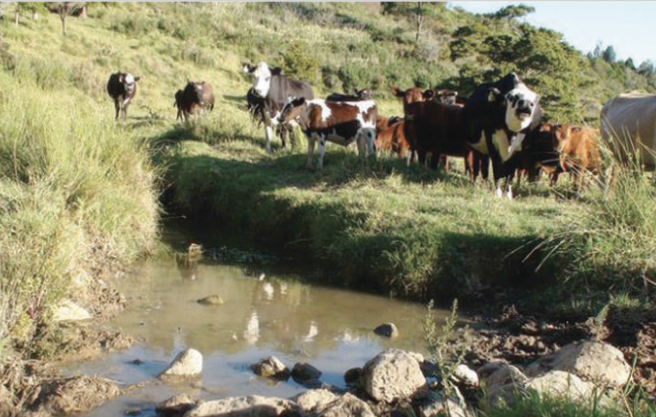

- Why are farmers asked to prevent livestock getting into streams?

- What are some options for doing this?

- What is 1 way the farmer could find out how healthy the stream is? Explain.

Item 4

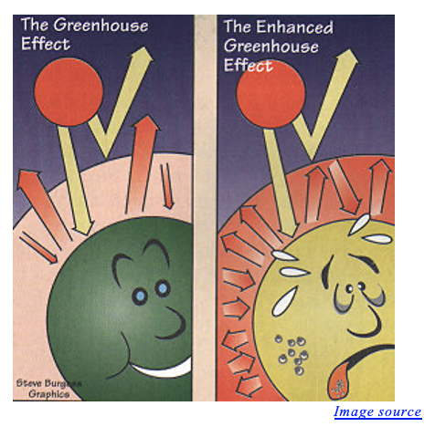
- What do these parts of the image represent:
- The arrows?

- The colours of the arrows?

- The 3 circles (small, large, largest)?

- The colour of the 3 circles?

- What are the two pictures telling us?

- i. So what do you think enhanced means?

ii. Check in a dictionary
Also:

Norman Lederman’s activities

https://citeseerx.ist.psu.edu/viewdoc/download?doi=10.1.1.513.1068&rep=rep1&type=pdf

Science Learning Hub

Tangram activity https://www.sciencelearn.org.nz/resources/431-the-extra-piece

Scrambled sentences https://www.sciencelearn.org.nz/resources/432-student-activity-scrambled-sentence

Science Learning Hub Mystery boxes: https://www.sciencelearn.org.nz/resources/430-observation-and-the-mystery-box

And others below each activity page

