Antarctica Food web activity

Divide the class into groups to share the research. For each different living organism find out what they eat and what eats them (don’t be satisfied with just 1 predator or prey). Also find out which of these organisms humans catch in Antarctica. Cut out the 15 boxes, Organise on a large sheet of paper, drawing in arrows to show the food web, then apply glue. Take a photograph for your notes.
[The trick with food webs is to have as few crossed over arrows as possible.]

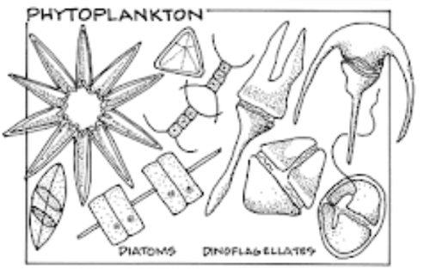 | Carnivorous  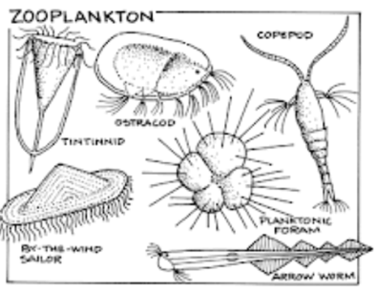 | Wandering albatross  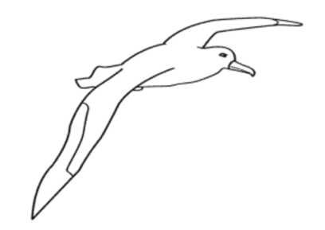
Emperor Penguin  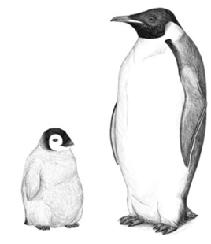 | Elephant seal  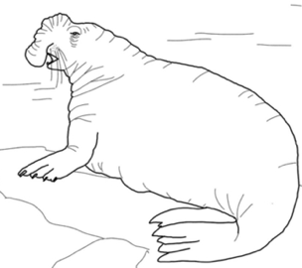 | Leopard seal  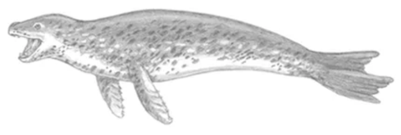
Krill  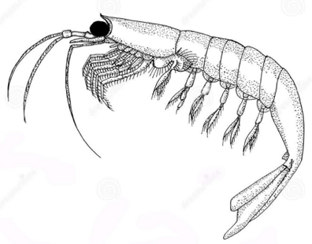 | Cod icefish  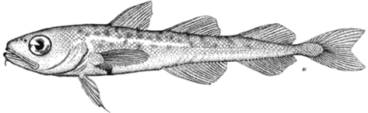 | Squid  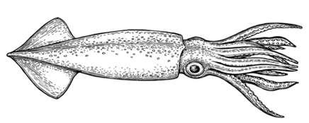
Humans  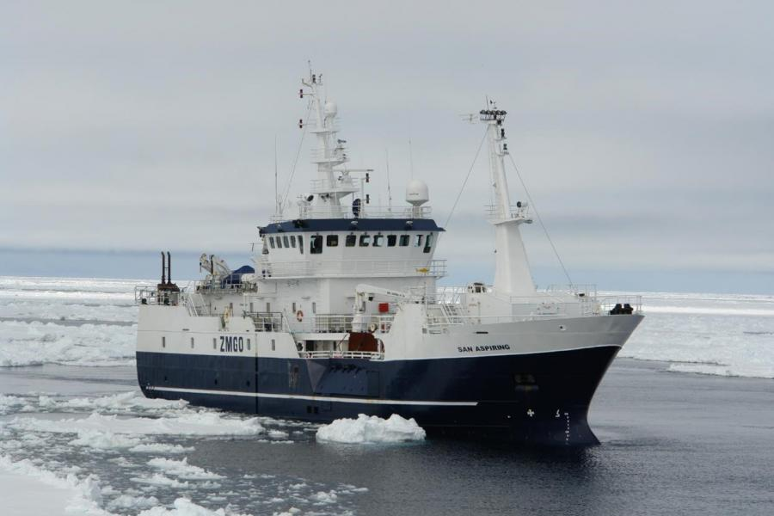 | Sperm whale (teeth)  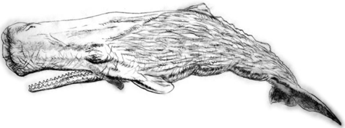 | Humpback whale (baleen)  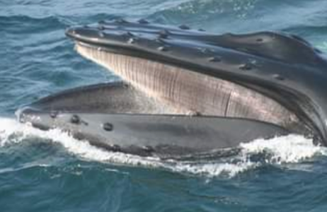
Orca  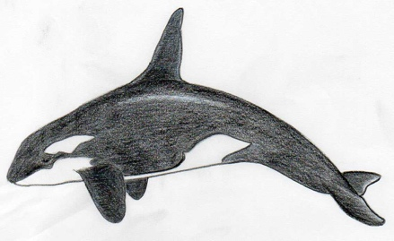 | Toothfish  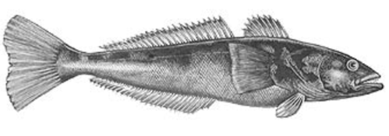 | Herbivorous  