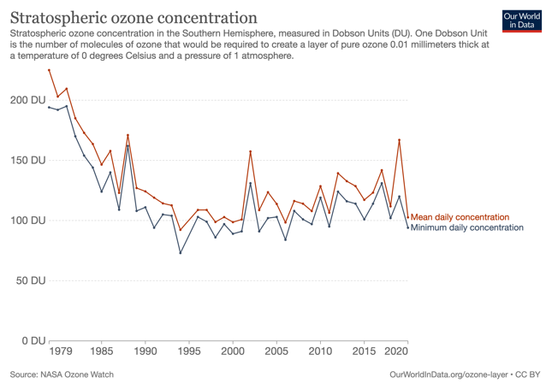
Ozone in Antarctica

You may have heard of an ozone hole over Antarctica. What is it and why is it important?

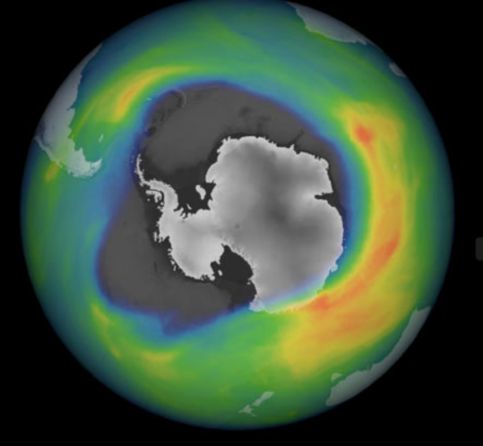
The oxygen gas we breathe in is a molecule made of 2 oxygen atoms joined together: O₂. Ozone is another form of oxygen, a molecule made up of 3 joined atoms: O₃. This molecule forms naturally when O₂ absorbs ultraviolet (UV) light, 20km high in the stratosphere. By absorbing UV ozone protects us from these harmful rays which can cause eye damage, sunburn and skin cancer, especially at latitudes close to the poles.
In the early 1980s scientists began to realize that Earth’s natural sunscreen was thinning dramatically over the South Pole each spring. This thinning of the ozone layer over Antarctica came to be known as the ozone ‘hole’. It’s not a real hole, it’s a metaphor for visualising areas where ozone concentrations drop below the historical threshold of 220 Dobson Units (DU).
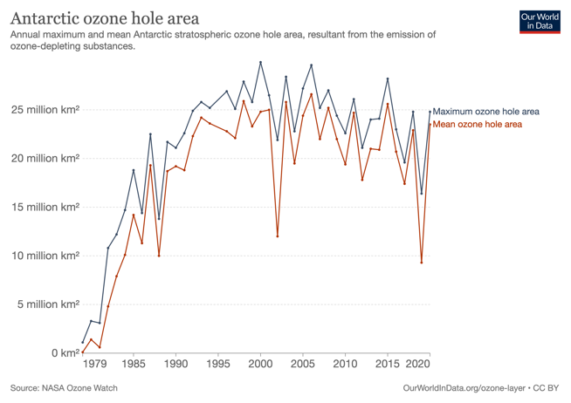
Measurements of ozone concentration, which began in 1979, continued to drop over the next 20 years, showing the ‘hole’ was thinnest in 1994, but it’s area was biggest in 2006. Publicising these findings opened the world’s eyes to the global effects of human activity on the atmosphere.
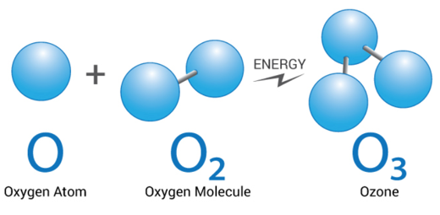
At the same time scientists were searching for a cause of ozone depletion and found the culprit to be chlorofluorocarbons (CFCs) and other substances. CFCs had been used as the coolant in fridges and in aerosol sprays since the 1930s. These long-lasting substances circulated in the stratosphere, where UV light split the CFC molecules, releasing chlorine which destroys ozone.
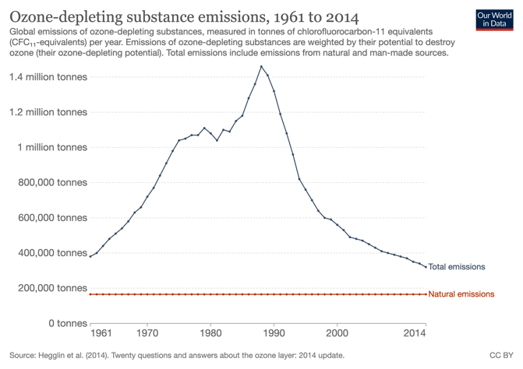
In 1987 the Montreal Protocol was signed, a treaty phasing out the production of ozone-depleting chemicals like CFCs. Although their use has declined by almost 99%, the concentration of these ozone-depleting substances in the stratosphere are not predicted to return to pre-1980 levels until on average 2050, even later for Antarctica.
Ozone depletion is more severe over Antarctica, mostly because it is the coldest place on earth and ozone destruction is more efficient at cold temperatures.
CFCs are also powerful greenhouse gases (GHGs), 10,000 times more powerful than CO₂. So reducing GHGs has also had a positive effect on climate change.
Activities:
1. The table below shows NASA’s data of mean daily concentration of ozone, 1979 – 2020.

Year | ‘79 | ‘80 | ‘81 | ‘82 | ‘83 | ‘84 | ‘85 | ‘86 | ‘87 | ‘88 | ‘89 | ‘90 | ‘91 | ‘92
Conc O₃ (DU) | 225 | 203 | 210 | 185 | 173 | 164 | 147 | 158 | 123 | 171 | 127 | 124 | 119 | 114

Year | ‘93 | ‘94 | ‘95 | ‘96 | ‘97 | ‘98 | ‘99 | ‘00 | ‘01 | ‘02 | ‘03 | ‘04 | ‘05 | ‘06
Conc O₃ (DU) | 113 | 92 | - | 109 | 109 | 99 | 103 | 99 | 101 | 157 | 109 | 124 | 114 | 98

Year | ‘07 | ‘08 | ‘09 | ‘10 | ‘11 | ‘12 | ‘13 | ‘14 | ‘15 | ‘16 | ‘17 | ‘18 | ‘19 | ‘20
Conc O₃ (DU) | 116 | 114 | 108 | 129 | 107 | 139 | 133 | 128 | 117 | 123 | 142 | 112 | 167 | 103
- Plot this data. Think carefully what to do for 1995.
- What were the lowest and highest concentrations of ozone and when?
- What trends can you see?
- What would you expect the reading to be this spring? Why do you say that?
- What are the implications for scientists working outside at Antarctica?
- What are some reasons why we sunburn here in NZ more easily than people living in the United Kingdom?
- The table below shows NASA’s data on the mean area of the ozone ‘hole’ (in 100,000 km²) 1979 – 2020.

Year | ‘79 | ‘80 | ‘81 | ‘82 | ‘83 | ‘84 | ‘85 | ‘86 | ‘87 | ‘88 | ‘89 | ‘90 | ‘91 | ‘92
O₃ Area | 1 | 14 | 6 | 48 | 79 | 101 | 142 | 113 | 193 | 100 | 187 | 192 | 188 | 223

Year | ‘93 | ‘94 | ‘95 | ‘96 | ‘97 | ‘98 | ‘99 | ‘00 | ‘01 | ‘02 | ‘03 | ‘04 | ‘05 | ‘06
O₃ Area | 242 | 236 | - | 228 | 221 | 259 | 233 | 248 | 250 | 120 | 258 | 195 | 244 | 266

Year | ‘07 | ‘08 | ‘09 | ‘10 | ‘11 | ‘12 | ‘13 | ‘14 | ‘15 | ‘16 | ‘17 | ‘18 | ‘19 | ‘20
O₃ Area | 220 | 252 | 220 | 194 | 247 | 178 | 210 | 209 | 256 | 207 | 174 | 229 | 93 | 235

- Plot this data
- What was the biggest area and when?
- What trends can you see?
- Watch the animation at https://earthobservatory.nasa.gov/world-of-change/Ozone What more
does this tell us?
- Why is this ‘hole’ taking so long to fix?

- A. Find out about the instruments scientists used to measure this data in the 1970’s and now.
B. Find out about the 3 scientists whose 1985 paper first alerted us to the issue of ozone depletion.

- A. Find out what happened to the refrigerants in old fridges in the 1980’s?
B. What happens to them now?

- A. Collect 10 aerosols at home.
B. From the label, name the propellant used in each one.
C. Find out which are environmentally friendly.

- A. What does the issue with CFCs, and with plastics too, tell us about the consequences of new
chemicals we might create?
B. How do we avoid issues such as these?

Sources
https://earthobservatory.nasa.gov/world-of-change/Ozone
https://ourworldindata.org/ozone-layer Mike Stone, NZASE

