Night Sky May
As the Autumn nights get longer and cooler some new constellations come into view, and others drop below the horizon.
Low in the western sky there are three bright stars in a line. These stars make up the ‘Belt of Orion’ - also known to us in Aotearoa as Tautoru. They are one of the most distinctive landmarks of the night sky. Tautoru makes up the bottom of 'The Pot', which now appears tipped on its side.
Extending the line of the belt stars upward and to the right, you will find Sirius/Takurua, the brightest star in the night sky. Sirius, 'the Dog Star', marks the head of Canis Major the big dog, now head down, tail up. Autahi/Canopus, second brightest star, is southwest of overhead.
Extend the line of Tautoru down and left from the belt and you would find the beautiful star cluster, Matariki but it is below the horizon in May. It will rise in June to herald the start of the Māori New Year.
Back at Orion’s Belt, identify the bright stars Puanga/Rigel (white) and Betelgeuse (reddish) which are above left and below right of the belt, respectively. Those two bright stars, together with two slightly fainter ones enclose most of Orion with Tautoru being in the middle. A small line of fainter stars above and left of the belt marks Orion’s sword. One of these ‘stars’ is the magnificent Orion Nebula (M42), the closest massive star forming region to us. It is a stunning sight even in backyard telescopes.
In the south-eastern sky, Scorpius, also known as Maui’s fishhook, will be rising in the early evening just as Orion is setting. Thus, Scorpius will become the dominant feature of our evening sky until spring. Orange Antares/Rerehu marks the Scorpion's body. The scorpion's upside-down tail curves to the right of Antares. Antares is a red-giant star like Betelgeuse: around 12 times the mass of the sun but wider than Earth's orbit. It is 600 light years away and 19 000 times brighter than the sun.
Further south, Crux, Carina and Centaurus are also major features of our autumn and winter skies.
During March, Canopus of the constellation Carina is southwest of overhead. Canopus, or Atutahi, was a key guide star used by the Polynesian voyagers and today it is used to guide interplanetary spacecraft.
Taki-o-Autahi or Crux, the Southern Cross, is southeast of the zenith, to the right of 'The Pointers'. Alpha Centauri, the brighter Pointer, is the closest naked-eye star, 4.3 light years* away. Beta Centauri, like most of the stars in Taki-o-Autahi, is a blue-giant star hundreds of light years away.
This south eastern sky is a very rich stellar region to explore with binoculars. The Milky Way is brightest toward Scorpius and Sagittarius. In a dark sky it can be traced up past the Pointers and Crux and fading toward Sirius. The Milky Way is our edgewise view of the galaxy, the pancake of billions of stars of which the sun is just one. The thick hub of the galaxy, 30 000 light years away, is in Sagittarius. The nearby outer edge is by Orion where the Milky Way is faintest. A scan along the Milky Way with binoculars shows many clusters of stars and some glowing gas clouds, particularly in Carina and Scorpius.
The Clouds of Magellan, are midway down the southern sky, easily seen by eye on a dark moonless night. The Large and Small Magellanic Clouds are up to 200 000 light years away. These galaxies are much smaller than our Milky Way but there are many billions of stars in each.
There is a partial solar eclipse 1 May which we will not see. On 16 May the moon will rise close to sunset already partly eclipsed and will be fully clear of earth’s shadow by 6:55 pm - this is a total lunar eclipse.
This autumn the naked eye planets grace the eastern morning sky in the hours immediately before sunrise. By 4am on 1 May you will see a line of 4 planets. The Moon is nearby and spectacular conjunctions and lovely planetary alignments continue in May.

MERCURY: Mercury is visible in the eastern sky til mid-May.

VENUS: On 1 May, this bright planet rises at 4am with Jupiter, both bright but Venus is more of a silver colour. The moon will be close by on the 27th and 28th.

MARS: Mars is the 2nd planet to appear on 1 May, rising about 2:30am, a clear red colour. It has a close encounter with Jupiter on May 30th.

JUPITER: Jupiter rises about 4am with Venus on May 1st in a very close and spectacular conjunction. Jupiter appears golden. By 4am 4 planets are visible in a line, equally spaced in the eastern sky. Jupiter forms a nice pairing with fainter Mars on May 30th.

SATURN: The first planet to appear, rising in the east around 1am at the start of May. It is cream-coloured and of medium brightness, but the brightest 'star' in this part of the sky. By late May Saturn is rising before midnight in the east.

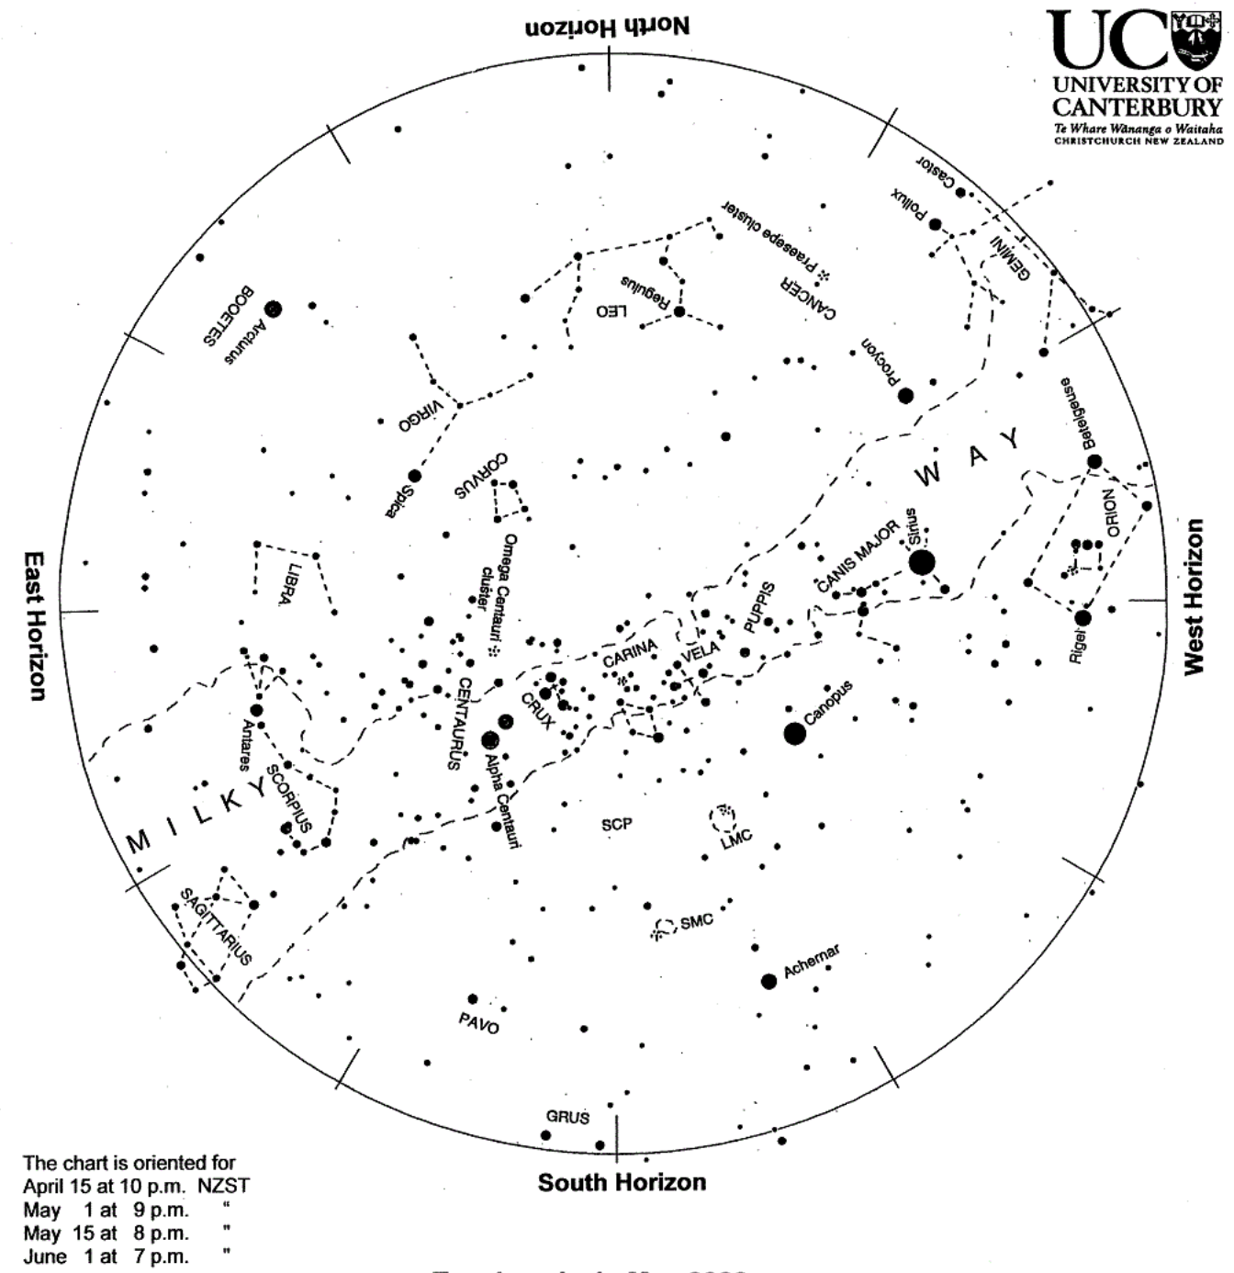
https://www.rasnz.org.nz/in-the-sky/the-evening-sky and https://www.stardome.org.nz/star-charts--sky-spotter

