Atmosphere
An atmosphere is a jacket of gas surrounding a planetary body. Astronomers are using what they know about atmospheres to predict the weather on distant moons and planets.
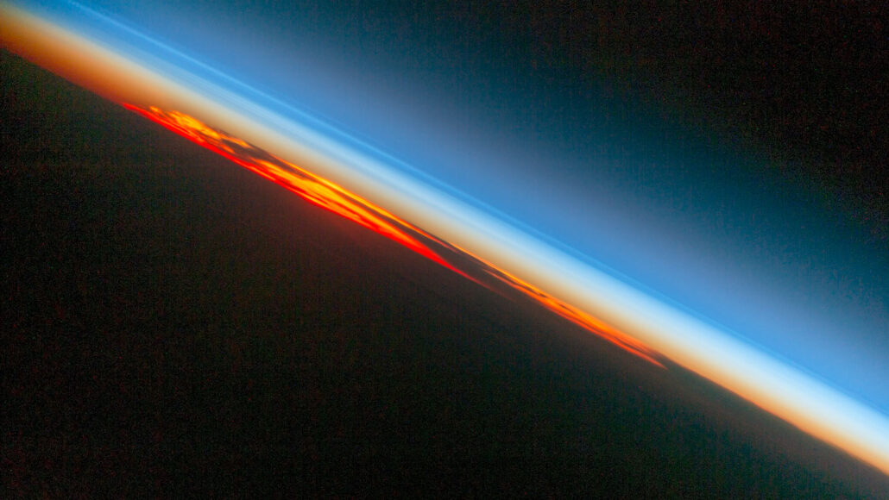
Science News for Students, 2 May 2022 by Maria Temming and Beth Geiger

An atmosphere is a mix of gases that surrounds a planetary body. Earth’s atmosphere extends from the ground to more than 10,000 km high. It’s about 78 % nitrogen. Another 21 % is oxygen. The rest is trace amounts of water vapor, methane, argon, carbon dioxide and other gases. Earth’s atmosphere contains five distinct layers, which get thinner higher up — until the atmosphere fades into outer space.
The Earth’s atmosphere at sunset taken from the International Space Station (ISS). The lowest layer, the troposphere, appears reddish brown, other layers above it appear in light and dark shades of blue. [NASA]

The atmosphere makes life possible on Earth. We breathe its oxygen. Plants use its carbon dioxide to grow. Ozone in the atmosphere shields life on the ground from the sun’s harmful ultraviolet rays. Clouds and weather play a central role in Earth’s water cycle. Carbon dioxide and other greenhouse gases in the atmosphere trap some of the sun’s heat. This makes Earth warm enough to live on. (Note: This “greenhouse effect” is natural. But human industry has pumped lots of extra carbon into the atmosphere, ramping the effect up. This is now driving climate change.)

Earth is not the only world with an atmosphere. Other planets, dwarf planets and moons do, too. Their atmospheres contain different mixes of gases. The dwarf planet Pluto has a wispy atmosphere made mostly of nitrogen, methane and carbon monoxide. Saturn and Jupiter, meanwhile, are padded with thick atmospheres of hydrogen and helium. These gas giants’ thick atmospheres, like Earth’s, can whip up dazzling storms and auroras. Astronomers have even glimpsed the atmospheres of planets orbiting other stars. And some of those exoplanets might just have weather similar to our own.
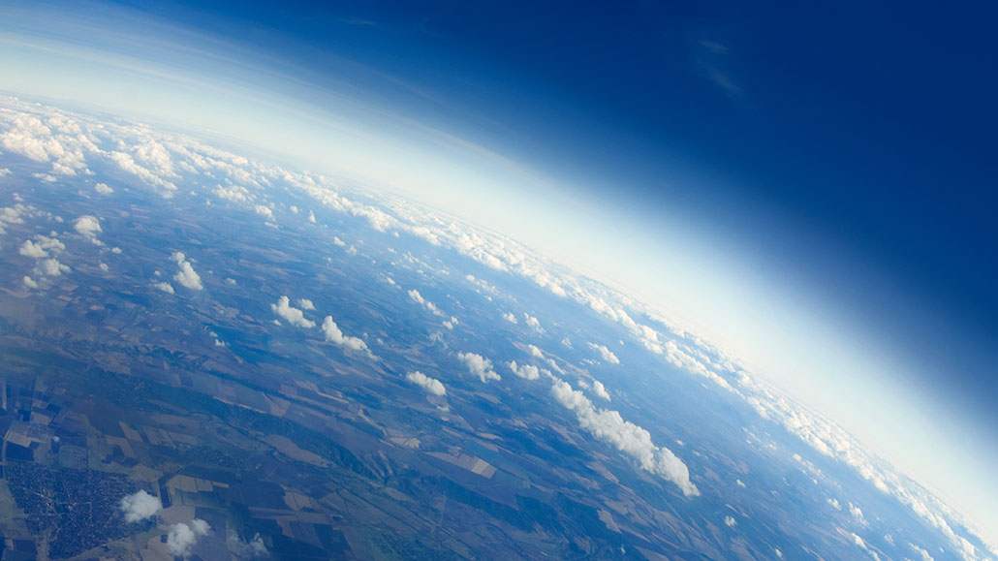
Our atmosphere — layer by layer

Explore the air, from Earth’s surface to the wispy edges where bits escape to outer space

Earth’s atmosphere is all around us. Most people take it for granted. But don’t. Among other things, it shields us from radiation and prevents our precious water from evaporating into space. It keeps the planet warm and provides us with oxygen to breathe. In fact, the atmosphere makes Earth the livable home that it is.
Earth’s cloudscape and the rest of our atmosphere taken from a height of more than 9km. The layers of the atmosphere reach up & into outer space. [AleksandarGeorgiev/E+/Getty Images]

The atmosphere extends from Earth’s surface to more than 10,000 km above the planet. Those 10,000 km are divided into five distinct layers. From the bottom layer to the top, the air in each has the same composition. But the higher up you go, the further apart those air molecules are.
Ready to reach for the sky? Here’s an overview, layer by layer:

Troposphere: Earth’s surface to between 8 and 14 km
Go ahead, stick your head right into the troposphere. This lowest layer of the atmosphere starts at the ground and extends 14 km up at the equator. That’s where it’s thickest. It’s thinnest above the poles, just 8 km or so. The troposphere holds nearly all of Earth’s water vapor. It’s where most clouds ride the winds and where weather occurs. Water vapor and air constantly circulate in turbulent convection currents. Not surprisingly, the troposphere also is by far the densest layer. It contains as much as 80 percent of the mass of the whole atmosphere. The further up you go in this layer, the colder it gets. Want snow in summer? Head to where the upper troposphere bathes the highest peaks. The boundary between the troposphere and the next layer up is known as the tropopause.

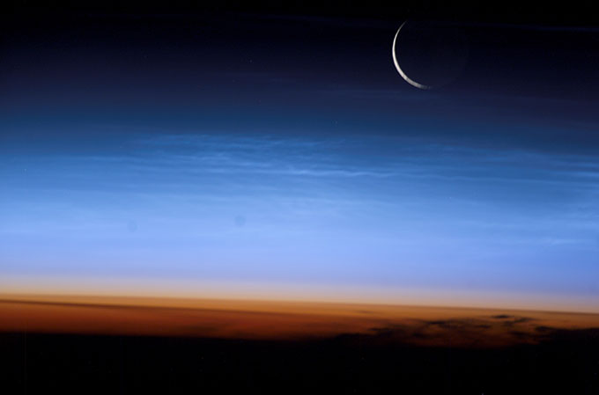
Stratosphere: 14 to 64 km
Unlike the troposphere, temperatures in this layer increase with elevation. The stratosphere is very dry, so clouds rarely form here. It also contains most of the atmosphere’s ozone, triplet molecules made from three oxygen atoms. At this elevation, ozone protects life on Earth from the sun’s harmful ultraviolet radiation. It’s a very stable layer, with little circulation. For that reason, commercial airlines tend to fly in the lower stratosphere to keep flights smooth. This lack of vertical movement also explains why stuff that gets into in the stratosphere tends to stay there for a long time. That “stuff” might include aerosol particles shot skyward by volcanic eruptions, and even smoke from wildfires. This layer also has accumulated pollutants, such as chlorofluorocarbons (Klor-oh-FLOR-oh-kar-buns). Better known as CFCs, these chemicals can destroy the protective ozone layer, thinning it greatly. By the top of the stratosphere, called the stratopause, air is only a thousandth as dense as at Earth’s surface.
In this image from the ISS the troposphere is orange. Blue is the bottom of the stratosphere. [NASA]

Mesosphere 64 to 85 km
Scientists don’t know quite as much about this layer. It’s just harder to study. Airplanes and research balloons don’t operate this high and satellites orbit higher up. We do know that the mesosphere is where most meteors harmlessly burn up as they hurtle towards Earth. Near the top of this layer, temperatures drop to the lowest in Earth’s atmosphere — about -90° Celsius (-130° Fahrenheit). The line marking the top of the mesosphere is called, you guessed it, the mesopause. If you ever travel that far, congratulations! You are officially a space traveller — aka astronaut — according to the U.S. Air Force.

The mesopause is also known as the Karman line, named for the Hungarian-born physicist Theodore von Kármán. He was looking to determine the lower edge of what might constitute outer space and set it at about 80 km up. Some agencies of the U.S. government have accepted that as defining where space begins. Other agencies argue this imaginary line is a bit higher: at 100 km.

The ionosphere is a zone of charged particles that extends from the upper stratosphere or lower mesosphere all the way to the exosphere. The ionosphere is able to reflect radio waves; this allows radio communications.
Thermosphere 85 to 600km
The next layer up is the thermosphere. It soaks up x-rays and ultraviolet energy from the sun, protecting those of us on the ground from these harmful rays. The ups and downs of that solar energy also make the thermosphere vary wildly in temperature. It can go from really cold to as hot as about 1,980 ºC near the top. The sun’s varying energy output also causes the thickness of this layer to expand as it heats and to contract as it cools. With all the charged particles, the thermosphere is also home to those beautiful celestial light shows known as auroras. This layer’s top boundary is called the thermopause.

Exosphere 600 to 10,000 km
The uppermost layer of Earth’s atmosphere is called the exosphere. Its lower boundary is known as the exobase. The exosphere has no firmly defined top. Instead, it just fades further out into space. Air molecules in this part of our atmosphere are so far apart that they rarely even collide with each other. Earth’s gravity still has a little pull here, but just enough to keep most of the sparse air molecules from drifting away. Still, some of those air molecules — tiny bits of our atmosphere — do float away, lost to Earth forever.
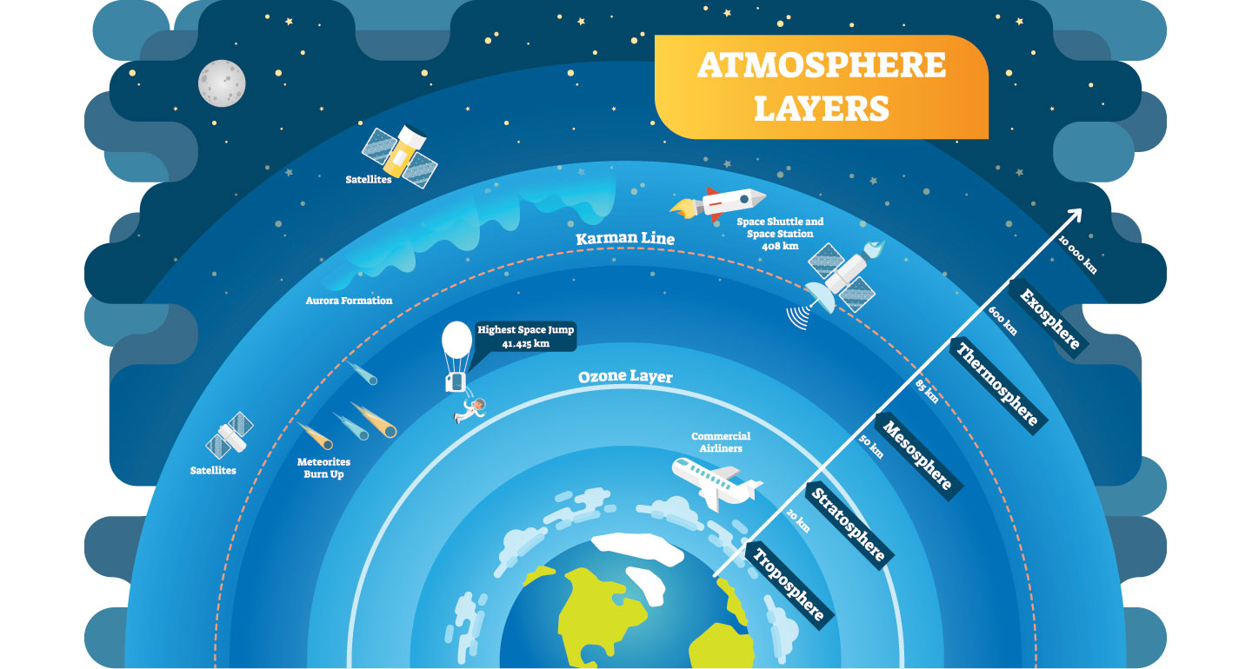As it rises out toward space, Earth’s atmosphere changes in density and much more. The depth of each layer can vary by the day and the latitude and are depicted here artistically (not drawn to scale).[VectorMine/iStock/Getty Images]

Fun facts
- Shock waves from earthquakes, volcanic eruptions and explosions on Earth’s surface can ripple through the atmosphere.
- The International Space Station (ISS) orbits Earth at an average altitude of about 400 km. That’s within the thermosphere. Satellites also operate in this region and higher, into the exosphere.
- The thermosphere is cluttered with human-made debris, such as old satellites and bits of rockets. Each year, collisions between these items create even more debris. Orbiting at incredible rates of speed, even a pea-sized particle can cause serious damage to working satellites. The International Space Station has had several near misses with space debris and now and then changes its position in orbit to avoid collisions.
- Greenhouse gases such as carbon dioxide, methane, water vapor and nitrous oxide occur naturally in the atmosphere. But human activity has boosted their levels. They absorb heat from Earth and radiate it back to the surface again, boosting warming.

Activities
- Draw an accurate scale drawing of the atmosphere,
  - label the layers and the boundaries
  - Beside each layer name, write 1 or 2 words about its key features
  - In a different colour add each of these to its correct layer (i.e. these are not key features):
    - ISS
    - Volcanic ash
    - Satellites
    - Planes
    - Aurora form
    - Meteors burn up
- Make up a mnemonic to help you remember the order from earth to space
- Find online an image of the temperature in these layers – sketch the key features of this graph

References
E. Astafyeva. Ionospheric detection of natural hazards. Reviews of Geophysics. Vol. 57, December 4, 2019, p. 1265. doi: 10.1029/2019RG000668.
Center for Science Education. University Corporation for Atmospheric Research. Layers of Earth’s atmosphere.
National Environmental Satellite, Data, and Information Service. Peeling Back the Layers of the Atmosphere. National Oceanic and Atmospheric Administration. February 22, 2016.

https://www.sciencenewsforstudents.org/article/explainer-our-atmosphere-layer-by-layer

