Ancient Aboriginal Stories Of Australia's Sea Levels Rising

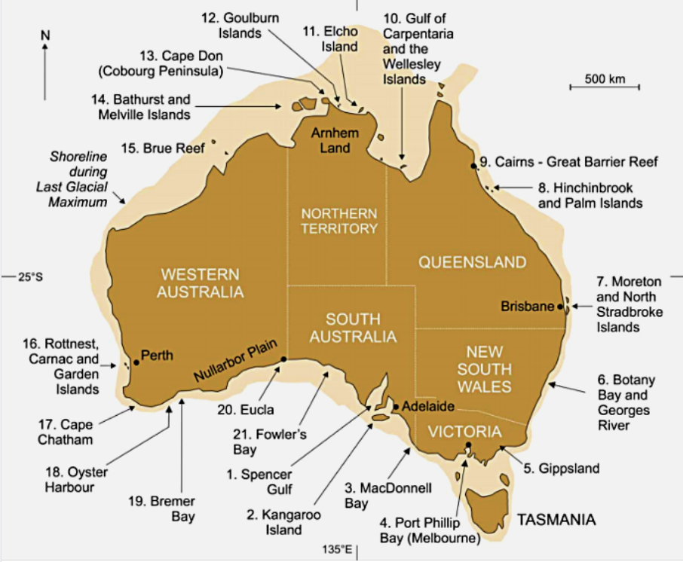

The map here shows 21 coastal locations from which First Nation stories about coastal water levels are described and show the extent of the continental shelf that was exposed during the low sea-level stage of the Last Glacial Maximum, about 20,000 years ago.
At an indigenous language conference in Japan, two researchers presented 18 analysed stories from around Australia’s coast. All tell tales of coastal flooding. They argue that these stories (and probably many others) recall coastal rising as sea levels reached their present level at least 6,000-7,000 years ago.
Around Australia, we know that at the coldest time of the last ice age about 20,000 years ago, sea level stood about 120 metres below its present level. When the last ice age began to end, a few thousand years later, huge masses of ice that had built up on the land, particularly in the northern hemisphere, began melting. Water poured into the world’s oceans, raising their levels in ways that are now well understood by Western science

READ MORE:
In 2015 Patrick Nunn and Nicholas Reid published 2 articles and a research paper.
Sovereign Union 13 Jan: Ancient First Nations stories preserve history of a rise in sea level. https://bit.ly/2TAAWSP
Sovereign Union 24 Sep: First Nations Stories of Ancient Sea-Level Rise Preserved for 13,000 Years. https://bit.ly/2XDkMcP
Australian Geographer 2016: Aboriginal Memories of Inundation of the Australian Coast Dating from More than 7000 Years Ago https://bit.ly/3gi67fv

https://www.facebook.com/

