Making beer
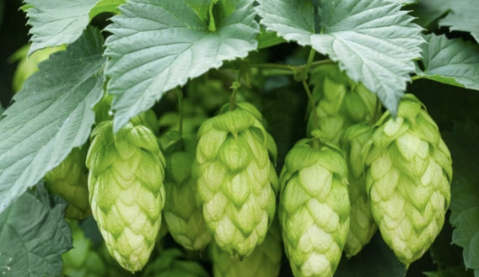
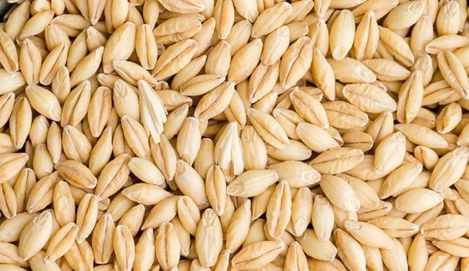
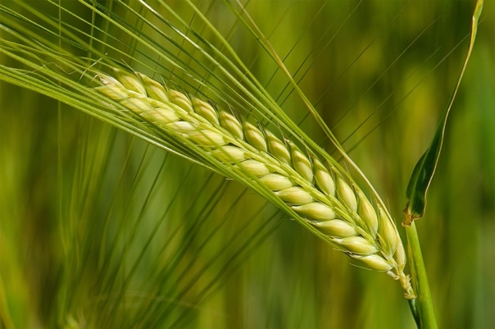
There are few things better than an ice cold beer on a hot day. Chances are, when you crack open a beer this summer, you probably won’t be thinking much about its biology or chemistry – but it’s a complex process involving many different substances.
This complexity is clearly seen in the brewing process that leads to the creation of beer. Before brewing can even start, the barley for the brewing must be prepared. This involves steeping the grains in water, then allowing them to germinate for several days, before then drying in a kiln. After this, the malted barley is broken down in a mill, so that enzymes can more easily reach the starch molecules during fermentation. Once broken down, mashing with hot water produces wort, a sugar-rich liquid.
The wort is strained and transferred to the brew kettle. This is where the hops are added, along with any other ingredients. The boiling process sterilises the wort, whilst the hops add bitterness and flavour to the beer. Any solids are separated, then the mixture is cooled to a temperature where the yeast can be added safely, as it is otherwise unable to grow at high temperatures. The yeast is added in a fermentation tank, where the beer is left to ferment, and sugars are converted into alcohol. It’s then moved to a maturing tank, where it remains for varying lengths of time dependent on the style of beer, after which it is filtered and bottled.
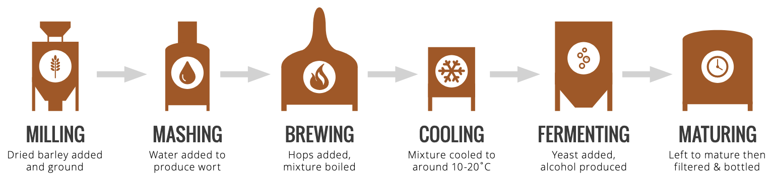

Sources: https://www.compoundchem.com/2014/07/10/beerchemicals/

Questions:

- a. Give an equation for fermentation.
b. Where do the sugars come from?
c. These days we add the yeast
i. Where did it originally come from?
ii. Why do we add yeast today?
- In your own words in 2-3 sentences describe the process of making beer.
- To make beer at home you need 4 main ingredients – can you figure out what they must be without looking it up?
- Why can we thank Louis Pasteur for beer?
- Beer can spoil if infected by bacteria -it becomes murky and acidic with a nasty taste. Find out which ingredient of beer prevents bacterial growth.
- In the 16th century the Germans regulated beer production with the Beer Prity Law or Reinheitsgebot. It specified the only 3 ingredients that could be used in the production of beer (see Q3). This list did not include yeast. Why not?

