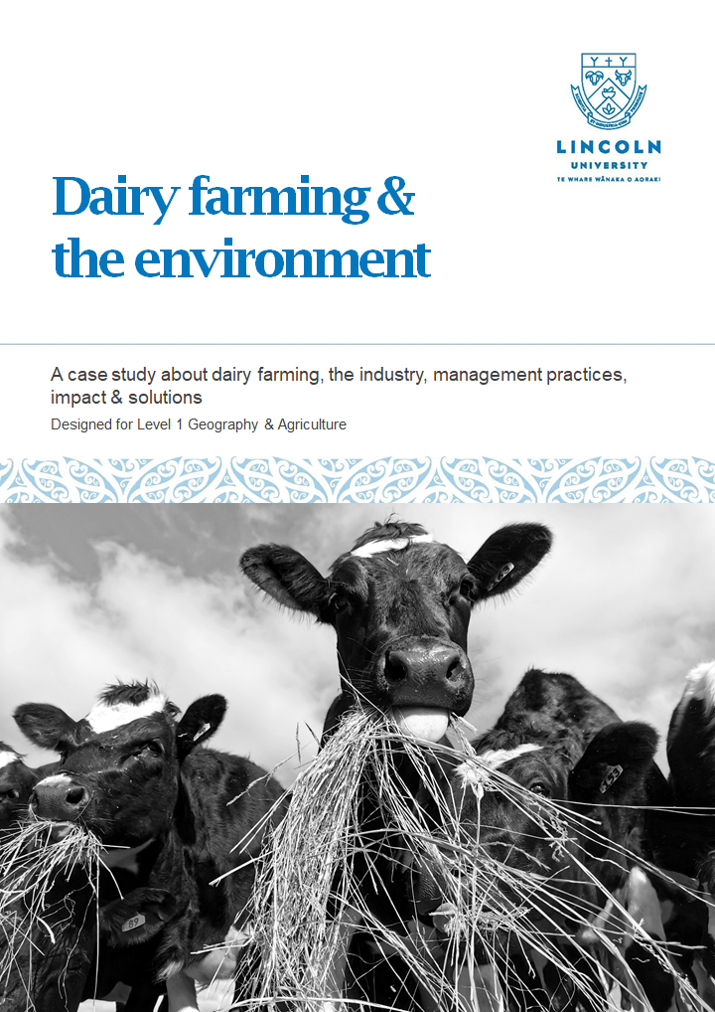

Keeping Heat in a Kiwi Home

Designed for Level 1 Science AS 91921 (Science 1.2 – Use a range of scientific investigative approaches in a taiao context)

Lessons, resources and investigations with a home insulation context

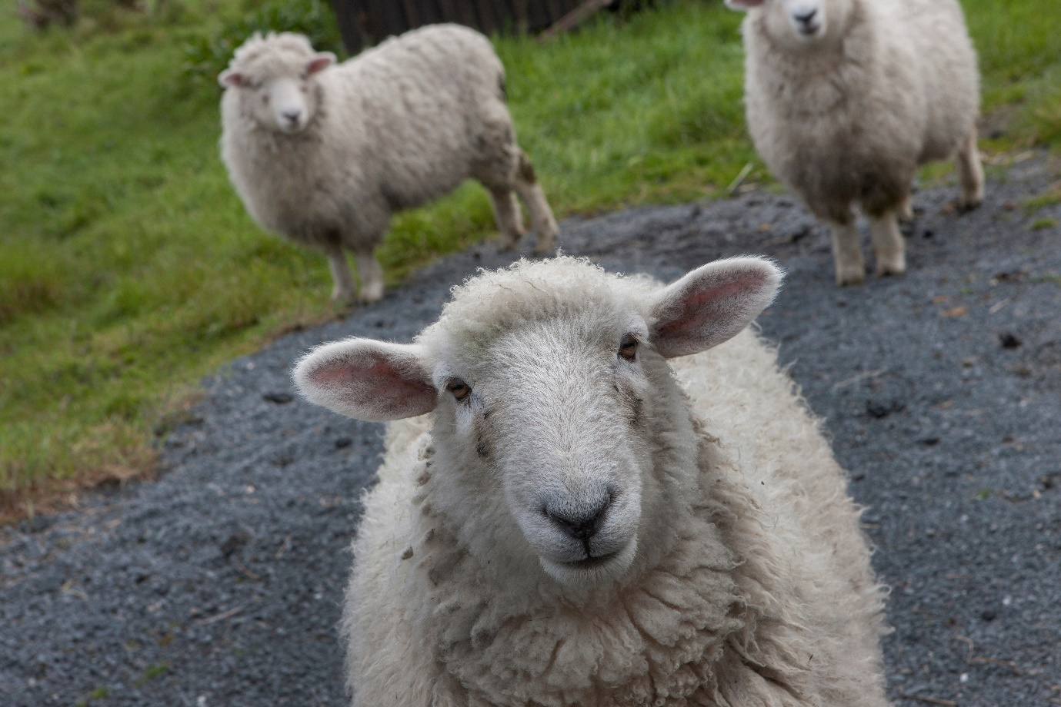**Unit Introduction**

This unit of work has been prepared to support the teaching of the new achievement standard 91921 (from 2023) Science 1.2 – Use a range of investigative approaches in a taiao context. It has been written with a home insulation context and consists of a series of lessons, resources, investigations and supporting teacher notes. Also included are some suggested extension activities and assessment options.

As this is a new achievement standard it is important to note that none of these materials have been moderated by NZQA. This means it is important that teachers using this unit of work ensure they have carefully read the achievement standard and all supporting materials on the [NCEA website](https://ncea.education.govt.nz/science/science/1/2?view=standard) and modified any assessment materials they choose to use in order to ensure they are confidently meeting the standard. Assessment is at the discretion of individual teachers and schools and is not covered by this unit.

This unit of work was created during 2022 in the second year of the pilot phase of this standard. Changes to the standard may still occur following the writing of this work and should be considered before using this resource. Feedback on some aspects of this unit, in particular assessment, was provided by a pilot school. This allowed for changes to be made based on the expertise of teachers who have been involved in the pilot delivery of this standard.

While we have used the word ‘lesson’ to describe each section of learning, we acknowledge the variety of different timetables and other factors that constrain class time in each school. These lessons are not designed with a timeframe in mind but should be considered more as a suggested package of related ideas and learning opportunities. Teachers know their learners best and should modify each lesson provided to meet the needs of their learners and the constraints of their timetables.

**Overview**

This standard focuses on two key concepts:

1. Scientists use different investigative approaches to answer questions
2. Scientists use wananga (conferencing) to answer questions.

Traditionally, fair tests have been taught and assessed at Level 1 and this is where discussion has commonly ended about the scientific method. This standard now focuses on students realising that information is collected in a variety of different ways depending both on the question asked and the setting they are in (taiao). These two links have been used in writing this unit to help explain some of these investigative approaches in more detail:

* Science Learning Hub

<https://www.sciencelearn.org.nz/resources/3038-investigating-in-science>

* Te Kete Ipurangi

<https://scienceonline.tki.org.nz/Teaching-science/Teaching-strategies/Types-of-investigation>

It is envisaged that schools will begin to embed the teaching of different investigative approaches in their junior science program, however, many Level 1 learners may not have been exposed to these ideas previously. This may mean there needs to be some explicit teaching of these investigative approaches when teaching this standard. NZASE have filmed a discussion between teachers in the pilot phase of teaching this standard. They provide some valuable insight and you can watch this here: <https://www.youtube.com/watch?v=xtwooIEBjiI>

In particular, the similarities and differences between different investigative approaches, is key understanding students need to develop. This is in addition to being able to evaluate the effectiveness of a particular approach.

Also central to the learning in this standard is the idea of wananga (conferencing). This aspect involves students discussing their questions and findings with a wide variety of other parties to inform an answer to their investigative questions. These discussions could include, but are not limited to:

* experiment results with other learners to evaluate accuracy and validity
* experiment design with other learners or teachers to develop workable method
* science ideas with learners/teachers/experts
* matauranga maori understanding and practices with local iwi
* current best practices with industry experts

Wananga also includes working as a group to develop a method, collect results, discuss ideas and/or suggest improvements to an experiment or plan. When students are engaging in wananga it is important that they are reflecting on what they have learned as a result of conferencing and how this has informed their understanding.

Ideas of places where wananga with outside groups could be incorporated into the classroom have been included in some lessons. As this is in a home insulation context a wide variety of speakers could be interviewed or invited to speak to the class. Public health and policy experts, architects, builders, hardware sales-people, insulation manufacturers, waste disposal experts and farmers, are all experts that could provide valuable insight to help students develop a deep understanding of aspects of this unit.

Teachers in the pilot group for this standard have commented that it has been a challenge to develop ways of capturing evidence of this wananga. Included in the investigation templates (which could form part of an assessment portfolio) are opportunities for students to record details of their conferencing. If teachers make these templates a digital option for students then this evidence could be in the form of videos or audio recordings rather than written summaries of conversations.

**Primary Industry Connection**

The key element that connects the home insulation context to primary industries, and therefore Lincoln University, is wool.

As humans globally work to exist more sustainably, the use of a renewable and local resource in our construction industry should be of immense interest. The environmental impact of wool is significantly lower than many other types of insulation when we consider that it is biodegradable, requires no mining or use of petroleum based products and is an animal welfare byproduct. While major gains have been made marketing fine, merino wool globally, reinvigorating our once lucrative strong wool market would have additional economic benefits for New Zealand. The innovative efforts underway to do just this are being endorsed and advertised by the Campaign for Wool initiative, read more [here](https://www.nzwool.co.nz/about/).

Other resources of interest include:

* Pāmu (Landcorp) wool used for insulation in USA

<https://pamunewzealand.com/news/2018/nz-wool-insulating-us-high-performance-homes>

<https://havelockwool.com/>

* Bremworth moves away from synthetic carpets

<https://www.nzherald.co.nz/the-country/news/bremworth-ceo-defends-strong-wool-over-synthetic-carpet-stance/6T4UKKXNLFNVKS7KFHWOB5VQAY/>

* Big Save Furniture: Our Wool Story

<https://www.bigsave.co.nz/our-wool-story/>

* Woolchemy innovation

<https://woolchemy.com/>

* Shear Edge with Logan Williams

<https://www.shear-edge.com/>

<https://www.youtube.com/watch?v=-YmqSDeQrTQ>

* Campaign for Wool

<https://www.nzwool.co.nz/>

**Connections to other standards**

As this unit has been written in a home insulation context, with the key Science concepts of heat transfer, there are clear connections to AS 92045 (P&ESS 1.2 *Demonstrate understanding of a physics phenomenon in the taiao through modelling*). The investigations conducted in this unit of work could easily be used for a launchpad or as partial evidence of learning for meeting the requirements of this standard. There is potential to alter the context of this unit to meet some of the requirements for sound and waves (eg. noise insulation in homes) in this standard.

AS 92047 (P&ESS 1.4 *Demonstrate understanding of physics concepts in the taiao*) includes conduction and convection in the list of concepts to be covered. Therefore, this unit could be used as part of the teaching for this standard.

Another potential connection is to AS 91928 (Ag&Hort 1.1 *Demonstrate understanding of life processes and how they are managed in a primary production system*). A unit focusing on the growth of wool and the farm management practices that can impact the features and quality of wool, could be supported by studying the properties of wool making it suitable for use as an insulation material.

The growth of wool is a life process that is impacted by the genetics of breeding, whakapapa of cross breeding and the effects of managing nutrition. These impact the final wool product, that needs to be consistent quality to be used in insulation.

**Resources Required**

In order to conduct the investigations in this unit you will need to source a variety of insulation products. Most of this will be able to be reused year-on-year but some small samples will need to be replaced each time the unit is taught (eg. for flammability and composting experiments).

Further details are included in the teacher notes for each investigation but prior to teaching this unit it is suggested to carefully read these and calculate quantities required for the numbers of learners. When sourcing insulation, try to ensure you are securing similar R-value products, so comparison is like for like. It is worth noting that the building code has new minimum R-value requirements as of November 2022 for new builds and it could be worthwhile researching requirements for homes in your area to give local context.

**Assessment Plan**

It is envisaged that this standard will be assessed by a portfolio, preferably with evidence collected and submitted digitally by students.

The assessment portfolio could contain:

* The completed templates for each of the five suggested investigations
* Supporting evidence eg. the environmental impact of insulation template, digital recordings or written notes of wananga
* Completed templates for any additional investigations student choose to carry out
* A summary report or template where students answer the overall question

Two suggested assessments are included but please remember that none of these resources have been moderated by NZQA. For this reason a suggested assessment schedule has not been provided. This is to ensure that teachers are carefully evaluating the requirements of the standard in order to modify assessment materials to comply as they see fit, and to make judgements based on their modified work that they feel best meet the requirements of this standard.

An overview of the questions asked and the investigations planned can be found below. Listed with these are the names of the documents created that could be used by students in a portfolio.

|  |  |  |  |  |  |
| --- | --- | --- | --- | --- | --- |
| **Overall Question** | What are the best materials to insulate our homes? | | | | |
| **Questions** | What materials do we use to insulate our homes? | Why are these materials suitable for insulating our homes? | How effective are they at keeping our homes warm? | How can we improve insulation effectiveness? | What happens to them when we’re finished using them? |
| **Type of Investigation** | Research/Classifying and Identifying | Exploring and Observing | Modelling | Fair Test | Modelling |
| **Documents** | Student Sheet Investigation 1 | Student Sheet Investigation 2 | Student Sheet Investigation 3  Isobooster Extension Task | Student Sheet Investigation 4 | Student Sheet Investigation 5  Environmental Impact of insulation types |

**Unit Map**

|  |  |  |
| --- | --- | --- |
| **Lesson** | **Title** | **Resources** |
| 1 | Dream Home | * Lesson 1 – Dream home (plan) * Round Robin Question Sheets * Feelings words for dream home activity |
| 1.5 | Heat Transfer  *Provided to assist for groups who have not covered heat transfer science ideas* | * Lesson 1.5 – Heat Transfer (plan) * Heat transfer true false activity * Heat transfer cloze * Heat transfer (powerpoint) |
| 2 | Pose a Question | * Lesson 2 – Pose a Question (plan) * LDWS task * Student Sheet Investigation 1 * Types of Investigation Posters |
| 3 | Sustainability and Environmental Impact | * Lesson 3 – Sustainability and Environmental Impact (plan) * Environmental impact of insulation types * Environmental impact of insulation types – Teacher notes * Compost bag experiment * Student Sheet Investigation 5 |
| 4 | Insulators for Homes | * Lesson 4 – Insulators for Homes (plan) * Air as an insulator * Hempkrete article excerpts * Insulation youtube discussion points * Insulation Video Student Worksheet with Answers * Student Sheet Investigation 2 * Teacher Notes Investigation 2 |
| 5 | What’s the Deal with Wool? | * Lesson 5 – What’s the deal with wool? (plan) * Wool video bingo * Bingo statements and discussion points * Wool as Insulator (PowerPoint) |
| 6 | Keeping Heat in Homes | * Lesson 6 – Keeping Heat in Homes (plan) * Student Sheet Investigation 3 * Teaching Notes Investigation 3 * Paper house template * Career Card Match * Isobooster Extension Task |
| 7 | Can we do better? | * Lesson 7 – Can We Do Better? (plan) * Student Sheet Investigation 4 * Teaching Notes Investigation 4 * Template for top of house box |
| 8 | Back to the Soil | * Lesson 8 – Back to the Soil (plan) * Cut-and-shake practical * Bleach Practical Teacher Notes * Compost Teaching Notes * Plastic Building Waste Excerpts Starter |

**Acknowledgements**

Amy Pailthorpe – Lead Writer (Casual Resource Developer Lincoln University 2022)

Lauren Roberts – Co-writer Lincoln University

Victoria Flynn – Technician Lincoln University

Leanne Hassall – Technician Lincoln University

Andrea Hills, Willem Tolhoek and Leo Yang – Lincoln High School

Brendon Monk – Paraparaumu College

Carolyn Green – Rolleston College

Linda Haycock – Green Bay High School

Tom O’Sullivan – CEO Campaign for Wool

Peter Weber – PV Weber Wools Ltd.

Hanna Potgeiter – Inzone Industries Ltd. (Mammoth insulation samples)

Lester Smit – Expol Ltd. (Expol insulation samples)

Richard Bennett – Wool Insulation NZ (Loose fill wool samples)

Terra Lanna (Wool batt samples)

Craig Cuff and Melissa Semmens – ComfortTech (Pink Batts samples)

Photographs taken by Amy Pailthorpe at Lincoln University or sourced free from [Adobe Stock Images](https://stock.adobe.com/nz?gclid=EAIaIQobChMIh9DjmaSd-wIVmX0rCh3r1wGAEAAYASAAEgLB__D_BwE&ef_id=EAIaIQobChMIh9DjmaSd-wIVmX0rCh3r1wGAEAAYASAAEgLB__D_BwE:G:s&s_kwcid=AL!3085!3!420226198683!e!!g!!adobe%20free%20images!325560647!80690803807&as_channel=sem&as_campclass=brand&as_campaign=NZ|CPRO|Stock|PURCH|CC-AI-ID-PS_Exact|GG||&as_source=google&as_camptype=acquisition&sdid=3F8XBNLZ&mv=search&as_audience=core)