**Connecting Chemistry Teaching to Sustainable development-oriented Critical Challenges through Systems Thinking**

**An Interactive and Hands-on workshop for Chemistry Teachers**

**Wellington: Tuesday April 18**

**Christchurch: Thursday April 20**

**Auckland: Friday April 21**

**9.00 to 2.30, including morning tea and lunch (provided by SCENZ)**

How can we as Chemistry Teachers empower our students to contribute to vital societal decisions related to their uncertain future in the Anthropocene? Unfortunately, teaching and learning resources and available professional learning for teachers has not kept up with the rapid increases in innovation taking place in industry. This interactive and hands-on workshop for teachers has been designed to address this gap.

The international education community has rallied around holistic approaches such as **systems thinking,**a possible component of *the new Level 1-3 Science/Chemistry standards.*But what is systems thinking?  Why might you try to incorporate it into your teaching of science and chemistry? How can systems thinking help your students connect chemistry to global sustainability challenges? Through a range of collaborative and practical activities that leverage sustainable development-oriented contemporary science innovations, this workshop will address these questions. It will engage teachers with research evidence on what does (and what doesn’t) work in the science and chemistry classroom and lay foundations for

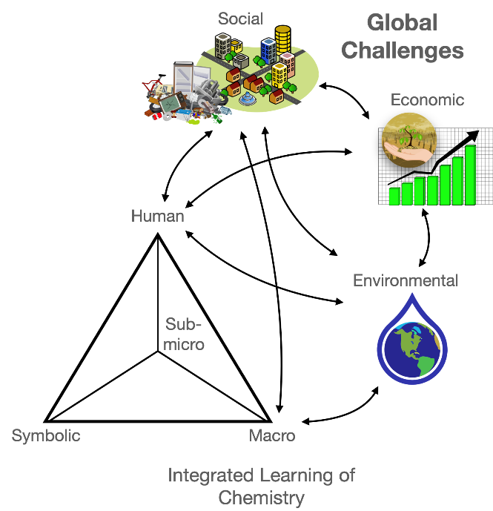

**Facilitator:** Dr Seamus Delaney, a Senior Lecturer (Science Education) and Science, Technology, Environmental Education (STEE) Discipline Head within the School of Education, Deakin University.

Seamus has worked as a classroom teacher, Head of Science, Head of eLearning, teacher educator and researcher. He is currently a task group member of an IUPAC project, *Systems Thinking for Sustainability: Toward 2030 and Beyond (STCS 2030+)*, developing teaching frameworks for situating sustainable development challenges in the chemistry classroom.

**Workshops will be free to all NZ Chemistry Teachers**

**Expressions of interest/enquiries** to Suzanne Boniface: [suboni52@gmail.com](mailto:suboni52@gmail.com)

*Sponsored by SCENZ, the IUPAC Committee on Chemistry Education and Deakin University*