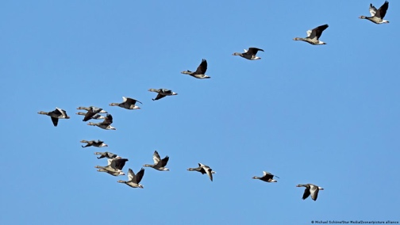
Bird Migration for year 7

Every year at spring and autumn some birds migrate. This means they travel hundreds, sometimes thousands of kilometres from one place to another. At some time later they return home. It is a remarkable journey for these animals who are often no bigger than our hands.
Geese [Michael Shone]
Why do they migrate? One of the main reasons is to find better weather and more food. Some birds live in places where the weather gets really cold in the winter, and there isn't enough food around for them to survive (due to the ground freezing or trees losing their leaves). So, they fly to warmer places where there's more food.

Another reason why birds migrate is to find good places to breed and raise their babies. Some birds need special conditions, like certain kinds of plants or particular seas or lakes, to lay their eggs and raise their chicks. When sitting on eggs or looking after their young, parent birds are especially vulnerable to attacks by predators. Sometimes their destination offers more protection from predators, e.g. being surrounded by water or better camouflage. So, they fly to places where these conditions are just right.

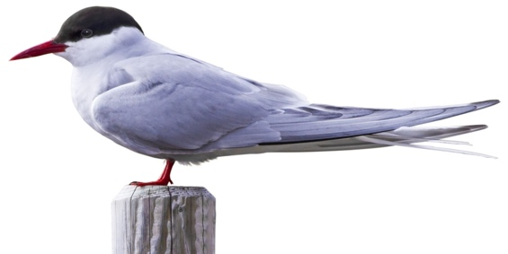
The warmer places tend be near the equator. So from New Zealand birds tend to fly north, but from places like America and England they fly south.

Birds have to be able to find their way to their destination, an ability called navigation. They use their senses to detect the light from stars, the sun, or the moon, or they use a built-in compass that can sense the earth’s magnetic field to guide their journey.
Arctic Tern [DK images]

Migration is not an easy journey for birds. They have to fly long distances and often face obstacles like storms, predators, wind turbines or mountain ranges. Not all birds reach their destination safely.

There are many different kinds of birds that migrate, from tiny hummingbirds to huge cranes. The small Arctic tern flies between icy regions, from the Arctic to Antarctica and back again, a flight of 71,000 km. They spend their lives in perpetual summer, first at the South Pole and then at the North. Another impressive migratory bird is the bar-tailed godwit, which flies about 12,000 kilometres from Alaska to New Zealand in 7 days (see map overleaf. Other birds, like some kinds of geese, only fly short distances.

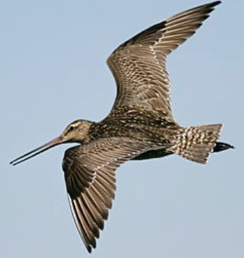
Some birds travel alone during migration, while others travel in large groups. These flocks help provide protection from predators and can share information about food sources. Birds with long wings like geese fly in small flocks in a V-formation. This makes the flying easier, as the following birds get lift and so use less energy and need to flap their wings less often.

Unfortunately, as the world's climate changes, bird migration patterns are also changing. The warmer temperatures are causing birds to fly earlier in the year than they used to, which can affect how they breed and feed.

This article was adapted from text generated by the AI at https://you.com
Bar-tailed godwit [Keith Woodley]
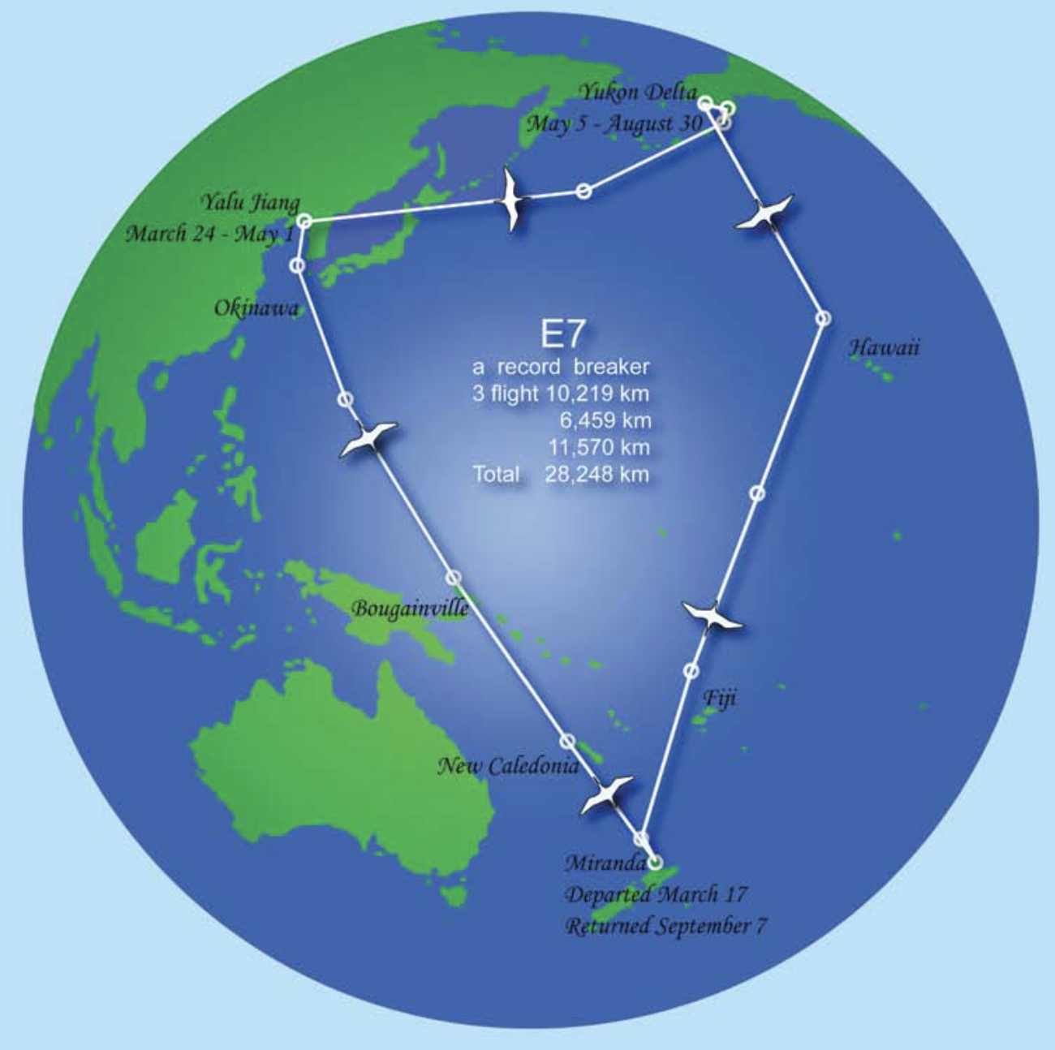

The tracked journey of godwit E7 [Keith Woodley]

