Uses for old OHTs

I am cleaning out my room and found a huge stack of the transparent sheets for old overheads. I’d hate to throw them out if there is something I can use them for. Any ideas?!?

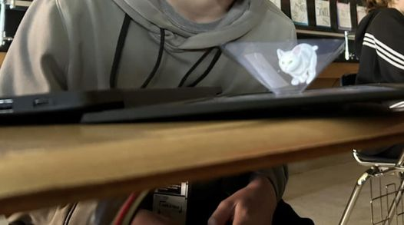
• You can make holograms with them- there's a template, and the kids make the template, and put it on their phones and use a hologram video. The plastic frames the reflection. It's cool.
• Depends on the type but some can be used to make shrinky dinks. It is fun to draw cells and the shrink them into key chains.
• I have used them for a transcription activity
• You can use them to trace things to copy on the copy machine.
• We use them to make topographic maps.
• Tape them on computer screen so students can write on questions for tests.
• Earth science. Have them mark earthquakes on one volcanoes on a 2nd then overlay on a map with plate boundaries make sure the map is split in the Atlantic not Pacific then tape on opposite sides great way to teach Ring if Fire
• They're good to show magnetic fields (especially if you've got an old overhead projector too). Put a magnet/magnets between two sheets and prop up the corners. Sprinkle iron filings over the field/s. A great visual
• We make a transparent, translucent, & opaque foldable where they cut out a square window and cover the window with examples of the 3 types of material light waves interact with.
• Great tool for marking the text in books
• Use them to make cell models. Cut the bottom out of a paper plate. Cut a circle out of the transparency sheet and tape inside. On the other paper plate students draw a plant or animal cell with all parts labeled. Color and staple together. A cool look through model.
• Take pictures and make a slide presentation.
• Let students lay them over worksheets and write with expo. Instant reusable worksheet! I also let kids use them with expo markers for scratch work (it can sit on the side or go over a specific spot to do things like label diagrams, annotate text, break down word problems, etc.)
• I use them as face shields for students to explore blinking muscle action - voluntary vs involuntary
• Get out the OHP and actually use them, the kids are in love it when you do.
• Quick way to check student answers when plotting points. I create an overlay using permanent marker and make a couple sets for students to check their answers
• You can copy anchor charts in them & hang in a window like the window clings
• I print my bulletin board titles on them
• Cover pages when you bind research papers for science fair
• They are great for the new online STAAR tests! Students can place them on the screen of their laptop and draw using a dry erase marker. Great for graphs, annotating, etc…
• I know art teachers love them for multiple projects. E.g. Make fake stained glass windows with sharpie markers
• I used them to teach maths transformations: slide, flips, and turns, as well as symmetry.

Comments from Kesler Science Professional Learning Network

