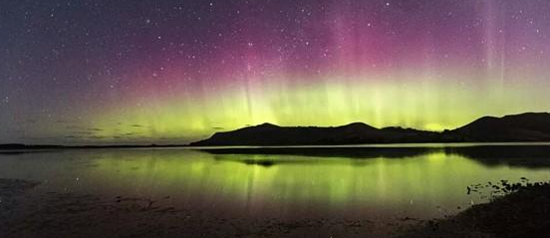
Earth and Space Science Educators of NZ Inc (ESSENZ)
Networks of Expertise: MOE10480_b-ac

Attn: ESSENZ PO Box 37-342 Christchurch 8245 admin@earthspacescience.org.nz
Earth and Space Science teacher PLD day
When: Thursday 21st September
Where: Rosmini College, Takapuna
Cost: There is no cost for this day. Food will be available from a nearby café and the cost will be covered by ESSENZ.
What to bring: your computer and willingness to discuss and collaborate
To register fill out this Google form https://forms.gle/4iUzEn1rZKFq7Fy19

Outline of the day: Incorporating Mātauranga Māori into Earth and Space Science
LEARNING OUTCOMES: At the completion of the day, participants should be able to feel more confident with integrating mātauranga Māori into their teaching of Earth and Space Science. They will have had contact with their regional representative and will know where to go for support when they need it.

9.00– 10.30 am
- Welcome, House Keeping, Introductions
- Introducing atmospheric and weather systems using mātauranga Māori
11.00 – 12.30pm
- A look at a range of resources that can be used to investigate latitudinal and temporal effects relating to the sun/Earth/moon system.
1.15 – 3.00pm
- How you can use a mātauranga Māori context to teach several different interactions relating to the sun/moon/Earth system
- Feedback and closing of day.

3.00 pm: Finish
Ross Stephen and John Smith are your Auckland ‘Regional Representatives’ for ESS.
We look forward to hosting you at Rosmini College for a long overdue look at how kaiako can incorporate mātauranga Māori into new and old PESS standards! We have some awesome resources created by ESSENZ to show you and hope to leave you inspired about this key aspect of the NCEA change.

NOTE: Funding is available for teacher release and travel via ESSENZ. This funding is especially for distant/new-to-ESS/isolated teachers but anything reasonable request will be considered. ESSENZ will pay for teacher release for the hours that they would have been teaching, and petrol.
Please apply to Jenny Pollock at earthspacenz@gmail.com.

