NZ Chemistry Olympiad
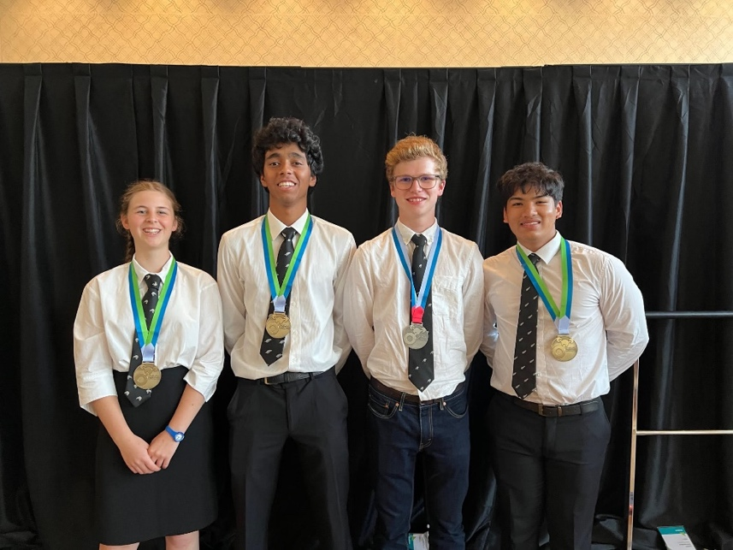
We are very proud to report the outstanding achievement of the 4 students who represented NZ at the International Chemistry Olympiad in Switzerland in July. Oliver Gunson (Ak Grammar) received a silver medal and the other 3 students all received bronze medals. They were Isla Swanney (Nayland College), Jayden Kumar (Ak Grammar) and Cedric Siriwardana (ACG Sunderland). Congratulations!!

Left to right: Isla Swanney (Nayland College), Jayden Kumar (Auckland Grammar), Oliver Gunson (Auckland Grammar) and Cedric Siriwardana (ACG Sunderland)

