# Floating Egg

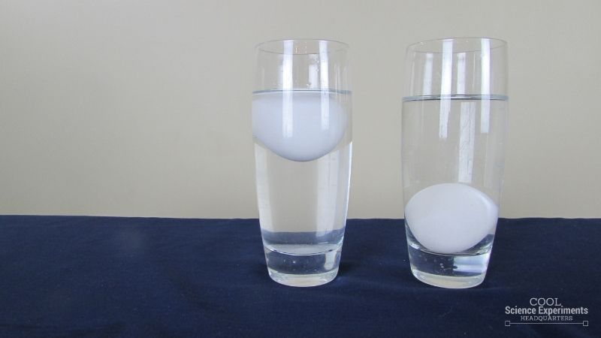

Top of Form

Bottom of Form

### Materials

* Egg
* Salt
* Water
* Drinking Glass (that an egg will fit in)

## Teacher Instructions

Start with some observations about the eggs. Note that they are both raw eggs and have a similar size and weight. Then ask some questions. Do you think that the eggs will sink or float when placed in water? Do you think it’s possible to make them float? If so, how? Write down your hypothesis (prediction) and then follow the steps below.

### Method

1. Fill a tall drinking glass about 3/4 full of water
2. Place the egg into the glass and watch.

Question A. What do you observe?

1. Fill another tall drinking glass about 3/4 full of water
2. Add 3 Tablespoons of Salt and stir until combined.

Question B. What do you think you will observe?

1. Place the egg into the glass and watch.

Question C. What do you observe?

## Video Tutorial [Watch the Floating Egg Science Experiment Step by Step Instructions](https://www.youtube.com/watch?v=Fbp5h7tzo6g)

## How Does the Floating Egg Science Experiment Work

Why does the egg sink in regular tap water, but float in saltwater? The answer lies in the density of water!

**Density** is a measure of the mass per unit volume of a substance. Simply said, how much “stuff” in a given volume. Water has a density of 1 g/mL (g/cm3). Objects will float in water if their density is less than 1 g/mL. Objects will sink in water if their density is greater than 1 g/mL

The egg will sink in regular tap water because the density of the egg is greater than the density of water. The egg’s density is only slightly higher than water at 1.03 g/mL, but that is enough to make the egg sink.

When you add salt to the water, you are increasing the density of the water by adding more mass (or stuff) in the given volume. You don’t really change the volume of the water by adding salt. By adding enough salt, you increase the density of the water so that it is higher than the density of the egg and the egg will float!

## Other Ideas to Try

Try this experiment again, with a potato slice or a carrot slice. You will have to play around with the amount of salt you add to the water because all objects have their own unique density. Add salt a tablespoon at a time and mix well until you cannot see any salt in the solution, then add your object to see if it floats or sinks. Remove your object and keep adding salt until you can get your object to float. To make it a true science experiment, create a data table to keep track of how much salt you add to the solution.

<https://coolscienceexperimentshq.com/floating-egg/>

**Sinking Mandarin**

Experimenting with objects to determine what will float and what will sink.

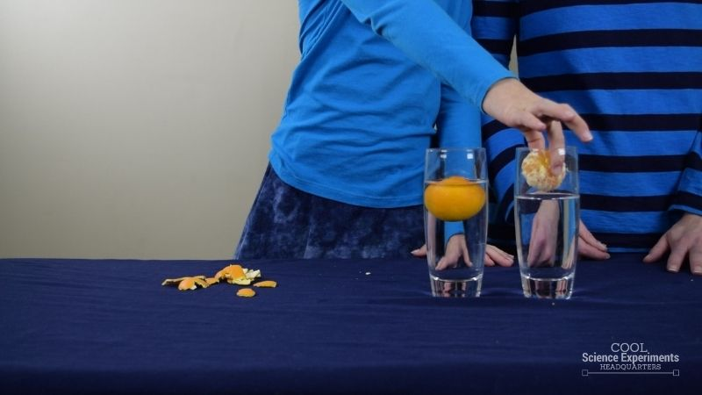

## Materials (per group or per demo)

* 2 mandarins
* 2 Glasses or containers (big enough to fit a mandarin.)
* Water
* 1 Magnifying lens

**Instructions**

1. Begin with two empty glasses or containers.
2. Fill each container 3/4 of the way full with water.

Question A. Look at the surface of the mandarin peel. What do you observe?

1. Slowly and carefully place a mandarin in one of the containers.

Question B. What do you observe?

1. Next, remove the peel from the second mandarin.

Question C. Which mandarin would you expect to be heavier?

Question D. What do you expect to observe?

1. Slowly and carefully place the peeled mandarin in the second container.

Question E. What do you observe?

Do you know the why the heavier mandarin floated and the lighter mandarin sank? Find out the answer in the [how does this experiment work](https://coolscienceexperimentshq.com/why-does-the-heavier-orange-float/#Explanation) section below.

## Video Tutorial

## <https://www.youtube.com/watch?v=W33dtzUBos0>

## How Does the Science Experiment Work

A mandarin with a peel is heavier than a mandarin without a peel. So why does the mandarin with the peel (the heavier one) float and the mandarin with the peel (the lighter one) sink?

The secret to this experiment is density! **Density** is a measure of the mass per unit volume of a substance. Water has a density of 1 g/mL (g/cm3). Objects will float in water if their density is less than 1 g/mL. Objects will sink in water if their density is greater than 1 g/mL.

The mandarin with the peel floats because the peel is porous and filled with tiny air pockets. These pockets of air help increase the **buoyancy** of the mandarin. This increase in buoyancy helps the mandarin become less dense than the water, so the mandarin will float in the water. Think of the pockets of air in the mandarin peel are like tiny floatation devices for the mandarin. On the other hand, when you remove the peel from the mandarin, you are in fact making it lighter, but you are also removing those tiny air pocket floatation devices. Therefore, the mandarin without the peel is denser than water and it sinks.

**Buoyancy** is the tendency of an object to float in fluids because of the upward force fluid exert on objects.

## More Science Fun

If you liked this experiment, check out these other experiment dealing with density:

* [**Rainbow in a Jar**](https://coolscienceexperimentshq.com/rainbow-in-a-jar/) – Create a Rainbow by using liquids of different densities
* [**How Different Liquids Impact Magnets**](https://coolscienceexperimentshq.com/how-liquid-impacts-a-magnet/) – Density also impacts magnetic force
* [**Mixing Oil & Water**](https://coolscienceexperimentshq.com/mixing-oil-water/) – Will the two liquids mix together? Only if you add a third ingredient into the mix
* [**Bottle Diver**](https://coolscienceexperimentshq.com/bottle-diver-science-experiment/) – You can make a scuba diver move up and down in the water.

<https://coolscienceexperimentshq.com/why-does-the-heavier-orange-float/>

**Floating and sinking soft drink cans**

Who has experience of diving to the bottom of the swimming pool to retrieve unopened cans of soft drink? But some cans don’t sink. Let’s find out.

**Materials**

* Large Bucket or aquarium, ¾ full of water
* Unopened soft drink cans (variety of types, some diet, all the same size)

**Instructions**

1. Begin by filling a large container with water. The water should be deep enough so you can easily tell which cans are floating and sinking.
2. Slowly place each can into the water one at a time. Make sure to tip the can on it’s side when you are placing it in the water so no air is trapped at the bottom of the can.
3. Observe the cans as you place them in the water.

Question A. Which ones float? Which ones sink? Record your results

Question B. What do all the cans that float have in common (check the labels)?

Video tutorial [https://coolscienceexperimentshq.com/floating-sinking-soft drink-cans/](https://coolscienceexperimentshq.com/floating-sinking-pop-cans/)

## Explanation for teachers

All of the cans have the exact same shape, size and volume. Density is the key to this experiment! Density is a measure of the mass per unit volume of a substance. Water has a density of 1 g/mL (g/cm3). Objects will float in water if their density is less than 1 g/mL. Objects will sink in water if their density is greater than 1 g/mL. The cans of diet soft drink are less dense than water, so they float. The cans of regular soft drink are more dense than water so they sink.

The density of the cans is different due to the type of sweetener used in each soft drink. Sugar is used to sweeten regular soft drink, a lot of sugar. This large quantity of sugar means the can will be more dense than water.

Artificial sweeteners are used in diet soft drink. However, a much smaller amount of artificial sweetener is used which causes the can to be less dense than water.

So, even though the cans were the exact same shape, size and volume (335mL) the densities were different due to the sugar!

**Extension for older or more able students**

* Try to work out the density of each can:
  + Volume – use the formula for the volume of a cylinder or measure water displacement
  + Mass - Weigh each can.
  + Mass divided by volume gives density. What is the unit?
* Try placing the cans into the water vertically, bottom first. Does this make any difference? Why?
* Work out or find out what 40g of sugar would be in teaspoons
* Add salt to the water (37g? in 3L). Stir till dissolved (warming speeds it up). What happens now?
* Are there any varieties of regular soft drink that will float? Are there any varieties of diet soft drink that sink? Can you think other factors that might influence which soft drinks float or sink?

References

<https://coolscienceexperimentshq.com/floating-sinking-pop-cans> <https://www.physics.upenn.edu/demolab/manumech/ms9.html> <https://www.chemedx.org/activity/float-or-sink-home-lab-density> <http://www.scifun.org/homeexpts/cans.htm> and