Mapping activity

This activity will help students understand and locate some of the main features of Antarctica. They will need an atlas, some coloured pens/pencils and access to the internet.

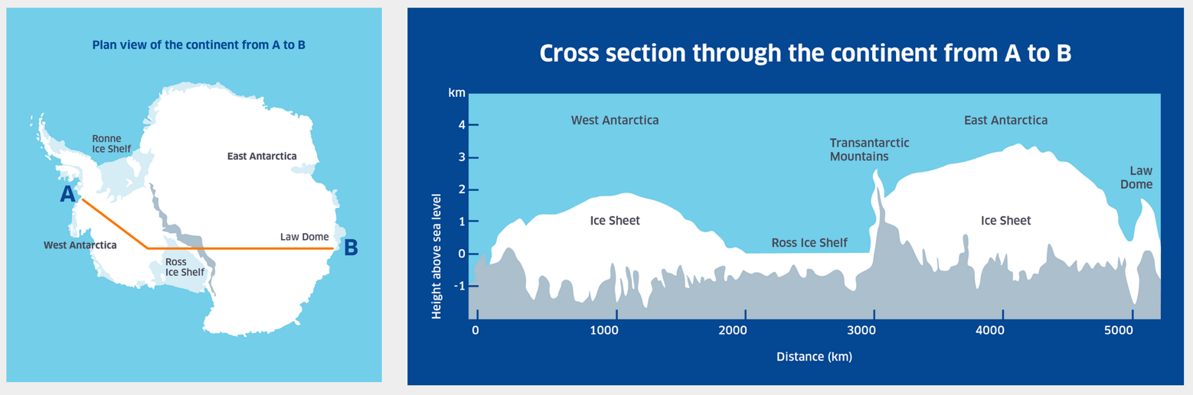

Almost all of Antarctica is covered in ice, in massive sheets. Antarctica can be divided into two major parts – the huge East Antarctic Ice Sheet and (smaller) West Antarctic Ice Sheet. These are separated by a long chain of mountains called the Transantarctic Mountain Range. About half of the coastlines are fringed with floating ice shelves, fed by ice sliding off the land. The Ross and Filchner-Ronne ice shelves are the largest of these. Extending from West Antarctica in an S curve towards South America is the Antarctic Peninsula. The geographic South pole is in the centre of the continent.
During the winter months the surrounding Southern Ocean becomes covered by a layer of sea ice that doubles the ice area of the continent. Most of the sea ice breaks up in the summer. The currents of the Southern Ocean flow right around the continent – the wildest and stormiest ocean in the world.
Many countries have bases here. New Zealand’s base is called Scott Base. Nearby is one of the American bases, McMurdo station. The Russian base is Vostok station and the main British station is called Rothera.
You will find these sources helpful
https://en.wikipedia.org/wiki/Research_stations_in_Antarctica#/media/File:Antarctica_Station_Map.png

Task: Locate and label these places on the map on page 2:-

Antarctic Circle
Antarctic Peninsula
Geographic South Pole
Larsen Ice shelf
Magnetic South Pole
McMurdo Dry Valleys
McMurdo Station
Mount Erebus
Ronne-Filchner Ice Shelf
Ross Ice Shelf
Ross Island
Rothera
Scott Base
Southern Ocean
Transantarctic Mountains
Vostok station
Weddell Sea

For those who finish early: try to find out how the Antarctic and Arctic differ. Look for several ways.

