Acid Rain Practicals suggested by Science Technicians 2023
https://www.youtube.com/watch?v=zBJizSQDBn4&ab_channel=JamesVandenBroekhttps://www.you
tube.com/watch?v=4Q6k822lSm4&ab_channel=FlinnScientific Stephanie Grey

We do one called “rock weathering”, where the students get bits of beach pebble, pumice, limestone (actually concrete), seashell and marble and see which ones react with “acid rain”. This is a natural process (dissolved CO2) but is made much worse by acid rain. David Stevenson

Gear: 2 gas jars with small volume water + universal indicator
Deflagrating spoons, one with a small piece of sulfur, one with cyclohexane.
Method: Ignite sulfur and place into gas jar 1 to burn
Ignite cyclohexane and place in gas jar 2 to burn.
Fumes should start turning UI to yellow, orange, red.

Plants in small pots with small containers with solid sodium metabisulfite in them in greenhouses made from sawn-off plastic bottles, sealed with plasticine or blu-tack at the base to a plastic board of some sort. Try those. Harry Nichol

All I can think of is something we call "Acid Attack" for the junior school.
The students take the following substances and observe what happens when you add 0.10molar HCl.
We Use: chalk, marble chips, sand stone
We had a granite bench top that I managed to get 1 chip off and we put that in a sealed test tube to show the students that granite is very hard and doesn't break down in acid.
See if you can get some chips of granite from a source (it’s near impossible to chip off from a slab) Georgina Harrison

We recently set up an experiment to drop condensed vinegar onto flower petals similar to what is described here https://www.steampoweredfamily.com/acid-rain-experiment/
Our students set up 3 systems, water, vinegar and no liquid in the out beaker.
Flower in small beaker in 30mL diH2O
Outer beaker 50mL of diH2O, vinegar or no liquid
Covered with cling film, optional marble to direct condensation onto petals.
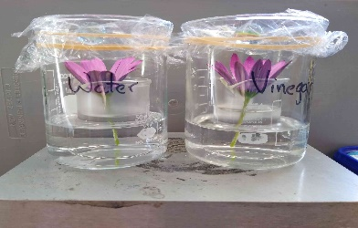
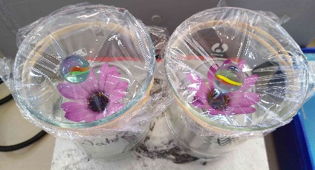
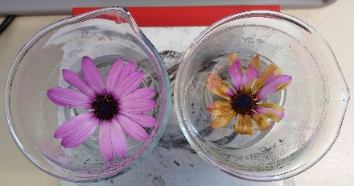
The attached images show the setup and end result for water vs vinegar. Sarah Smart

