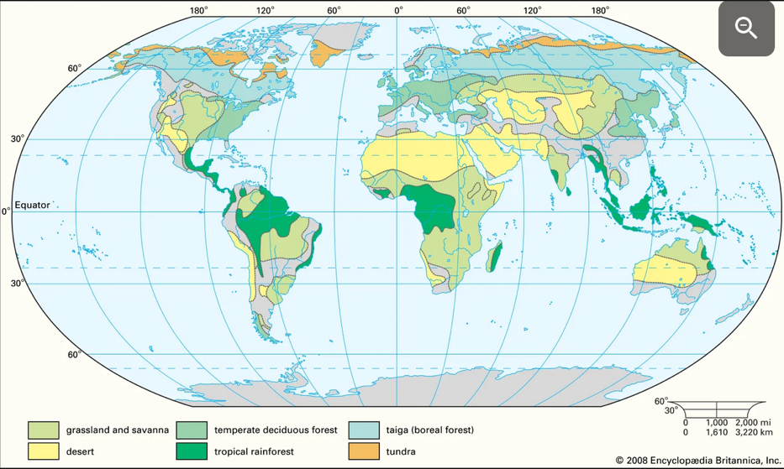**The Five Major Types of Biomes**

Plants and animals are adapted to a specific environment. On a small level this environment may be called a habitat. On a large level the living community and its environment may be called a biome. A biome comprises the large community of vegetation and wildlife as well as the physical environment they are adapted to, including the climate and soil.

A biome is a large area and may span more than 1 landmass, as the map shows. There are 5 major types of biomes, each with smaller categories:

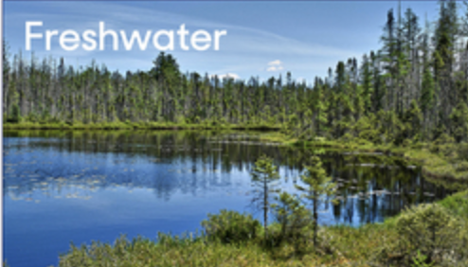**Aquatic** biomes may be freshwater or marine. Freshwater biomes are bodies of water surrounded by land (such as ponds, rivers, and lakes) that have a salt content of less than 1%. Marine biomes cover close to three-quarters of Earth’s surface and include the ocean, coral reefs, and estuaries.

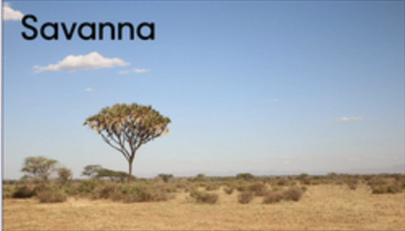**Grasslands** are flat, open regions that are dominated by grass and have a warm, dry climate. There are two types of grasslands: tropical grasslands (sometimes called savannas) and temperate grasslands. Savannas are found closer to the equator and can have a few scattered trees. Temperate grasslands do not have any trees or shrubs, and receive less precipitation than savannas. Prairies and steppes are two types of temperate grasslands; prairies are characterized as having taller grasses, while steppes have shorter grasses.

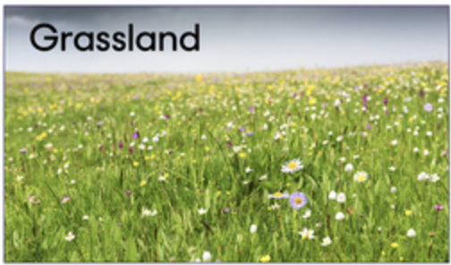**Forests** are dominated by trees, and cover about one-third of the Earth. Forests contain much of the world’s terrestrial biodiversity, including insects, birds, and mammals. The three major forest biomes are temperate forests, tropical forests, and boreal forests (also known as the taiga). These forest types occur at different latitudes, and therefore experience different climatic conditions. Tropical forests are warm, humid, and found close to the equator. Here there are two seasons: wet (due to monsoons) and dry. Temperate forests are found at higher latitudes and experience all four seasons. They are noted for their broad-leafed trees that lose their leaves in autumn as the temperatures drop (deciduous). Boreal forests (mostly conifer and evergreen trees) are found at even higher latitudes, and have the coldest, driest climate, where precipitation occurs mainly as snow.

|  |  |  |
| --- | --- | --- |
|  |  |  |

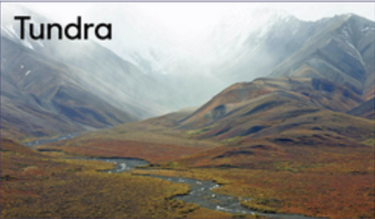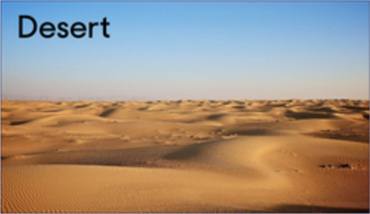**Deserts** are dry areas where rainfall is less than 50 cm per year. They cover around 20% of Earth’s surface. Deserts can be either cold or hot, although most are found in subtropical areas. Due to their extreme conditions, there is not as much biodiversity found in deserts as in other biomes. Any plants and animals living in a desert need adaptations for surviving in a dry environment. Deserts can fall into four categories according to their geographic location or climatic conditions: hot and dry, semiarid, coastal, and cold.

**Tundra** has extremely inhospitable conditions, with the lowest measured temperatures of any of the five major biomes - average yearly temperatures range from -34 to 12 degrees Celsius. They also have a low amount of precipitation, just 15–25 cm per year, as well as poor quality soil nutrients and short summers. There are two types of tundra: arctic and alpine. Tundra does not have much biodiversity and vegetation is simple, including shrubs, grasses, mosses, and lichens. This is partly due to a frozen layer under the soil surface, called permafrost. The arctic tundra is found north of boreal forests and the alpine tundra is found on mountains where the altitude is too high for trees to survive. Any wildlife inhabiting the tundra must be adapted to its extreme conditions to survive.

**Biomes in Aotearoa**

Although New Zealand occupies a temperate latitude it has few deciduous trees and it also shows some features of tropical biomes.

Our native **forests** ("the bush") are broadly divided into temperate (broadleaf) and beech forests (*Nothofagus* species). Beech forests are most common in high altitudes and cold climates, while temperate forests dominate elsewhere. It is common for New Zealand's forests to be referred to as rainforest particularly in the west where rainfall is high. [Pine forests are not included here as they are introduced].

Temperate forests vary across the country, but prefer warmer environments to the beech forests. They are noted for the rich diversity of plants in their canopy and undergrowth layers, and an abundance of vines and perching plants, both of which are more typical of tropical forests. Near the coast the trees become stunteddue to exposure to salt and wind. Temperate forest is also found on the Chatham Islands.

Beech forests are divided into four varieties based on the dominant tree species and their altitude. Black Beech forests are found in the warmer lowlands of the North Island and northern South Island. Red Beech are found in drier foothills, while Silver Beech prefer wetter foothills. Mountain Beech are found at high altitude near the tree line, which in Aotearoa is below 1000 m. Beech trees only flower sometimes, in what is called a mast year. This leads to the whole canopy producing seeds at the same time, causing a population spike in herbivores like mice and predators like rats.

As well as forests, we have extensive natural tussock **grasslands** in places where altitude and climate limits forest growth. This includes the North Island’s Central Plateau around the snow-covered mountains and extensive areas of the South Island between the tree line and the alpine environment. Tussock grasslands are also found on flood plains, but are smaller in area due to the constantly shifting substrate and greater likelihood of frost. Multiple species of tussock are present and dominate at different altitudes and climates, with their maximum size smallest at high altitude.

The subantarctic islands, to the south of New Zealand, are cold and windswept, characterised by the low, cold-adapted plants of the **tundra**.

**Sources:**

[Brittanica](https://www.britannica.com/science/biome), [National Geographic](https://education.nationalgeographic.org/resource/five-major-types-biomes/) (creative commons), [Quizizz](https://quizizz.com/admin/quiz/60c84068117c32001be4ff0b/biome-review-oxford-discover-4-unit-17), [Wikipedia](https://en.wikipedia.org/wiki/Environment_of_New_Zealand)

Possible Activities

1. What do these terms mean?
   1. precipitation
   2. estuary
   3. terrestrial
   4. monsoon
   5. conifer
   6. biodiversity
2. Explain the difference between
   1. latitude and altitude
   2. deciduous and evergreen
   3. tropical and temperate
3. Write one sentence about each major biome – try to make this in your own words
4. Any world map of biomes often does not show New Zealand clearly. Below is a map of New Zealand biomes made by Murdoch Primary (in England).
   1. What do you think of this map? E.g. what’s good, what’s unnecessary, what’s missing?
   2. Find a blank map of NZ (with the Chathams and subantarctic islands if possible) e.g. <https://vemaps.com/new-zealand/nz-02> or <https://gis.stackexchange.com/questions/473205/new-zealand-map-that-includes-chatham-islands>
   3. Now see if you can do a better job of mapping our biomes.
   4. 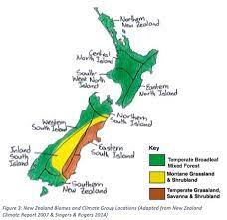Post it online (eg on your school website) so Murdoch’s version is not the only one people find when they search for Aotearoa New Zealand biomes.