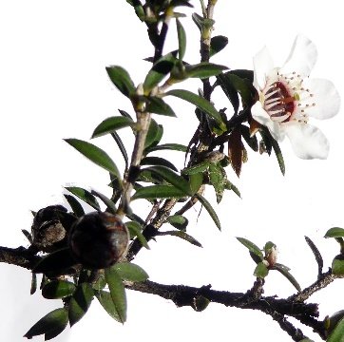
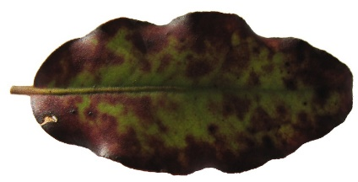
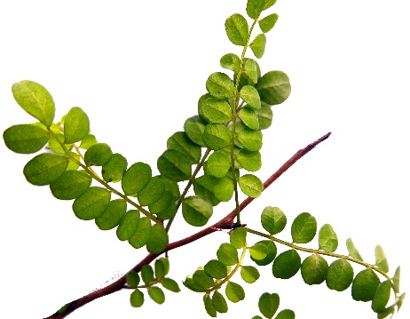
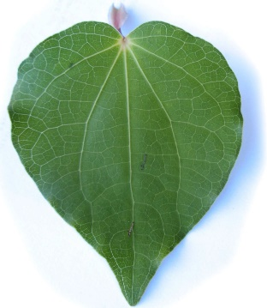
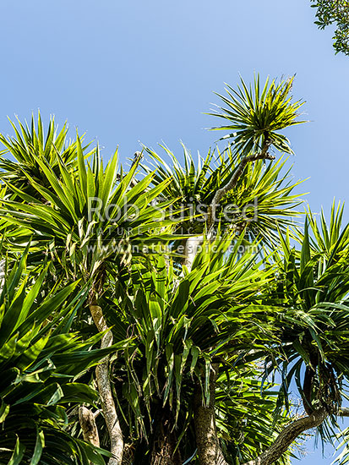

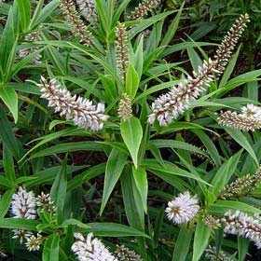

Piwakawaka track hīkoi

Group Names: ____________________________________________________________________________________________________________
Can you identify each of the plants above?

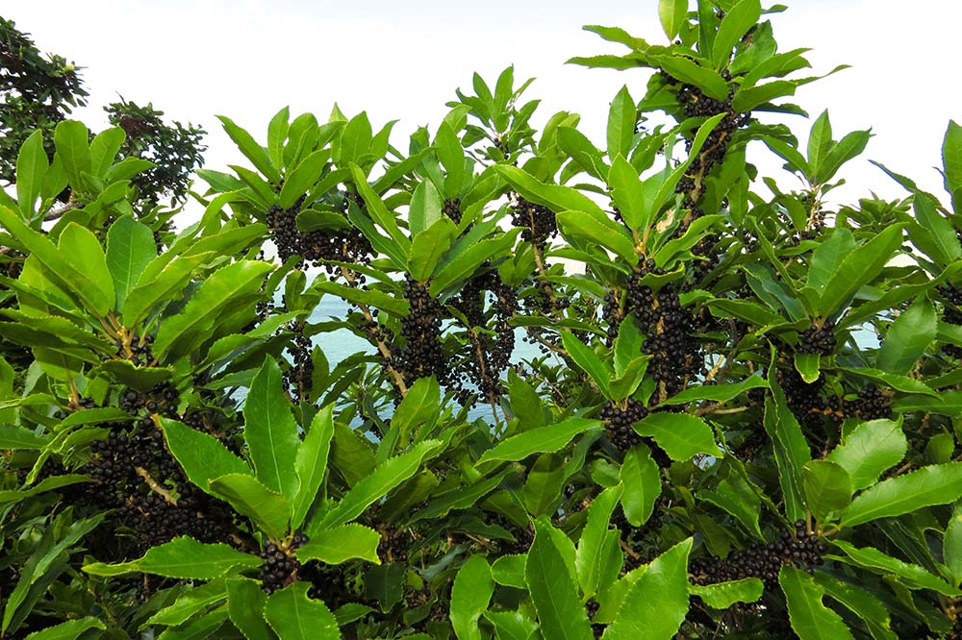

Find a Māhoe tree

Collect one leaf skeleton from underneath the tree.

Rongoa:
The leaves of the Māhoe tree were boiled to help with diarrhoea and menstrual pain. The berries were mixed with Kauri gum to create the pigment for Tā Moko.

This tree is associated with Maui getting the secret of fire from Mahuika. Who in your group knows this pūrākau? Write a brief summary below.

There are five other trees that can be used to make fire. Can your group name one other?

_________________________________________________________________________

Find a Koromiko tree.

Carefully pick one leaf from the bottom of the tree.

Rongoa:
The koromiko is important in Māori rongoa. It was used for diarrhoea and dysentery. During World War 2 wāhine would send them to soldiers fighting overseas to help with diarrhoea. The leaves can be chewed raw and not swallowed, or the liquid from the steeped leaves can be drunk to cure diarrhoea and dysentery. It is good for the kidneys and bladder. Chewing the leaves can be an appetite stimulant. The leaves can be applied to ulcers and boils. The liquid from boiled leaves can be used as a mouthwash.

The koromiko tree was often planted around the outside of a whare as it is a useful medicinal plant.

Name 2 things it can be used for:

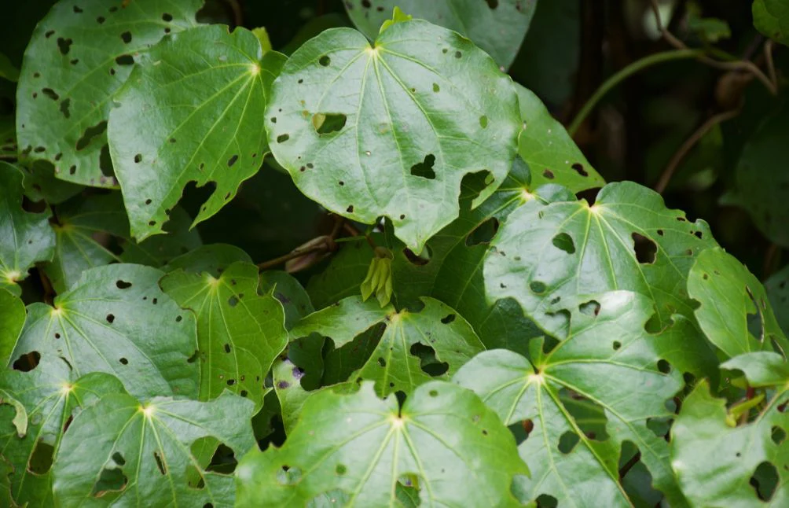

Find a Kawakawa plant.

When picking leaves from the Kawakawa it is important to pick the grandparent leaves, not the baby ones. You may pick one leaf for your group.

Rongoa:
Kawakawa is used for many medicinal purposes. How many things can your group name that kawakawa is used for?

Māori widely promote harvesting leaves with holes in them. There are 2 main reasons for this:
- Insects will only eat the best healthy leaves.
- The plant gives its medicinal properties to that leaf when it has been bitten or bruised.
The leaves that have the most holes are considered to hold the most medicinal value.

Researchers at Auckland University are now running trials testing the potential for kawakawa to reduce inflammation and improve health for non-communicable diseases (lifestyle diseases like type 2 diabetes and heart disease).

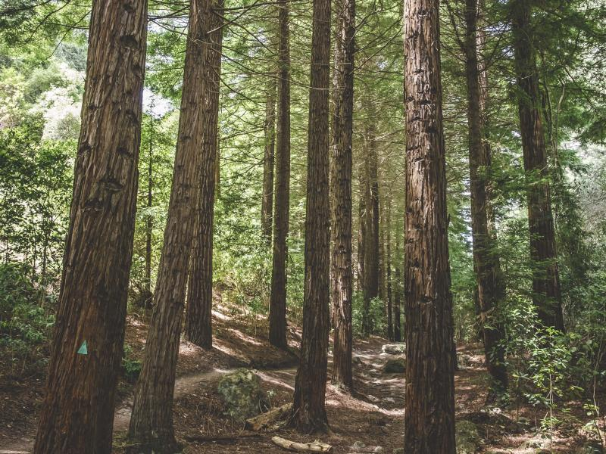
When you are at the redwoods… Stop and listen!

Name:
3 things you can hear:

3 things you can see:

3 things you can smell:

3 things you can touch:

What sense have I missed out?
_________________________________________________________________________

Name the most beautiful thing that has struck you so far
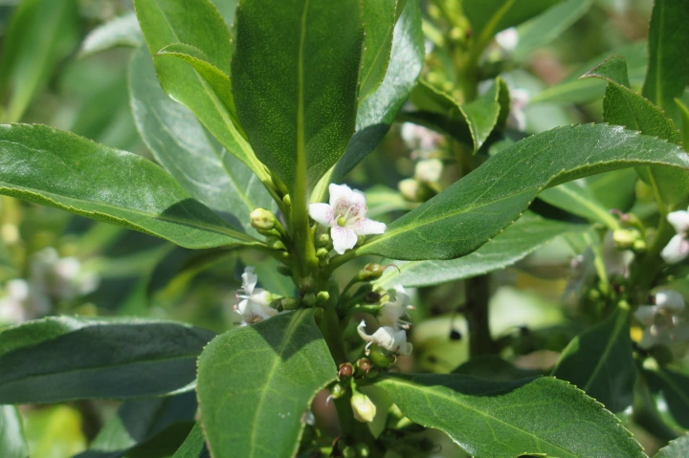
Just past the redwoods, can you find a Ngaio tree? What pūrākau is associated with this tree?

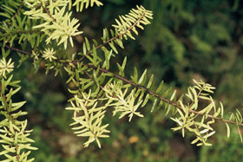
Can you find a Totara tree somewhere on the track?
Draw a picture below.

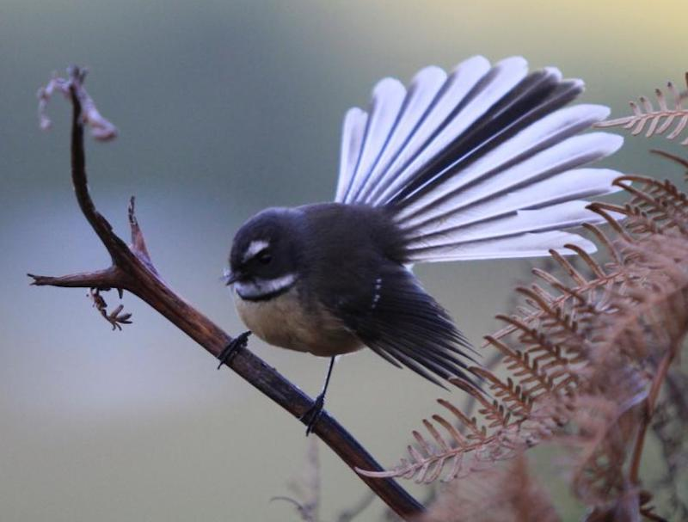
Can you spot a piwakawaka?

The twelve hukumaro (tail feathers) of the piwakawaka represent the twelve heavenly realms. These are the same twelve heavenly realms which Tāne Mahuta ascended to attain Ngā Kete o Te Wananga - The Three Baskets of Knowledge.

There are 19 different Māori names for the piwakawaka. Can you name 2?

Can your group name any pūrakau about the piwakawaka?

Draw a picture of a fantail below.

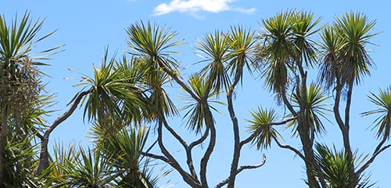

Find a Ti Kōuka tree.

How many Tī Kōuka can you see?

How do you know which is the oldest tree?

The Tī Kōuka was used as a food source. The root, stem and top of the tree are all edible and a good source of starch and sugar.
The roots were used in traditional medicine and the leaves were also made into tea to cure diarrhoea and dysentery.
They were planted to mark trails, boundaries, urūpa and births, as they are generally long lived and easily spotted from a distance.

What do you think the leaves could be used for? (how many can you name?)

