**Biology 11: Energy and Matter**

**Solutions Types Worksheet**

For each scenario in questions 1 to 5:

1. Assume the cell membrane is permeable only to the water molecules.
2. Draw a diagram and label the solute and solvent concentrations both inside and outside the cell.
3. State the solution type.
4. Use arrows to indicate the direction of osmosis.
5. State what will happen to the cell.
6. An animal cell has a concentration of 3% solute and 97% water. It is placed into an environment of 6% solute and 94% water.
7. A plant cell with a concentration of 5% solute has not been watered for weeks. The concentration of water in the cell’s environment is 30%.
8. A plant cell with a concentration of 5% solute is in an environment that is 3% solute.
9. An animal cell with a concentration of 2% solute is placed in an environment with a water concentration of 98%.
10. An animal cell with a concentration of 14% solute is placed in distilled water.
11. On the diagram below, label the solution type at the top. At the bottom, explain the results of a cell in this type of solution.

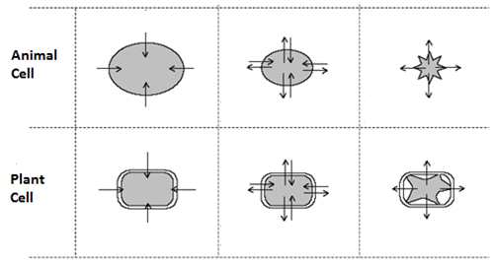

1. Why do grocery store owners spray fresh fruits and vegetables with water?
2. In the winter, many roads are salted to melt the ice. What does this do to the plants around the roadside? Why?
3. If a shipwrecked crew drinks sea water, they will probably die. Why?
4. If a bowl of fresh strawberries is sprinkled with sugar, a few minutes later the berries will be covered with juice. Why?