Resource Booklet to Support Internal Report

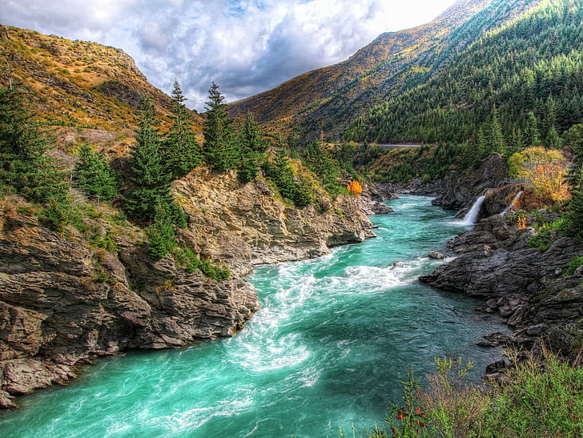

91920

Richard Booth

Nga Tawa Diocesan 2024

91920

The Problem with our Water

**Is Rangitikei Water Polluted ?**

**Are there Scientific Solutions ?**

**The Issue**

**The state of New Zealand's freshwater resources and solutions science can offer**

As New Zealand tries to squeeze maximum value out of its natural resources, conflicts over water are coming to a boil. We’re fast approaching water resource limits in some parts of the country, and pollution issues are threatening our clean, green brand.

Despite a comprehensive clean-up of dirty ‘point-source’ discharges in the 1990s, water quality in many of our lakes and rivers is still declining. The cause this time is ‘diffuse-source’ pollution associated with intensive land use, particularly pastoral farming.

So how do we balance the drive to grow our economy with the need for clean water? Can our freshwater systems sustain the spread of intensive dairying?

Accusations of dirty dairying, conflicts over irrigation proposals, and the swimmable status of our waters continue to grab headlines. Respondents to a 2008 opinion poll by consultants EOS Ecology rated water pollution and water-related issues as the number one environmental issue facing New Zealand. So how bad is it really, and what solutions can science offer?

**The Natural Process (from Nature Article)**

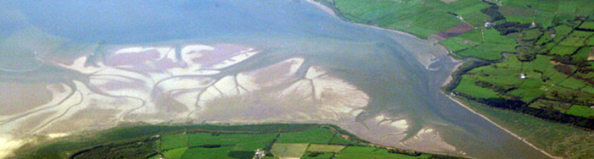

## Introduction

Nitrogen is one of the primary nutrients critical for the survival of all living organisms. It is a necessary component of many biomolecules, including proteins, DNA, and chlorophyll. Although nitrogen is very abundant in the atmosphere as dinitrogen gas (N2), it is largely inaccessible in this form to most organisms, making nitrogen a scarce resource and often limiting primary productivity in many ecosystems. Only when nitrogen is converted from dinitrogen gas into ammonia (NH3) does it become available to primary producers, such as plants.

In addition to N2 and NH3, nitrogen exists in many different forms, (e.g., ammonia, nitrate). Nitrogen undergoes different transformations in the ecosystem, changing from one form to another as organisms use it for growth and energy. The major transformations of nitrogen are nitrogen fixation, nitrification and denitrification The transformation of nitrogen into its many oxidation states is key to productivity in the biosphere and is highly dependent 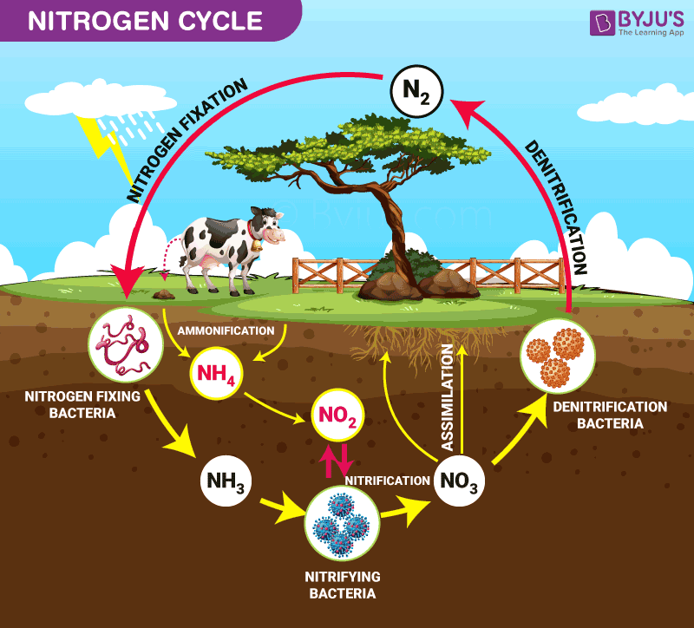on the activities of a diverse assemblage of microorganisms, such as bacteria, archaea, and fungi.

Since the mid-1900s, humans have been exerting an ever-increasing impact on the global nitrogen cycle. Human activities, such as making fertilizers and burning fossil fuels, have significantly altered the amount of fixed nitrogen in the Earth's ecosystems. In fact, some predict that by 2030, the amount of nitrogen fixed by human activities will exceed that fixed by microbial increases in available nitrogen can alter ecosystems by increasing primary productivity and impacting carbon storage Because of the importance of nitrogen in all ecosystems and the significant impact from human activities, nitrogen and its transformations have received a great deal of attention from ecologists.

## Nitrogen Fixation

Nitrogen gas (N2) makes up nearly 80% of the Earth's atmosphere, yet nitrogen is often the nutrient that limits primary production in many ecosystems. Why is this so? Because plants and animals are not able to use nitrogen gas in that form. For nitrogen to be available to make proteins, DNA, and other biologically important compounds, it must first be converted into a different chemical form. The process of converting N2 into biologically available nitrogen is called nitrogen fixation. N2 gas is a very stable compound due to the strength of the triple bond between the nitrogen atoms, and it requires a large amount of energy to break this bond. The whole process requires eight electrons and at least sixteen ATP molecules (Figure 2). As a result, only a select group of prokaryotes are able to carry out this energetically demanding process. Although most nitrogen fixation is carried out by prokaryotes, some nitrogen can be fixed abiotically by lightning or certain industrial processes, including the combustion of fossil fuels.

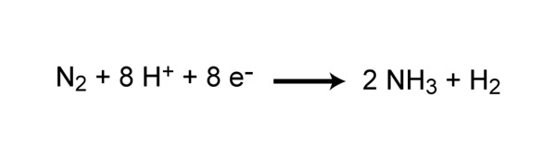

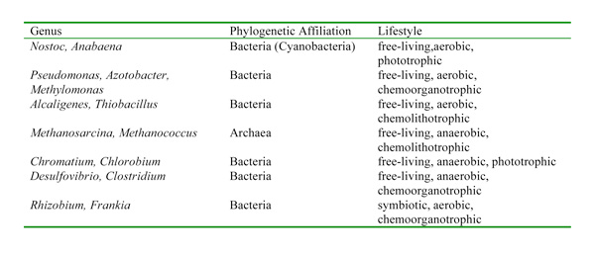Some nitrogen-fixing organisms are free-living while others are symbiotic nitrogen-fixers, which require a close association with a host to carry out the process. Most of the symbiotic associations are very specific and have complex mechanisms that help to maintain the symbiosis. For example, root exudates from legume plants (e.g., peas, clover, soybeans) serve as a signal to certain species of *Rhizobium*, which are nitrogen-fixing bacteria. This signal attracts the bacteria to the roots, and a very complex series of events then occurs to initiate uptake of the bacteria into the root and trigger the process of nitrogen fixation in nodules that form on the roots (Figure 3).

Some of these bacteria are aerobic working with oxygen, and others are anaerobic which means they work without the presence of Oxygen

The broad distribution of nitrogen-fixing genes suggests that nitrogen-fixing organisms display a very broad range of environmental conditions, as might be expected for a process that is critical to the survival of all life on Earth.

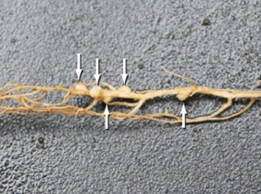Nitrification is the process that converts ammonia to nitrite and then to nitrate and is another important step in the global nitrogen cycle. Most nitrification occurs **aerobically** and is carried out exclusively by prokaryotes. There are two distinct steps of nitrification that are carried out by distinct types of microorganisms. The first step is the oxidation of ammonia to nitrite, which is carried out by microbes known as ammonia-oxidizers. Aerobic ammonia oxidizers convert ammonia to nitrite. The process generates a very small amount of energy relative to many other types of metabolism; as a result, nitrosofiers are notoriously very slow growers.

## Denitrification

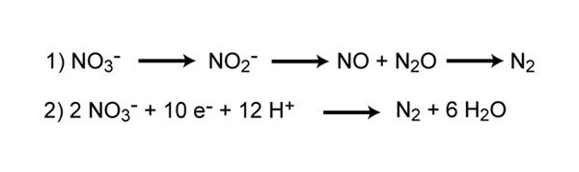Denitrification is the process that converts nitrate to nitrogen gas, thus removing bioavailable nitrogen and returning it to the atmosphere. Dinitrogen gas (N2) is the ultimate end product of denitrification, but other intermediate gaseous forms of nitrogen exist (Figure 7). Some of these gases, such as nitrous oxide (N2O), are considered greenhouse gasses, reacting with ozone and contributing to air pollution.

Unlike nitrification, denitrification is an anaerobic process, occurring mostly in soils and sediments and anoxic zones in lakes and oceans. Similar to nitrogen fixation, denitrification is carried out by a diverse group of prokaryotes, and there is recent evidence that some eukaryotes are also capable of denitrification (Risgaard-Petersen *et al*. 2006). Some denitrifying bacteria include species in the genera *Bacillus*, *Paracoccus*, and *Pseudomonas*. Denitrifiers are chemoorganotrophs and thus must also be supplied with some form of organic carbon.

Denitrification is important in that it removes fixed nitrogen (i.e., nitrate) from the ecosystem and returns it to the atmosphere in a biologically inert form (N2). This is particularly important in agriculture where the loss of nitrates in fertilizer is detrimental and costly. However, denitrification in wastewater treatment plays a very beneficial role by removing unwanted nitrates from the wastewater effluent, thereby reducing the chances that the water discharged from the treatment plants will cause undesirable consequences (e.g., algal blooms).

## The Haber Bosch Process

**This is a** method of directly synthesizing [ammonia](https://www.britannica.com/science/ammonia) from [hydrogen](https://www.britannica.com/science/hydrogen) and [nitrogen](https://www.britannica.com/science/nitrogen), developed by the German physical chemist [Fritz Haber](https://www.britannica.com/biography/Fritz-Haber). He received the [Nobel Prize](https://www.britannica.com/topic/Nobel-Prize) for Chemistry in 1918 for this method, which made the manufacture of ammonia economically [feasible](https://www.merriam-webster.com/dictionary/feasible). The method was translated into a large-scale process using a [catalyst](https://www.merriam-webster.com/dictionary/catalyst) and high-pressure methods by [Carl Bosch](https://www.britannica.com/biography/Carl-Bosch), an industrial chemist who won a Nobel Prize in 1931 jointly with [Friedrich Bergius](https://www.britannica.com/biography/Friedrich-Bergius) for high-pressure studies.

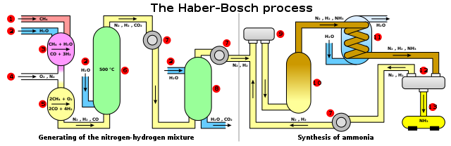

Haber-Bosch was the first industrial chemical process to use high [pressure](https://www.britannica.com/science/pressure) for a [chemical reaction](https://www.britannica.com/science/chemical-reaction). It directly combines nitrogen from the air with hydrogen under extremely high pressures and moderately high temperatures. A catalyst made mostly from [iron](https://www.britannica.com/science/iron-chemical-element) enables the reaction to be carried out at a lower temperature than would otherwise be practicable, while the removal of ammonia from the batch as soon as it is formed ensures that an [equilibrium](https://www.merriam-webster.com/dictionary/equilibrium) favouring product formation is maintained. The lower the temperature and the higher the pressure used, the greater the proportion of ammonia yielded in the mixture. For commercial production, the reaction is carried out at pressures ranging from 200 to 400 atmospheres and at temperatures ranging from 400° to 650° C (750° to 1200° F). The Haber-Bosch process is the most economical for the [fixation of nitrogen](https://www.britannica.com/science/nitrogen-fixation) and with modifications continues in use as one of the basic processes of the [chemical industry](https://www.britannica.com/technology/chemical-industry) in the world.

## Ecological Implications of Human Alterations to the Nitrogen Cycle

Many human activities have a significant impact on the nitrogen cycle. Burning fossil fuels, application of nitrogen-based fertilizers, and other activities can dramatically increase the amount of biologically available nitrogen in an ecosystem. And because nitrogen availability often limits the primary productivity of many ecosystems, large changes in the availability of nitrogen can lead to severe alterations of the nitrogen cycle in both aquatic and terrestrial ecosystems. Industrial nitrogen fixation has increased exponentially since the 1940s, and human activity has doubled the amount of global nitrogen fixation.

In terrestrial ecosystems, the addition of nitrogen can lead to nutrient imbalance in trees, changes in forest health, and declines in biodiversity. With increased nitrogen availability there is often a change in carbon storage, thus impacting more processes than just the nitrogen cycle. In agricultural systems, fertilizers are used extensively to increase plant production, but unused nitrogen, usually in the form of nitrate, can leach out of the soil, enter streams and rivers, and ultimately make its way into our drinking water. The process of making synthetic fertilizers for use in agriculture by causing N2 to react with H2, known as the Haber-Bosch process, has increased significantly over the past several decades. In fact, today, nearly 80% of the nitrogen found in human tissues originated from the Haber-Bosch process.

Much of the nitrogen applied to agricultural and urban areas ultimately enters rivers and nearshore coastal systems. In nearshore marine systems, increases in nitrogen can often lead to anoxia (no oxygen) or hypoxia (low oxygen), altered biodiversity, changes in food-web structure, and general habitat degradation. One common consequence of increased nitrogen is an increase in harmful algal blooms (Howarth 2008). Toxic blooms of certain types of dinoflagellates have been associated with high fish and shellfish mortality in some areas. Even without such economically catastrophic effects, the addition of nitrogen can lead to changes in biodiversity and species composition that may lead to changes in overall ecosystem function. Some have even suggested that alterations to the nitrogen cycle may lead to an increased risk of parasitic and infectious diseases among humans and wildlife. Additionally, increases in nitrogen in aquatic systems can lead to increased acidification in freshwater ecosystems.

## Summary

Nitrogen is arguably the most important nutrient in regulating primary productivity and species diversity in both aquatic and terrestrial ecosystems. Microbially-driven processes such as nitrogen fixation, nitrification, and denitrification, constitute the bulk of nitrogen transformations, and play a critical role in the fate of nitrogen in the Earth's ecosystems. However, as human populations continue to increase, the consequences of human activities continue to threaten our resources and have already significantly altered the global nitrogen cycle.

**Eutrophication**

Eutrophication is an increase in the nutrients in a water body, which can increase growth of primary producers (e.g., aquatic plants, stream periphyton, estuarine algae) to nuisance levels and degrade water quality (e.g. reduced oxygen levels and visual clarity).

**Eutrophication**, the gradual increase in the concentration of [phosphorus](https://www.britannica.com/science/phosphorus-chemical-element), [nitrogen](https://www.britannica.com/science/nitrogen), and other plant nutrients in an aging aquatic [ecosystem](https://www.britannica.com/science/ecosystem) such as a [lake](https://www.britannica.com/science/lake). The productivity or fertility of such an ecosystem naturally increases as the amount of organic material that can be broken down into nutrients increases. This material enters the ecosystem primarily by[**runoff**](https://www.britannica.com/science/runoff) from land that carries debris and products of the reproduction and death of terrestrial organisms. [Water blooms](https://www.britannica.com/science/water-bloom), or great concentrations of [algae](https://www.britannica.com/science/algae) and microscopic organisms, often develop on the surface, preventing the light penetration and oxygen absorption necessary for underwater life. Eutrophic waters are often murky and may support fewer large animals, such as [fish](https://www.britannica.com/animal/fish) and birds, than non-eutrophic waters.

[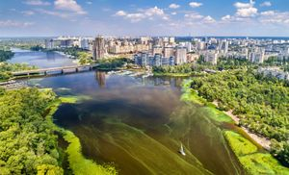](https://cdn.britannica.com/71/202771-050-787A97B1/view-algae-bloom-Dnieper-River-Ukraine-Kiev.jpg)[Eutrophication](https://www.britannica.com/science/cultural-eutrophication) occurs when human and [water pollution](https://www.britannica.com/science/water-pollution) speeds up the aging process by introducing sewage, [detergents](https://www.britannica.com/technology/detergent), [fertilizers](https://www.britannica.com/topic/fertilizer), and other nutrient sources into the ecosystem. Cultural eutrophication has had dramatic consequences on freshwater resources, [fisheries](https://www.britannica.com/topic/fishery), and recreational bodies of water and is one of the leading causes of aquatic ecosystem [degradation](https://www.merriam-webster.com/dictionary/degradation).

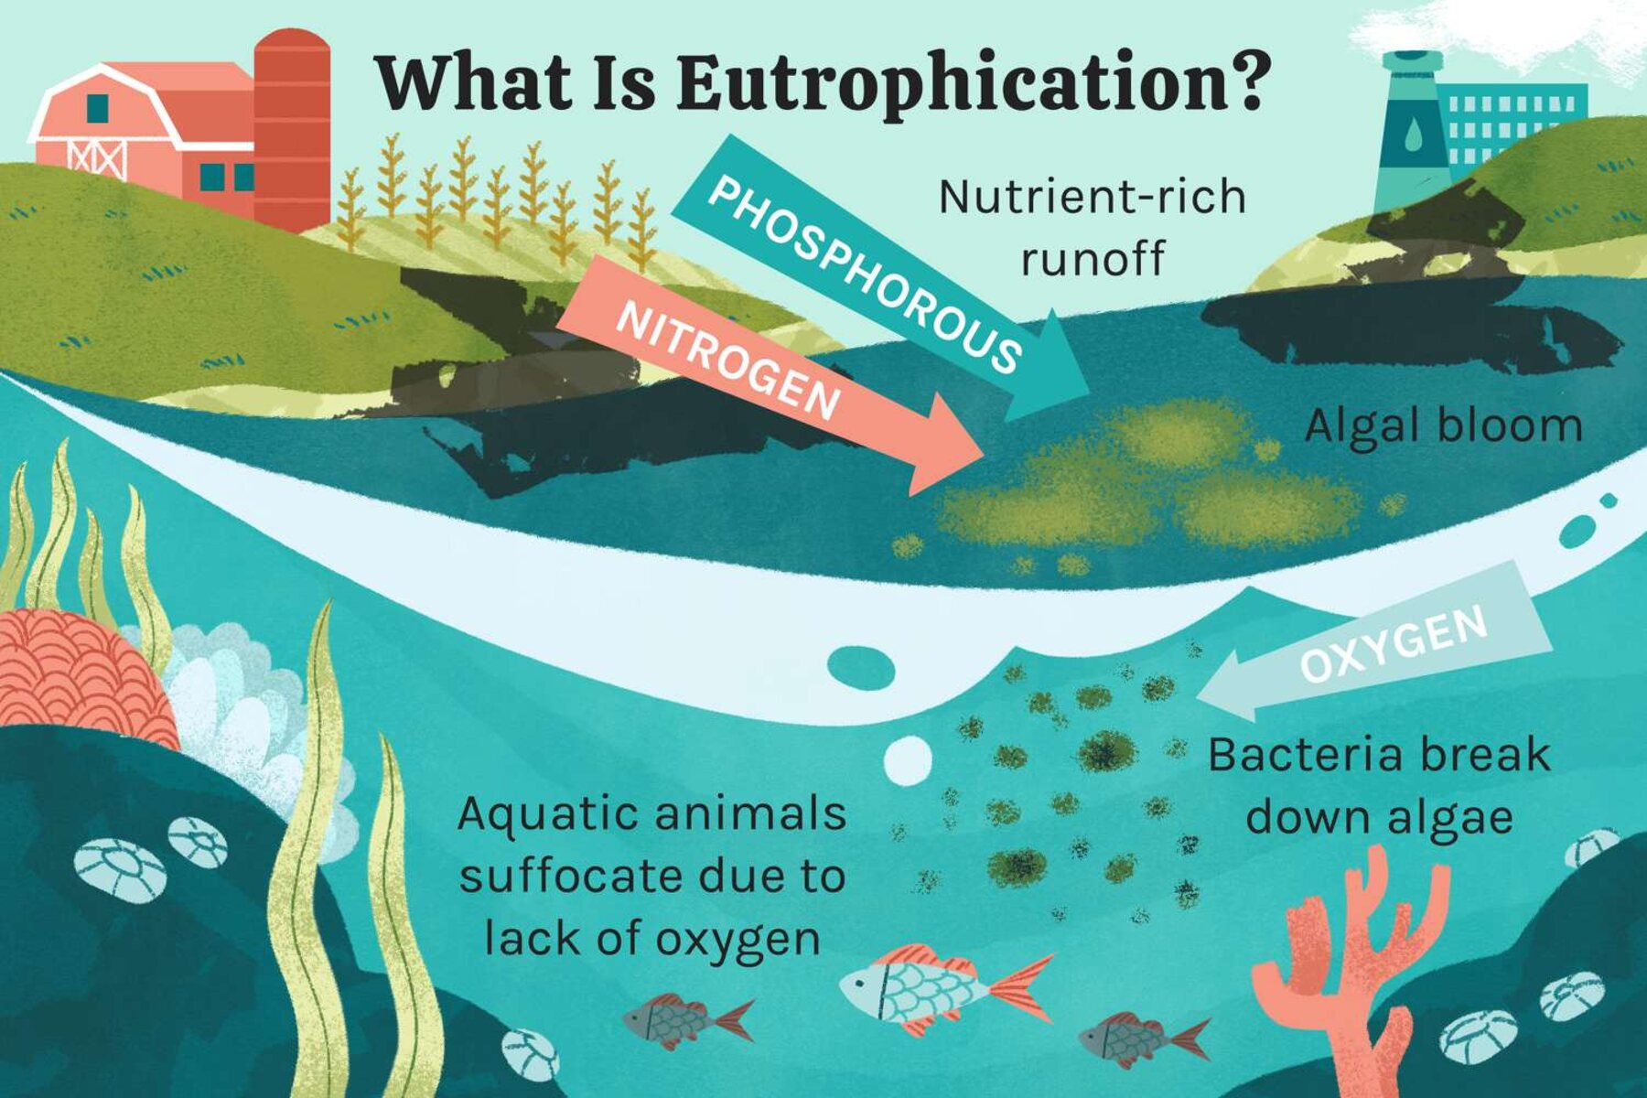Commonly, eutrophic aquatic systems show extremely low [oxygen](https://www.britannica.com/science/oxygen) concentrations in bottom waters, a condition known as [hypoxia](https://www.britannica.com/science/hypoxia). This is particularly true of stratified systems such as, for instance, lakes during summer when concentrations of molecular oxygen may reach levels of less than about one milligram per litre—a [threshold](https://www.merriam-webster.com/dictionary/threshold) for various biological and chemical processes. Low oxygen levels can be further [exacerbated](https://www.merriam-webster.com/dictionary/exacerbated) by [water blooms](https://www.britannica.com/science/water-bloom) that often accompany nutrient loading of waters and may poison wildlife. In the [Black Sea](https://www.britannica.com/place/Black-Sea) and elsewhere, hypoxic waters from cultural eutrophication have resulted in massive fish kills, with rippling effects throughout the [food chain](https://www.britannica.com/science/food-chain) .

Coastal marine systems also may be affected by this process. On a global scale, the input of organic matter by rivers into the oceans today is twice the input in prehuman times, and the flux of nitrogen, together with that of phosphorus, has more than doubled.

Much of the phosphorus in streams and lakes is delivered from agriculture, both through [soil](https://www.britannica.com/science/soil) erosion and [fertilizer](https://www.britannica.com/topic/fertilizer) [runoff](https://www.britannica.com/dictionary/runoff). Nitrogen from municipal [sewage treatment](https://www.britannica.com/technology/wastewater-treatment) plants and the direct runoff from animal feedlots are serious problems in many places. [Pollution control](https://www.britannica.com/technology/pollution-control) and improved municipal, industrial, and agricultural practices could do much to curb the cultural eutrophication of inland and coastal waters.

## Status and trends in water quality in NZ

Monitoring is fundamental to determining the state of our freshwaters, the impacts of land use changes, and the success of clean-up efforts. The country’s only national-scale monitoring programme, the National Rivers Water Quality Network (NRWQN), is operated by NIWA. Currently, this provides the best source of national-scale water quality data in New Zealand. The network regularly samples 77 sites, including 35 major rivers that drain 50 percent of our land area. “It gives a really good overview of what’s going on” with water quality, says Todd Krieble, Director of Information at the Ministry for the Environment (MfE). NRWQN data are freely available online.

Regional councils also monitor water quality for state of the environment (SoE) reporting at about 500 sites. “The overall picture emerging from the NRWQN is that our water quality, while generally good by international standards, is declining,” says NIWA freshwater scientist Rob Davies-Colley. Many rivers show excessive nutrients, reduced visual clarity due to suspended sediments, and pollution by faecal bacteria. Water quality is appreciably worse at several hundred sites in lowland rivers monitored by regional councils.

Trends in NRWQN data between 1989 and 2007 (published on the MfE website) show an overall degradation in water quality in our major rivers. Over that period, nitrogen and phosphorus – key plant nutrients added in fertilisers – increased strongly at many sites. Nitrogen increased by about 1.4 percent per annum over most of the country, but remained steady at pristine sites like the Haast River; no sites recorded a drop in nitrogen concentrations (see map). Trends for phosphorus were mostly upwards. Another cause for concern is that upward trends for temperature, nitrogen, and phosphorus have strengthened in recent years compared with the period 1989–2003.

There were no statistically significant or meaningful decreases. A ‘meaningful’ trend is one which is statistically significant, with a rate of change greater than 1% per annum. A ‘significant’ trend is one which is statistically significant at the 95% confidence level, but with a rate of change less than 1% per annum.

Water quality information for lakes, groundwater, and estuaries is much patchier, as there is currently no national scale monitoring for these water bodies. Regional council monitoring published by MfE in 2006 tells us that many of our lakes are in bad shape: of 134 lakes monitored, 56 percent are ‘eutrophic’ or worse. This means they suffer from nutrient enrichment that promotes frequent algal blooms, including major blooms of toxic cyanobacteria, a type of algae that has plagued central North Island and some South Island lakes over the past decade.

These changes all have consequences for how we use our freshwater resources – whether it’s for drinking, stock watering, food harvesting, or recreational activities – and for their aesthetic qualities, ecological functioning, and spiritual integrity or ‘mauri’. MfE is attempting to establish national water quality standards for these different uses.

## Contaminants from the land

## Pollution from land use is overwhelmingly the main cause of water quality degradation in New Zealand today. Research and monitoring have identified nitrogen (particularly its dissolved form, nitrate), phosphorus, faecal microbes, and sediments as the key contaminants from diffuse sources.

Pastoral farming – which accounts for 40 percent of New Zealand’s land area – is undoubtedly the main source of this pollution. Evidence from studies generally show a gradient in water quality from excellent in native forest, to good in plantation forest, to poor in pastoral and urban streams. Streams in dairy land are among **the most polluted.**

There is no doubt that our declining river water quality over the last 20 years is associated with **intensification** of pastoral farming and the conversion of drystock farmland to dairy farming, particularly in Waikato, Southland, and Canterbury. For example, between 1992 and 2002, the number of cows in Waikato increased by 37 percent; during the same period nitrogen levels in the region’s streams increased by 40 percent and phosphorus levels went up by 25 percent.

We know that New Zealand’s aquatic systems are particularly sensitive to nitrogen and phosphorus, so even small increases can have marked effects. “There’s an order of magnitude of difference between the amount of nutrient required to get good pasture growth and the amount, particularly of nitrate, that causes problems in waterways,” says Neil Deans, Resource Management Coordinator for Fish & Game New Zealand. “If you add that to the time lags between surface water inputs and outputs, you have a big problem.”

“Dairy farming is a very leaky process,” says NIWA physical chemist Bob Wilcock. Using results from nutrient budget modelling, the Ministry of Agriculture and Forestry (MAF) reported in 2008 that the average nitrogen lost from the soil on dairy farms was 39 kilograms per hectare per year, compared with 12 kilograms for deer farms and 8 kilograms for sheep and beef farms. Substantial quantities of nutrients, sediments, and faecal bacteria can wash into pastoral streams, particularly on steep country, during rainstorms.

Cattle also cause significant damage to **‘riparian’** habitats along the edges of streams, wetlands, and lakes. This can radically alter stream ecology by reducing water clarity and removing riparian plants, which are an important natural feature of streams. These plants provide cover for fish and invertebrates and shade the water. Without this shade, the higher water temperatures and light levels become stressful for some stream species. When coupled with nutrient enrichment, they promote the growth of periphyton (nuisance riverbed algae) and undesirable water weeds in summer when water flow is low.

There is now considerable evidence that the combined effect of light exposure, bank damage by livestock, and poor water quality has substantially degraded the ecological health of pastoral streams. Nutrient enrichment, when combined with sediments and other stressors, can cause irreversible shifts in aquatic ecosystems, particularly in downstream lakes and estuaries.

Once they reach coastal waters, the combined effects of sediments, nutrients, and urban contaminants (such as heavy metals washed off roads and roofs) degrade water quality, ecosystems, and fisheries. In addition, faecal microbes render shellfish unfit for human consumption, which reduces opportunities for Kaimoana harvest, and threatens New Zealand’s burgeoning aquaculture industry.

“The real impact of diffuse pollution on ecosystems downstream is multiple stressors: one stressor almost never works on its own,” says Clive Howard-Williams, NIWA’s Chief Scientist, Freshwater.

The picture is further complicated by time lags in groundwater systems, with water sometimes taking decades after falling as rain before emerging as springs into surface water. “Because of these time lags in some catchments, we’re only now seeing the effects of farming practices in the ’60s and ’70s, and it’s going to be another 30–40 years before we see the effects of current practices,” says Dr Howard-Williams.

## Fixing the problems: lessons from research

Restoring water quality to its original state, or even rehabilitating lakes and rivers to a swimmable condition, can be an expensive business. Efforts to stem pollution and repair the damage must be targeted and cost-effective. “It’s about not trying to do everything everywhere, but doing the right thing in the right places,” says NIWA.

Science can help guide mitigation measures where they’ll give the ‘biggest bang for buck’ by identifying the key contaminants, pollution hotspots, and pathways in different catchments. Sophisticated computer models that can model nutrient and sediment transport and the dynamics of water flow are playing an increasingly important role in this.

“Science is hugely important because we understand in principle that there is a link between water quality and the intensity of adjacent land use,” says Fish & Game’s Neil Deans, “but with diffuse pollution it’s very difficult to attribute it to a particular land use. What we need is to have these models as sophisticated as possible to be well informed about the levels of intensification that can be sustained downstream. And also, the effectiveness of riparian buffers and other techniques such as nitrate inhibitors.”

Catchment-based research like the Mangaotama project in the Waikato hill country (see sidebar) has demonstrated that protecting and restoring riparian land and wetlands – through fencing and planting – can achieve big improvements in water quality for a relatively small investment. Riparian and wetland areas often occupy less than 10 percent of the catchment but can partially buffer waters from the worst effects of intensive pastoral agriculture. They do this by filtering contaminants, shading streams, and excluding livestock from water bodies.

But riparian buffers can do little with nutrients that are entering into streams by underfield tile drains, particularly in high rainfall areas, says NIWA aquatic pollution scientist Chris Tanner. Tile drains are used under pastures in poor draining areas, particularly on flat land with heavy clay soils. Annual nitrogen losses from tile drains in intensively grazed dairy pastures in New Zealand commonly range from 20–60 kilograms of nitrogen per hectare, which can pose a significant threat to sensitive receiving waters, including estuaries.

Artificial or ‘constructed’ wetlands offer a cost-effective, practical option for intercepting tile drainage flows and treating contaminants, says Dr Tanner. Denitrifying bacteria in the wetlands remove nitrogen (including nitrate) by converting it to nitrogen gas. Tanner and his colleagues at NIWA have developed guidelines to enable farmers to construct wetlands to treat their tile-drain discharges. The guideline recommendations are based on the results and modelling of farm-scale trials in Waikato, Northland, and Southland.

Collaborations between the dairy industry, scientists, and local government are identifying mitigation measures that will work in different parts of New Zealand through the Best Practice Catchments for Sustainable Dairying programme. This industry-initiated programme, jointly funded by MAF and DairyNZ, is identifying and testing a host of best management practices (BMPs) farmers can apply to minimise impacts on streams. These include: better handling of dairy shed effluents; nutrient budgeting to balance nutrient inputs with soil needs; providing herd homes to minimise soil damage in wet weather; and excluding stock from the streams by installing bridges, culverts, and riparian fencing.

While such studies demonstrate that BMPs can be effective, there can’t be a ‘one size fits all’ approach in a country as diverse as New Zealand. “Stock exclusion and riparian planting all reduce inputs of sediments, nutrients, and bacteria to different degrees, but they will all have varying degrees of success depending on local conditions, such as the climate or topography,” says Shirley Hayward, a water quality specialist with DairyNZ’s sustainability team.

The effectiveness of different mitigation strategies will also depend on what’s causing the problem – whether it’s nutrients, sediments, bacteria, or lack of stream shading. “Science can help identify the priority areas for intervention,” says Ms Hayward. “Nitrate may not always be the most important area to address.” While nutrients appear to be the main issue for lakes, sediments and lack of shade may be more important for small lowland streams, she says. For these streams, you won’t restore the ecosystem by controlling nitrate; you have to deal with the issues of sediment and shading.

## Identifying contaminant limits

“Getting the stock out of streams isn’t going to be enough where there is a high intensity of farming,” says Mr Deans. “What we’re beginning to see is that the land-use outputs themselves need control.”

To assist management agencies to set overall contaminant load limits, scientists need to identify the key contaminants and the ecological thresholds or tipping points at which water quality and ecosystem functioning begins to degrade rapidly. “This is something scientists are getting close to for some systems,” says NIWA’s Dr Howard-Williams.

Interactions between water quality and quantity (flows) are an important area of emerging research. High nutrient pollution levels, for instance, have a much stronger impact on rivers and streams at low flow. Streams and riverbeds benefit from periodic flushing flows that clear away nuisance periphyton and fine bed sediment, so any changes to water flow – for example through extraction for irrigation or hydro-scheme storage – need to be considered alongside activities that affect water quality.

Regional councils have traditionally managed water flow and quality issues separately and have approved multiple small extraction and discharge consents without consideration for their total effects. But now there’s greater recognition of cumulative effects – the adding up of many small extraction and discharge activities over space and time – and some regional councils are setting nutrient load limits for catchments as part of their regional plans. The next step is to work out how to achieve those limits: for this, allocation mechanisms may become increasingly important.

## Applying the numbers: limiting contaminant inputs

Scientists are beginning to identify the key contaminant issues and limits for some water bodies through detailed research and modelling, providing the numbers to guide good management.

NIWA is collaborating on research of nutrients feeding into some iconic lakes. Research with the universities of Waikato and Otago, for instance, has identified nitrogen as the key contaminant for Lake Taupo and Lake Rotorua. As a result, regional councils and stakeholder groups are considering nitrogen cap-and-trade schemes for both lakes. This radical management approach would involve allocating nitrogen outputs among different users to achieve a desirable water quality target.

The best scientific evidence suggests we need to reduce nitrogen load in Lake Taupo by 20 percent to maintain its health in the long term and avoid a costly catastrophe. Farms occupy only 18 percent of the surrounding land but contribute more than 90 percent of the manageable nitrogen input to the lake. In their regional plan, Environment Waikato chose to adopt a relatively simple system of managing nutrient loads in Lake Taupo by focusing on farm exports of nitrogen rather than total lake inputs. Each farmer is allocated an annual nitrogen discharge allowance, which they can trade with other farmers. The downside is that it doesn’t take account of natural attenuation of nitrogen between the farm and the lake, or groundwater time lags (nitrogen that drains into groundwater can take decades to reach the lake).

Developing a nitrogen trading scheme that controls lake inputs is a much more challenging proposition, both scientifically and administratively. Environment Bay of Plenty (EBoP) has set a target of reducing nitrogen inputs to Lake Rotorua to 435 tonnes per year, the input during the early 1960s. There is a feasibility study to develop such a scheme for Lake Rotorua, using NIWA’s N-trader model to simulate a nutrient trading market. This will be a test case for developing nutrient trading schemes elsewhere in New Zealand.

While we’re identifying limits for some iconic and vulnerable water bodies, we’ve barely begun this process for the majority of our rivers and lakes. As it’s unrealistic to achieve this level of investment for all of New Zealand’s water bodies, what we need is a way to extrapolate from detailed case studies to the rest of the country. New spatial modelling techniques and classification systems like NIWA’s River Environment Classification offer a tool for achieving this. By grouping rivers together on the basis of physical similarities, we can apply knowledge from well-studied rivers to similar rivers elsewhere.

“Because many of the issues we’re facing with water quality – such as diffuse pollution from land use – are large scale, we need to do large-scale science,” says Dr Howard- Williams. New Zealand needs to scale-up its water quality monitoring, databases, and modelling to a national level. But we also need to capture the enormous differences across the country, which requires catchment-scale studies, integrated through spatial frameworks such as the River Environment Classification.

## Beyond the numbers: agreeing objectives

While scientists can, given sufficient time and information, identify the impacts of different land-use scenarios on water quality, it’s up to the wider community to decide what water quality values they want to protect.

“Water quality is not just about numbers, it’s also about the relationship people have with water,” says DairyNZ’s Shirley Hayward. Water quality objectives vary, depending on the ecological, cultural, or economic value we attach to different water bodies. For national treasures, such as Takaka’s Waikoropupu Springs or the Haast River, nothing short of pristine will do, whereas New Zealanders may choose to accept a lower standard for a pastoral or urban stream.

Under the New Start for Fresh Water strategy, the Government has signalled a ‘collaborative governance’ approach to working out water quality objectives and hammering out conflicts. This is happening at a local level in some areas, most notably over the clean-up of Lakes Taupo and Rotorua, and for the Waikato River, where a co-management approach is being pioneered.

The Land and Water Forum represents collaborative governance at a national level. The first part of its work has involved getting major stakeholders together and finding out what their goals and strategies are, says Forum Chairman Alastair Bisley. The Forum is due to report back to the Government with some options for water management reform by the end of August.

## The future: hopes and challenges

“New Zealand’s future depends on having environmentally sustainable land use…. The real underlying question is: can we sustain these rates of intensification?” says Fish & Game’s Neil Deans.

The fact that some heavily polluted rivers – mostly in dairying areas – have turned the corner in recent years gives us cause for optimism for the future, says Dr Davies-Colley. For instance, the NRWQN shows water quality has improved in some Taranaki rivers and the Manawatu. A programme of widespread riparian fencing and planting in Taranaki probably explains most of the improvement there, he says.

But although science identified the effectiveness of these measures 15 years ago, implementation has been lacking, according to Mr Deans. “There’s a bit of fiddling while Rome burns, I’m afraid. Unless we take action, we’re going to see continuing water degradation and be in a worse position in five- or ten-years’ time.”

While many dairy farmers are improving their environmental performance, the latest results from the Dairying and Clean Streams Accord – a voluntary agreement among Fonterra’s suppliers – are disappointing. And while it’s a laudable initiative, the Accord excludes small streams, where the greatest effects of dairying are seen, says Deans.

As NIWA scientist Bob Wilcock points out, best management practices on dairy farms are effective in some situations, but they can do only so much. “We also need to identify high and low risk areas for dairying.” He’s concerned about the expansion of dairying into high rainfall or heavily irrigated areas where there’s a greater risk of contaminants getting washed into waters.

Water-sensitive land designs offer a way of moderating the impact of land use on water quality. “These are about looking at the sensitivity of waters, key limiting factors, and going back to the land and designing land use and mitigation measures to fit those,” explains NIWA scientist John Quinn. “It’s about applying knowledge to develop the best solution to protect waters while still allowing productive use of the land.”

“New Zealand may need to consider rolling back from intensive land use in some catchments where even ‘best practice’ will not be sufficient to meet water quality targets,” says Dr Davies-Colley.

One thing is certain: we’re facing some tough decisions over New Zealand’s water resources. More than ever, we need robust science to inform the debate.

Solutions

#### There's a new, premium fertiliser on the market with a uniquely local point of difference that will sure help your lawn and plants grow.

Emerge struvite is made right here in Tāmaki Makaurau. In fact, it's a produce of phosphorus and nitrogen that crystalises during the wastewater treatment process. The natural, renewable resource is extracted, sun-dried, sieved and sorted at our resource recovery facility within the Māngere Wastewater Treatment Plant.

Resource recovery manager Rob Tinholt says, it's odour and pathogen free, making it ideal for growing plants and grass.

Rob with a bag of Emerge Struvite, ready for sale.

###### **"We are taking something traditionally seen as waste and harnessing the good in it."**

Rob Tinholt, resource recovery manager

Rob continues, "We have shifted our thinking of what it is we do from simply treating wastewater to realising we have one of the highest phosphorus and nitrogen concentrations in NZ right at our fingertips, so we are developing practical ways of extracting that nutrient value to return to soil. One of our key priorities for us as a company is to be fully sustainable, so it's a natural progression to look at how we can apply circular economy principles to reimagine waste as a valuable resource."

After conducting several trials and meeting the standards for being recognised as a normal fertiliser according to the New Zealand Fertiliser Association Code of Practice, Rob made the first sale of Emerge struvite to a turf management company earlier this year.

The sandy, pre-packaged product is now available from the Eco Shop at Whangaparaoa’s Community Recycling Centre.

Will Bowden, Manager of NZ Turf Management Solutions, a turf consultant company, sees significant value in this approach and ethos. In fact, he's been involved with initial struvite trials and found it to be so successful that he's recommending it for clients across a range of turf applications. He's also looking at the fertiliser's future potential to support pasture growth.

"When you think about some of the ethics and the carbon footprint of importing fertilisers - in particular phosphorus - from overseas the value of using a locally produced product like struvite is a no-brainer," Will says.

###### **"The added bonus is that struvite is also mitigating waste generation here in New Zealand."**

Will Bowden, manager of NZ Turf Management Solutions

"Regional governments and community stakeholders are more engaged than ever in the work we do to deliver quality sports surfaces and recreational facilities within a sustainable framework," says Will. "The potential of using struvite as a supplementary amendment for turf nutrition aligns well with our commitment to researching sustainable products and specifying 'better' alternatives to the amenity sector."

Sarah from Whangaparaoa’s Eco Shop gets her hands on the new product.

We have capacity to produce hundreds of tonnes of struvite a year and Rob has plans to expand the product's market reach. All sales are reinvested back into the resource recovery workstream for further investigations.

# **A Very Local Solution in the Manawatu**

# **New technology helps farmers to remove nitrates from drainage**

Saturday 19 June 2021

Massey scientists reveal at Fieldays two new ways to help farmers remove nitrates from drainage.

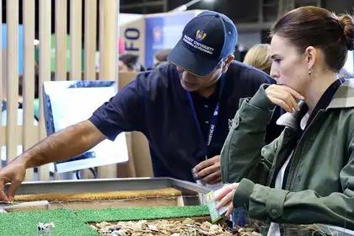Associate Professor in Environmental Hydrology and Soil Science Ranvir Singh explains to Prime Minister Jacinda Ardern the results of their research.

*Last updated: Monday 28 November 2022*

Massey University scientists unveiled a prototype of their novel systems for stripping nitrate from farm drainage at this year’s Fieldays, capturing hundreds of people's attention including farmers of all ages, members of the public and Prime Minister Jacinda Ardern.

Associate Professor in Environmental Hydrology and Soil Science Dr Ranvir Singh and Associate Professor in Soil Science Dr David Horne have been working on this project since 2018 and were excited to share the next step with the public.

The project involves working with local farmers to develop innovative drainage management practices to reduce nitrate losses from agricultural lands to waterways.

Project co-lead Dr Singh says artificial drainage systems provide an important function in poorly drained or very shallow groundwater areas. Drainage is beneficial in removing excessive soil wetness to support plant growth, grazing and field operations, but if not managed properly can lead to losses of nitrate from soils to waterways.

“Controlled drainage and woodchip bioreactors are cost-effective techniques to reduce nitrate in drainage waters; they don’t negatively affect drainage, are cheap to build, and require very little maintenance over their long life.

What we learn from this prototype is how these systems can be applied elsewhere."

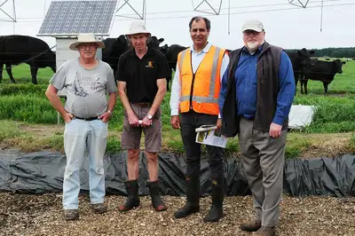Members of the nitrate team David Feek, David Horne, Ranvir Singh and Ross Gray.

### **How does it work?**

Woodchip bioreactors work in much the same way as wastewater treatment plants but for nitrate in drainage waters. As water from the drain is released into the bioreactor, the woodchips absorb the nitrogen and nitrogen-free water flows out.

Nutrient management and limiting the impacts on water quality are critical issues in agriculture and horticulture in New Zealand.

“If we can help farmers reduce the impact of their farms on surface water quality and help conserve drainage waters for use as irrigation, we can reduce the demand on ground and surface water sources, while improving their quality.

“This technology has not been trialed in New Zealand much before this project and it’s important we see how it can be applied and integrated into our agriculture systems here.”

Trials overseas in the US, Ireland and Denmark are different says Dr Horne as they have more arable systems and New Zealand has more open grazing.

“Nitrate is still a problem in all these places and the issues surrounding it are similar, so we do share and exchange knowledge globally.”

There have been on farm trials of the controlled drainage and woodchip-technology in Manawatū, but Dr Singh says bringing the research to Fieldays and sharing their findings so far helps to maintain momentum.

# **Productive farming with reduced nutrient loss**

Nutrients such as nitrogen and phosphorus can accumulate in the soils on farms and create leaching and runoff issues: nutrients can flow from farmland into waterways, where they promote excessive biological growth (of algae, for instance), which damages ecosystems by depleting dissolved oxygen and reducing the biodiversity of aquatic species.

Nitrate is highly soluble in water. However, nitrate is a reactive compound, so as it is moving through the environment, natural microbial activity can cause ‘From a sustainable development point of view we want to have a productive food system, but we don’t want nitrate to escape from farms to our receiving environment,’ says Associate Professor Singh. ‘It can leach via the drains that farmers have installed to take excess water out, and in some cases, it can go through groundwater to our waterways. In other words, nitrate can find different pathways to the receiving environment. The focus of our research is to find out where nitrate accumulation happens, why, and how we can enhance it to reduce the flow of nitrate from land to water.’

## We don’t want nitrate to escape from farms

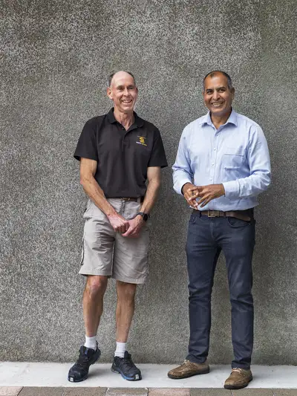Associate Professors Singh and Horne are using a combination of field observations, in-field experiments and hydrological models to study the flow of nitrate through the soil, groundwater and drainage systems to see how it gets into waterways. They have found that nitrate levels in groundwater can vary widely from one area to the next – even within the same farm – depending on variations in soil and geology.

‘We are looking to map areas of high and low attenuation in catchments,’ says Associate Professor Singh. ‘Once we can understand this, we can look at having intensive farming activities in areas that have more capacity to deal with nitrate attenuation and managing farming activities differently in areas where there is more nitrate leakage. That way we can optimise production in our catchment but have less nitrate going to our water bodies.’

Another area of research involves developing smarter drainage systems for farms to help reduce nitrate leaching. It is common for subsurface drainage systems to be installed on farms in areas with fine-textured soils that hold a lot of water, or where groundwater is shallow. The drains allow these areas to be used for intensive production, but they can become pathways for nitrate to go quickly into the environment. ‘We are experimenting with a controlled drainage system, which is an open drain with a structure installed in the outlet that can be closed to hold the water back and prevent the loss of contaminants. When a storm is coming, the drain can be opened,’ says Associate Professor Singh. ‘Usually, drains always work freely, but we want them to only work in wet times.’

This controlled drainage system is applicable mostly in flat areas, however, and is challenging to manage on slopes, so Singh and Horne are working on another technology based on woodchip bioreactors. These consist of lined trenches that are filled with woodchips. They hold drainage water for a certain number of hours, depending on the flow and concentration of nitrate, and allow the same process of denitrification that happens in groundwater.

‘The chips supply the carbon; microbes grow on them and reduce the nitrate in the water,’ says Associate Professor Singh. ‘We can have quite a high level of nitrate coming in and a low level going out. This performance of bioreactors depends on the flow conditions and can be optimised for local environmental conditions. We have built a bioreactor and controlled drainage network on a farm in coastal Rangitīkei and our initial findings suggest that a combination of controlled drainage and bioreactors can decrease nitrate losses from the fields by 70 per cent. We are creating flexibility in the system and making it more user-friendly, so farmers can control and treat drainage outflow from their fields.’

Finally, Singh and Horne are also exploring the potential of systems for drainage water recycling, where farmers can identify a low-lying area, direct drainage water into a pond or dam and put it back as irrigation, supporting production and closing a nutrient loop within the farm.

‘With drainage water recycling, woodchip bioreactors, controlled drainage, or a combination of those depending on the environment we are dealing with, we can build more nutrient attenuation capacity into our landscape and make more resilient catchments that are still productive with less nitrate going into our waterways,’ says Associate Professor Singh. Associate Professor Horne agrees: ‘Traditionally, reducing leaching is often costly and constrains production. These technologies allow us to maintain productivity and mitigate the impact on the environment in a very efficient and cost-effective manner.’

**IWI Perspective**

Tikanga Māori, Mātauranga Māori, Māori values and principles. The views and perspectives of Iwi (tribe) are most often seen through the lens of their ancestors, generations present and future, personal and shared experiences, observations, knowledge of traditions, events, resources and priorities of the time. They can be dynamic, changing and evolving but also static, fixed, and resolute. The tikanga (right ways of doing things), matauranga (knowledge), uara (values) and matapono (principles) can vary from Iwi to Iwi. They inform, guide, and sometimes direct the views and perspectives of Iwi. In relation to wastewater, whilst each Iwi and indeed each hapū will have their distinctive and specific experiences, there are some common, shared, and similar values and perspectives. At its most basic, human waste is considered harmful, tapu, and needs to be kept separate from where people cook, eat, harvest food, talk and sleep. Wai (water) is a taonga and essential to life. In Māori traditions water was present at the beginning of origin stories. It has a mauri (life force) and can be a medium for both enhancing and removing tapu. Papatūānuku (Mother Earth) is a primal parent, the foundation of all life. Papa is the cleanser and the place where all life returns. Kai (food) sustains life. Harvesting wild foods and crops are an important tradition among Iwi. Specific species of flora and fauna are synonymous with Iwi identity, mana (prestige) and hospitality. The abundance and high quality of these species is of paramount importance to Iwi.

**Example Locally :Matauranga Mauri in Science – Lake Oporoa, Rangitikei**

Lake Oporoa is a lowland lake connected by an outlet stream and wetlands to the Rangitīkei nearby. The lake is 7.1 hectares in area and 3 metres deep, and today is surrounded by farmland and a mixture of native evergreen and exotic vegetation. Lake Oporoa is a taonga with a rich history. The water quality in the lake has declined over the last 30 years.

**In this excerpt from the new book**[***Mountains to Sea: Solving New Zealand’s Freshwater Crisis***](https://www.bwb.co.nz/books/mountains-sea)**, Tina Ngata talks about the whakapapa of life-giving freshwater.**

### The whakapapa of water

Our world, Te Ao Māori, is a whakapapa – one vast genealogical chart that connects us as siblings, mutually dependent upon all that surrounds us in this time, and across time. Water first manifests in this genealogy as Wainuiātea – the great expanse of water, the gathering of all. We can therefore see freshwater as the inevitable consequence of atmosphere, upon which all life depends. It is brought about through the separation of land and sky.

Traditionally, these genealogical relationships aided our movements through this world. They helped us to understand our relationships to the trees, to the animals and the elements, and their relationships to each other. Whakapapa helped us to consider the consequences of our actions across multiple spaces and make sense of what was happening around us. Indeed, relationships – whakapapa – are regularly cited as a foundational principle of Te Ao Māori. Most certainly our belief system of interconnectedness underpinned a different set of obligations to nature, and in turning away from that system, we also turn away from those obligations. What was once a relationship based upon connectedness and reciprocity between us and our non-human ancestors thereby shifts towards one of dominion over and ownership of assets.

### **The sacredness of water**

When we consider these genealogical relationships, and the positioning of water within that genealogy, we see water for the sacred entity that it is – no less so than Rangi and Papa, the parents from whom we all descend.

In addition to the sacred dimensions of water we had, and have, many other uses for it too. Water, of course, is vital for food, and mahinga kai (food systems) form the centre of village life. For Māori, the ability to provide food direct from our sources was a reflection of our mana – it demonstrated our ability to work together, to care for our resources, to remember and retain the skills that our ancestors refined over thousands of years.

Water, like rain, and wind, was understood through a deeply complex framework, reflected by a multitude of names, each related to a different characteristic. Waiunu refers to drinking water, Manowai is water that has deep, strong undercurrents; Waiariki refers to healing or curative waters, often hot springs. At the other end of the scale we have Waiparu, clouded waters; Waipiro, odorous waters; Waikino, polluted waters; Waikawa, rancid, slow-moving waters; and Waimate, stagnant, dead or death-inducing waters.

Our ability to interact with these many forms of water appropriately depended upon our ability to ‘commune’ with the water, to listen, smell, taste and observe.

### **Waiora and ahi kaa – waters of life, and fires of occupation**

When we tell the story of the decline of the well-being of our own ancestral catchment, we often link it to the depopulation of our rural lands. Indeed, in many cases the degradation of our waterways, from a Māori perspective, is a part of a larger story of colonisation, urban migration and the loss of ancestral knowledge around care and communication with nature ‘By ‘rematriation’ I mean ‘to restore a living culture to its rightful place on Mother Earth,’ or ‘to restore a people to a spiritual way of life, in sacred relationship with their ancestral lands, without external interference.’ As a concept, rematriation acknowledges that our ancestors lived in spiritual relationship with our lands for thousands of years, and that we have a sacred duty to maintain that relationship for the benefit of our future generations.’

‘Mātauranga Māori may at times be enhanced by western science but must never be dictated by it.’ – Hal Hovell

My vision is the full restoration of our relationship to our waters. The honouring of our divine whakapapa, our genealogical relationship to and intimate interdependency with the waters. The return of our fluency in the communication of the awa, and responsiveness to the needs of our awa. The means of achieving this vision will require those same political, legislative, economic and educational tools. Within this vision rests the requirements for us to repopulate our territories and occupy our ancestral spaces. Within this vision also rests the requirements for us as Māori to engage with the gifts and skills left to us by our ancestors to inform our own creation, uptake and application of modern technology, in order to be the very best kaitiaki we can be.

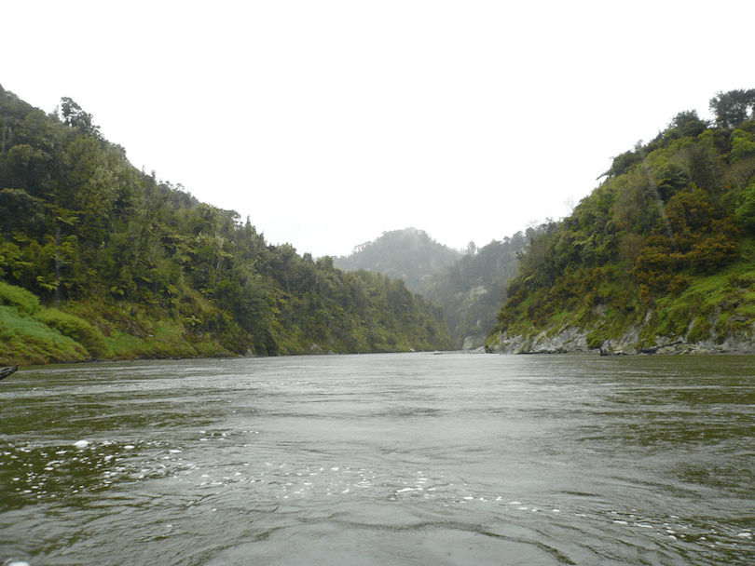In 2017, Parliament passed a historic bill to recognise the special relationship between the Whanganui River and Whanganui iwi which provided for the river’s long-term protection and restoration by making it a person in the eyes of the law.

While our ancestors left us valuable messages and inspirational models, we should never forget that our lands and rivers were different for them, with different needs, surrounded by different systems of living. Possibly the most powerful model of inspiration that we can draw from our ancestors is that of careful, purposeful care and observation. Through approaches informed by time-honoured holistic observations, and enhanced by technological advancements, our fluency in the reo of the awa can be renewed. Across our islands, our communities are taking up this challenge, and renormalising the ancestral arts of holistic, systematic observation and tracking. These systems of integrated habitat analysis are well recognised within conventional science as providing robust readouts on the well-being of freshwater systems – readouts that match those of hydro-chemical analysis.

The establishment of co-authority (Government, Iwi and Councils ) surrounding our taonga calls for planning and decision-making powers to be shared equally with iwi and hapū. The potential for these partnerships to afford our waterways the very best care possible will lay in the emphasis placed upon the vital dimension of relationship restoration. That challenge rests not only with us as tāngata whenua, but also with local government, which has become accustomed to the wielding of absolute power over the natural taonga of iwi and hapū.

While many challenges remain, I hold out great hope for our future – the intertwined future of our waters and us as people. Our healing journey as a nation, however, must begin now. It must begin with an honest account of colonisation and its impacts, it must begin with an understanding of the social dimensions of environmental devastation, and it must begin with immediate shifts in the power dynamics that have thwarted social and environmental progression. Where steps have been made in that direction, healing has begun. It is my vision, and prayer, that those steps continue.

In Our Region – Monitoring Lake Oporoa

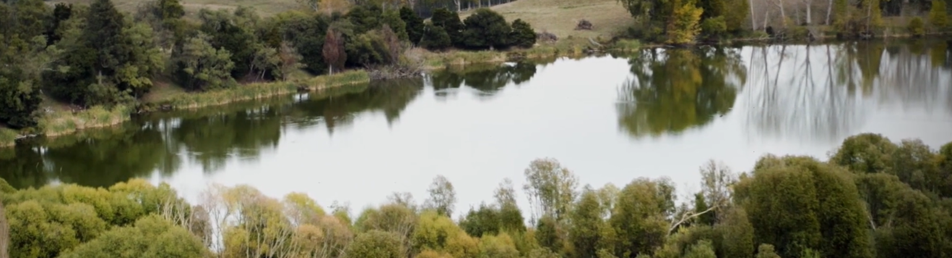Oporoa is a significant lake with a history that relates to an early Māori explorer who explored and named places in the area around 800 years ago. Following the flightpath of a huge flock of tūī, he discovered the lake making many observations of the wildlife flora and fauna that were present there. This information has been passed down through oral tradition. The lake was an important food gathering place and large numbers of Eel (tuna) resided in the lake. In the late 1940s and ’50s the annual spring rains would trigger a mass migration of Eels from the lake to sea. The eels are declining, due to nutrient enrichment and lower lake levels causing a decline in water quality.

The once plentiful tūī - and other native birds - have also declined as the native forest has been replaced by pastoral farming throughout the catchment. Sheep, cattle and other introduced species frequent the lake and its surrounds. Rain falling into the lake or flows in from the surrounding hillside is the only water source for the lake. There is evidence of an outlet drain being excavated next to the outflow stream, to lower the lake level which may be one of the causes of the current algal blooms in the lake. Anecdotal accounts suggest that the outflow stream and connecting wetlands that previously linked the lake with the Rangitīkei only flow infrequently during periods of high rainfall. Poplar trees planted 30 years previously have caused build-up of a layer of humus in the lake, due to the shedding of their leaves in the Autumn. This layer is very different and thicker than the previous clay rich layers. Eutrophication in the lake is caused by extra nutrients which runoff from the land to enter the lake, and coupled with higher temperatures cause an explosion in the algal population. In the summer this can block out light from reaching other plants in the lake, in the winter the bloom dies off and can remove oxygen from the water killing sensitive insects which are a food source for the fish present.

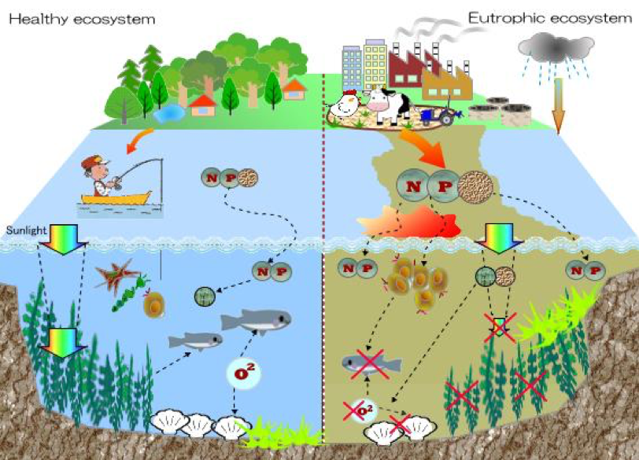

**Eutrophication**

Nitrogen and Phosphorous are found in fertilizers and animal faeces (poop). Both of these substances are easy to dissolve in the rainwater. Rainwater enters the lake as runoff, and this rich mixture of nutrients increases the rate of photosynthesis in Algae.

With the help of the local Iwi, the lake is to be restored to its natural state with the following measures :

1. *Removal of the Poplar trees and any other non-native plants, planting Kowhai.*
2. *Removal of the lake drainage culvert to allow the lake to reach its former level.*
3. *Riparian planting of Native species around and in the lake to improve water quality.*
4. *Increasing the biodiversity of the Aquatic environment with the reintroduction of lost species.*
5. Poplar trees are deciduous and provide shelter from the wind and were used to also remove water by evapotranspiration from the ground. They have a tendency to increase the pH of the soil, making it more alkaline. This in turn increases the pH of the water in the lake. Algae prefer a pH of between 7.0 and 8.0.

1. Shallow lakes allow more sunlight to penetrate to the bottom of the lake. If there is a darker layer of humus, this will absorb the suns energy and heat up the water above it more quickly that deeper water.

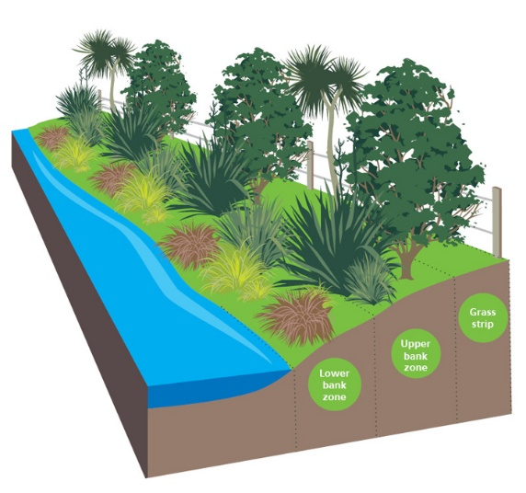

1. Riparian zones are the areas that border streams and rivers, and other bodies of water like ponds and lakes. Planting riparian zones benefits the environment by filtering sediment and nutrients before they enter waterways. The plants also help prevent bank erosion and improve the habitat for native wildlife. Riparian planting creates a buffer zone between the agricultural areas and the lake. This type of plant absorbs a lot of the Nutrients through their roots, removing it from the system. Manuka and Kanuka also have a lot of economic value, as well as providing shelter to other species.

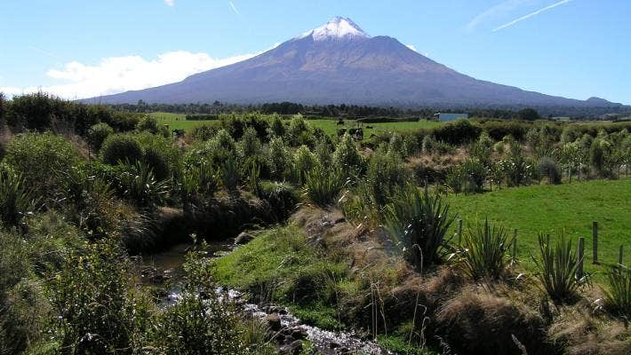**Does Riparian Planting Work ?**

Yes – but it needs to be done correctly. Planting near a waterway, it also must include the exclusion of cattle, a large source of N and P production to create a buffer zone. Studies have shown an increase in biodiversity in the Taranaki region, due to the uptake of these nutrients by riparian planting. This has resulted in much higher water quality, but you still wouldn’t want to drink or swim in it as E-Coli cannot be removed.

Increasing biodiversity increase the number of different living things in an ecosystem leading to a more complicated food web. Planting along the waters edge increases shade which some species prefer, and allows breeding grounds for others. This increase gives a greater variety of food sources to resident population of Eels, and encourages more wildlife further up the food chain. A typical NZ ecosystem (note Trout is an introduced species )

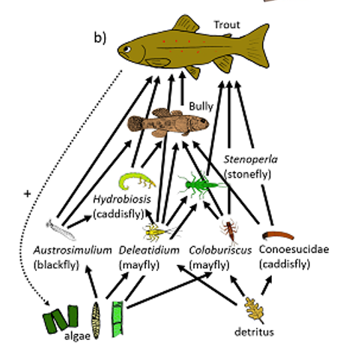

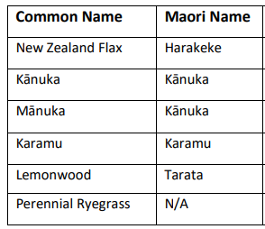

**Evidence Gathering Techniques**

Sediment Cores taken from the lake reveal how land use around the lake has changed over the last 1200 years. The grey areas indicate pollen levels in the lake sediment and the black indicates charcoal level and algae respectively. The chart below shows a typical core sample taken from NZ lakes.

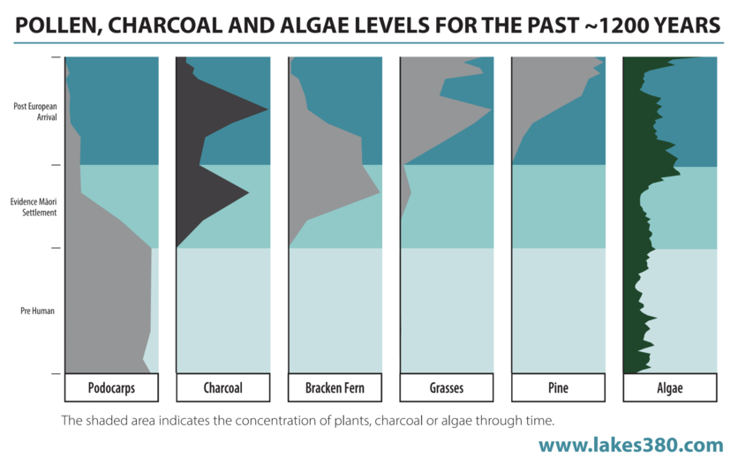

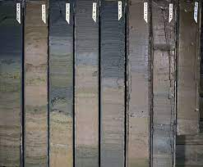Soil Cores are taken – the top of the core is the most recent material, and the bottom of the core is the oldest material. Cores from Oporoa contain a thick black layer of humus at the 30cm, with a high percentage of non-decomposed leaves. Cores like this may also contain layers of Ash from volcanic eruptions such as Tarawera in 1887 and provide useful dating evidence. **Carbon 14 dating** is used for older material. Some lakes have summer and winter layers, making the dates easier, similar to counting tree rings. From this data it is possible to see the changes over the last 1200 years of settlement.

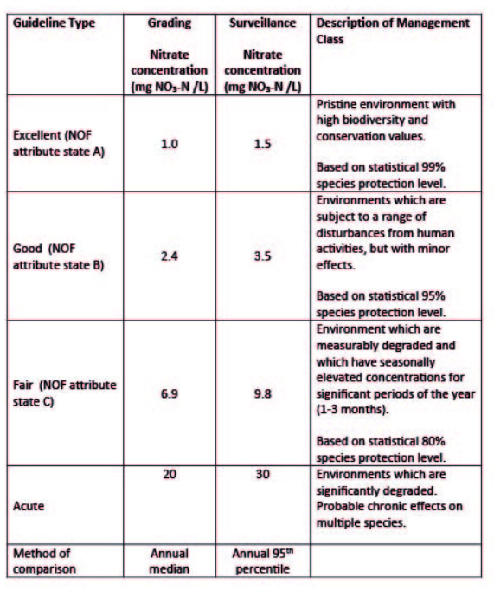

Grading System for Nitrate levels in

Water courses NZ (NIWA)

***How Radio-Carbon 14 Dating wor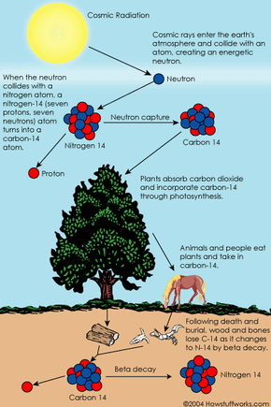k***

Co­smic rays enter the earth's atmosphere in large numbers every day, every person is hit by about half a million cosmic rays every hour. A cosmic ray collides with atoms in the atmosphere, creating an energetic neutron which collides with nitrogen atoms which turns into a carbon-14 atom. Carbon-14 is radioactive, with a [half-life](https://science.howstuffworks.com/nuclear.htm) of about 5,700 years.

The C14 created by cosmic rays combines with oxygen to form carbon dioxide, which plants absorb naturally and incorporate into plant fibres by photosynthesis (carbon exchange). Animals and people eat plants and take in carbon-14 as well.

As soon as a living organism dies, it stops taking in new carbon. The ratio of carbon-12 to carbon-14 at the moment of death is the same as every other living thing, but after death, the carbon-14 is not replaced. All living things absorb carbon from the atmosphere, including an amount of radioactive carbon-14. When a plant or animal dies, it stops absorbing carbon. But the radioactive carbon-14 it has accumulated continues to decay. Scientists can measure the amount of carbon-14 left over and estimate how long ago the plant or animal died.

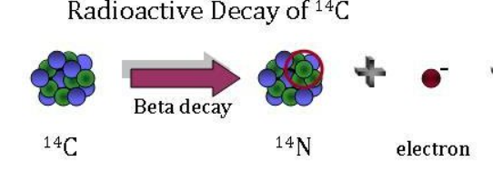

Why Core samples are Important

Core Samples allow us to examine how an environment has changed at a particular location over a long period of time. Lakes often lay down different sediment types in the summer and Winter time and these are easily identifiable. Once a layer is dated using C14, all the other layers can be identified.

Appendices – Quantifying Nitrate Levels

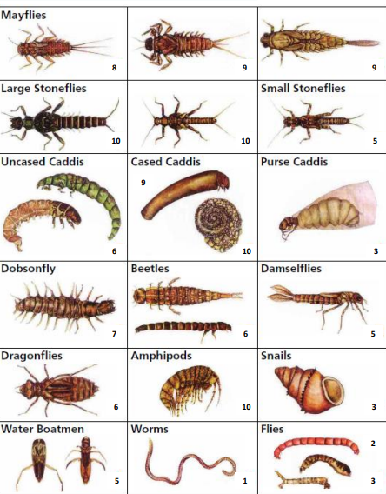

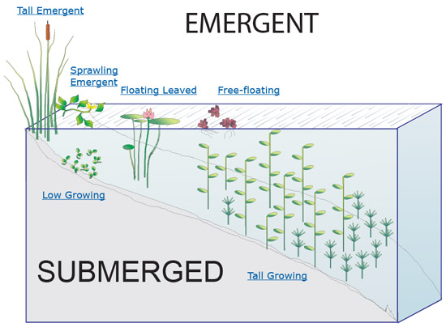

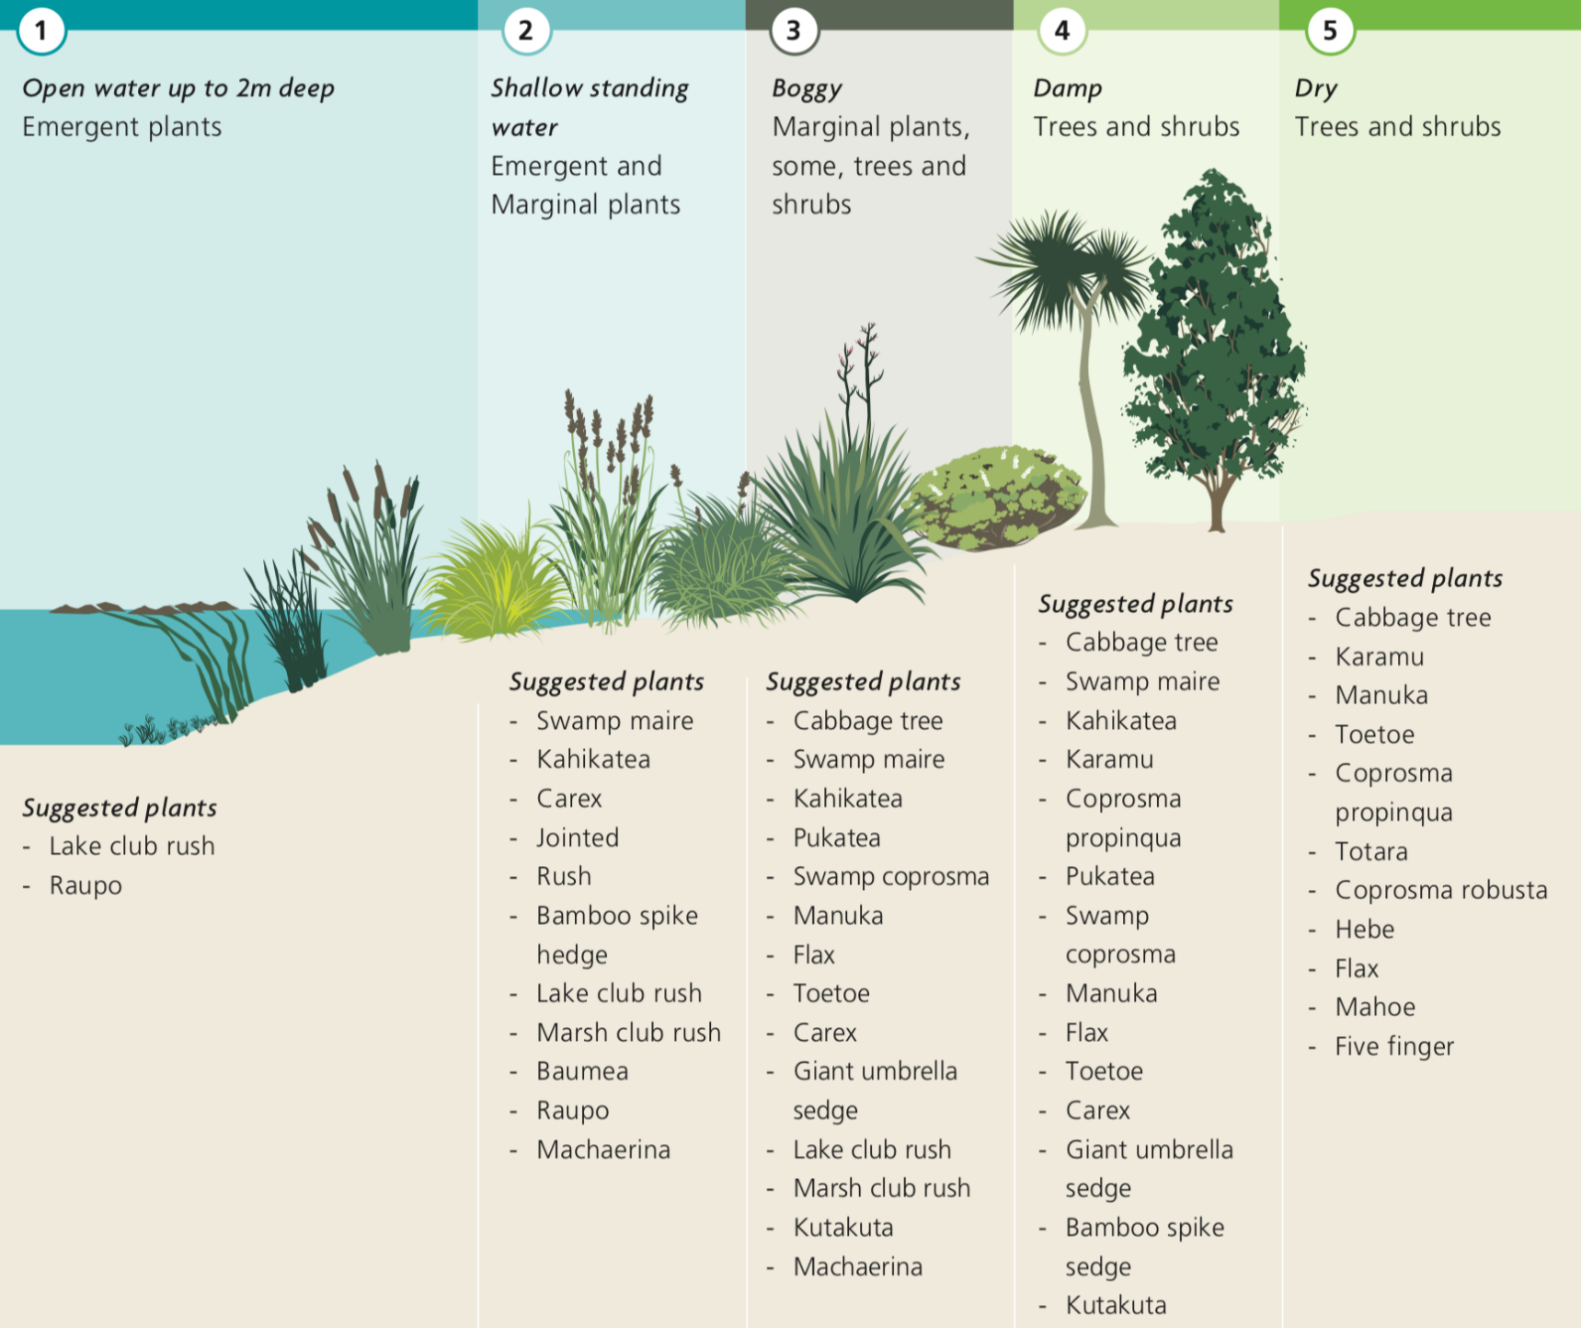

Everyone should be able to trust that the water from their tap is safe to drink. Access to safe drinking water is a basic human right – but nitrate contamination of drinking water is putting people at risk.

Scientists warn that high concentrations of nitrate in our water could be causing 100 cases of bowel cancer and 40 deaths per year in New Zealand. [1] Research has shown a link to bowel cancer from long term exposure to nitrate in drinking water above 1 mg/L (NO3-N) – a much lower amount than the current drinking water standard of 11.3mg/L.

**Nitrate is a natural chemical and it does occur naturally in groundwater, but generally at low concentrations. Estimates of natural nitrate-nitrogen concentrations in New Zealand groundwater range from as low as 0.25 mg/L (Morgenstern & Daughney, 2012) to as high as 3.5 mg/L**