4/1/2024
Richard Booth
Nga Tawa Diocesan 2024 91920
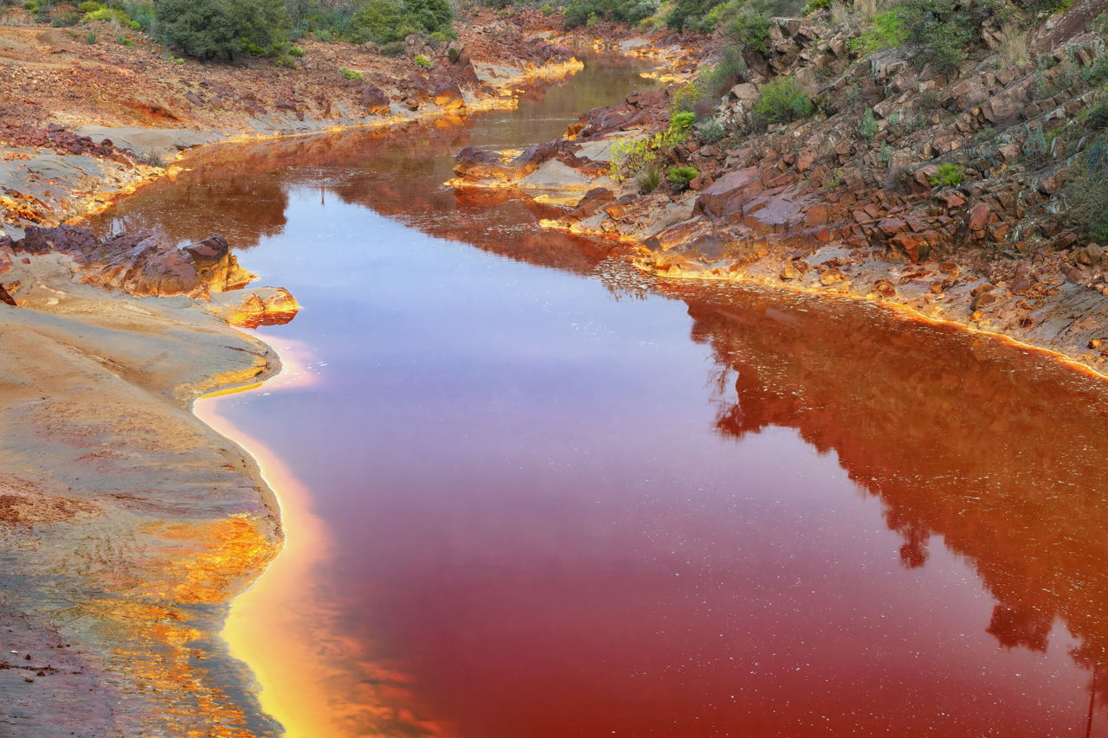
Is Our Water Really that Bad ?
Identifying the Problem.
In the resource book is a variety of Literature on the Water Quality of the Rangitikei Region
Identify the Issue facing our Region

What are the causes of this problem and why is it an issue of the 20th century ?

Notes on the Scientific Process that contributes Nitrates

Local Solutions to the Problem

History of the Area to be studied

Key Words and definitions

Data Collection
What area (s) is / are to be researched and how will your data be collected.

Iwi Perspectives

Analysis of Data

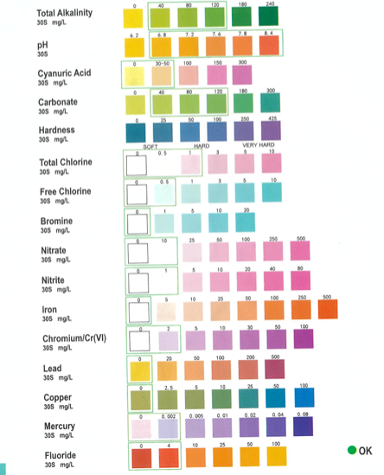
Survey Sheet – Water Quality
From the map, sample at each location marked on the map and use this chart to measure the levels of nitrate in the Lake Oporoa area.
Also record the levels of Nitrate from the Rangitikei river at one location specified or from a sample collected by your teacher.
The control sample is distilled water to make sure the test strips do not give a false reading.


Location (from Map) | Nitrite Level | Nitrate Level | pH | Total Alkalinity | Carbonate | Other Observations
A
B
C
D
E
F
other
Rangitikei Sample
Control Sample

Survey Data – Wildlife invertebrate survey
One Group will sample each location for wildlife invertebrate population, using the identification chart at one specific location, the data is then shared with the group to minimise impact of the environment. Each invertebrate has a score. Those marked in red indicate 3 different types for each, if found scores are added.

Location | Mayflies | Stonefly | Caddis | Dobsonfly | Beetle | Damselfly
A
B
C
D
E
F
Rangitikei
 | Dragonfly | Amphipod | Snails | Boatman | Worms | Fly Larva
A
B
C
D
E
F
Rangitikei

Processing of Data
Site | Total Score | Number of different Invertebrates (M) | Divide by (M) and multiply by 20 | MCI INDEX
A
B
C
D
E
F
Rangitikei

Site Map with locations marked

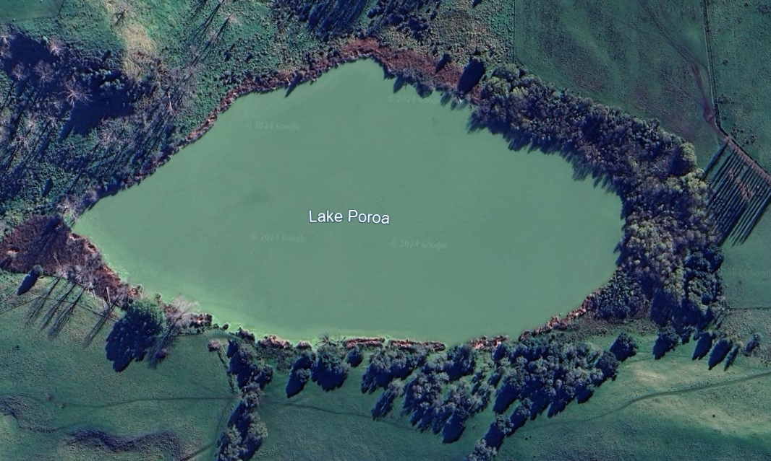

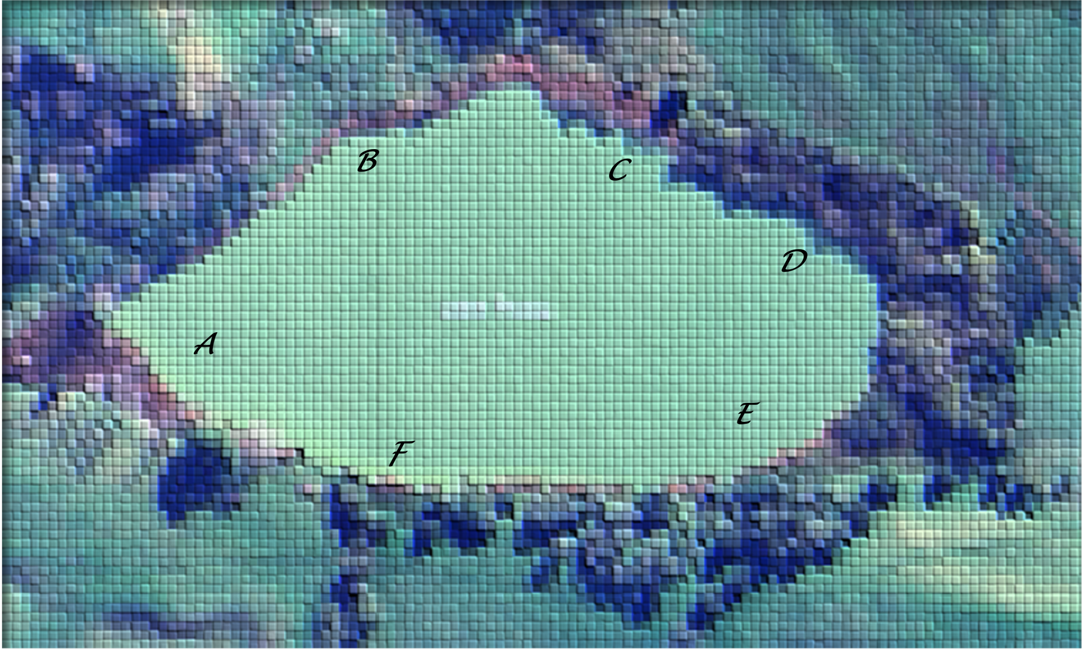

Riparian Plant Survey Emergent / Shallow Standing (RED = Invasive)

Emergent Plant | QR | picture | A | B | C | D | E | F | Rangitikei
Lake Club Rush |  | 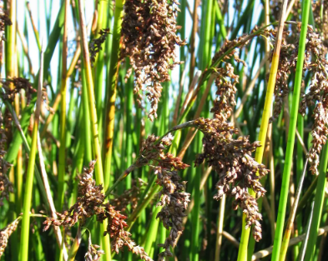
Raupo |  | 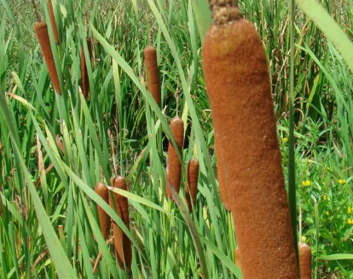
Waoriki |  | 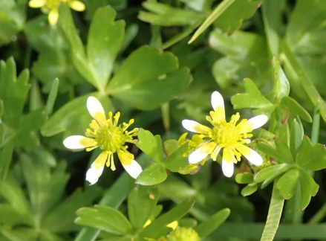
Parrots Feather |  | 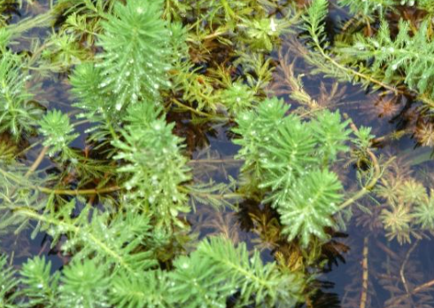
Alligator Weed |  | 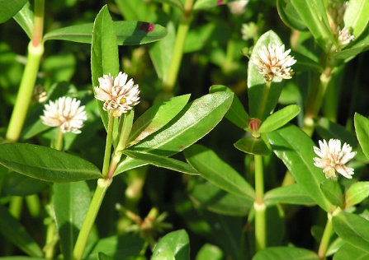
Parva |  | 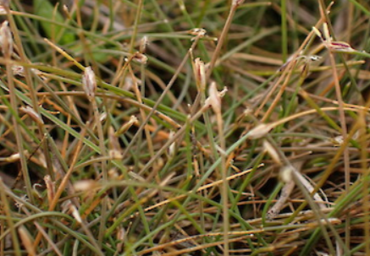
`
Other

Shallow Standing Plant/Boggy | QR | picture | A | B | C | D | E | F | Rangitikei
Swamp Maire |  | 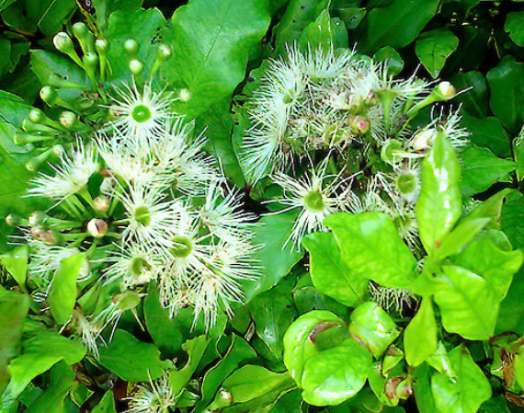
Kahikatea  White Pine |  | 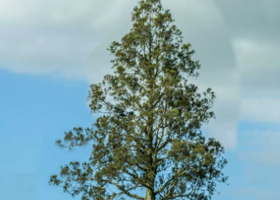
Carex |  | 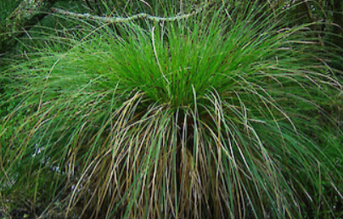
Lake Club Rush
Raupo
Bullrush
Pukatea  Laurel |  | 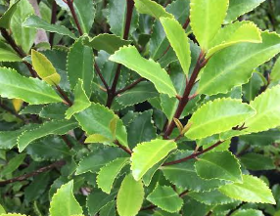
Kutakuta  (Bamboo Spike) |  | 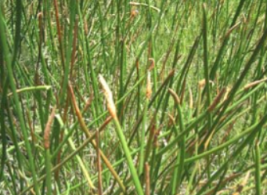
Manuka |  | 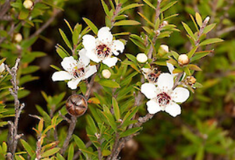


Notes and Ideas
Guiding Principle :

Notes


Use the Graph Paper to Plot any results
Observations/Conclusions



Observations / Conclusions

