**Pupuke Moana** – Najin Suvi, Massey HS

Today, we look at one of the oldest volcanoes in the Auckland Volcanic Field, Pupuke Moana/Pupuke Volcano!

Pupuke Moana is approximately 190,000 years old and is located in the northern Auckland Volcanic Field. It is classified as a maar volcano, formed during wet explosive eruptions that blasted a crater into the ground that later filled with water, forming Lake Pupuke. The lake's name is a shortened form of Pupuke Moana, meaning 'the overflowing lake', and in early European times was sometimes referred to as Lake Takapuna. Like most of Auckland's volcanoes, Pupuke erupted during colder ice age times when the sea level was below the present and the Waitematā Valley and its tributaries were covered in forest. Early lava flows from Pupuke invaded some of these nearby kauri forests, and the fossilised shape of some of these trees and branches can be seen within the solidified basaltic lava flows in Takapuna Fossil Forest. If you want a fun weekend activity, why not take a walk around Takapuna at low tide and try to spot some of these features!

**Geological overview of Pupuke Volcano**

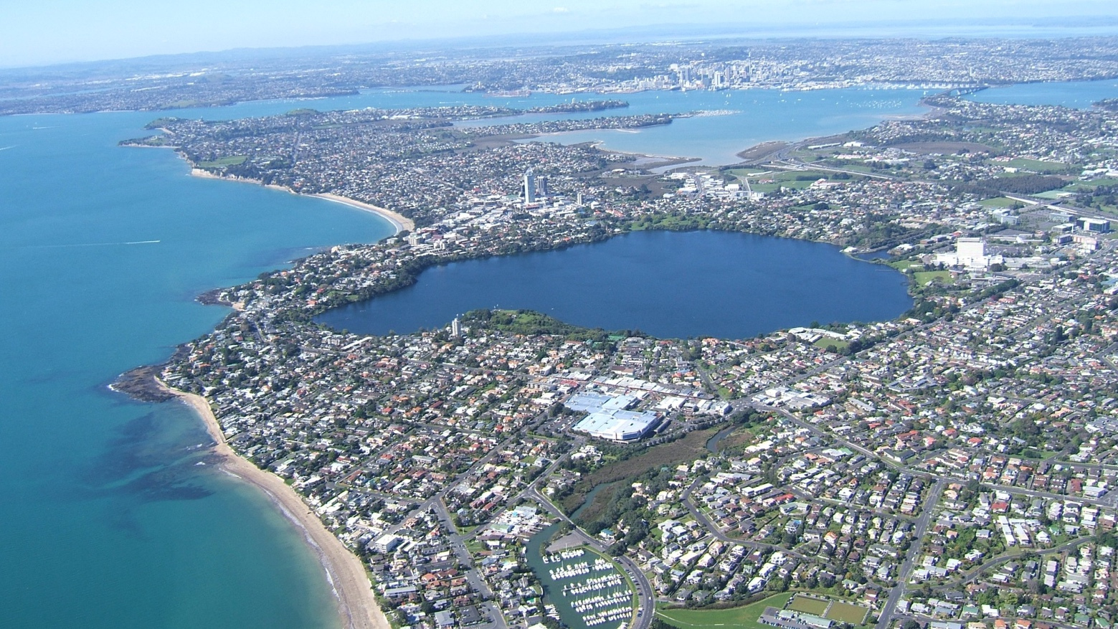

Lake Pupuke [Bruce W Hayward, 2009]

The eruptive sequence of Pupuke Volcano differs from all others in Auckland in that the wet explosive phase happened last. The early activity was through dry eruptions from two different vents; one near the centre of the present day, the other in the north-eastern corner where there is a semi-circular embayment in the lake's otherwise circular outline. These eruptions built a low shield volcano of thin overlapping basaltic lava flows, with two different lava compositions inferred to have erupted from each vent. These dry eruptions potentially produced small scoria cones directly above the vents, which can be seen solely as scoria deposits in the road and quarry faces near Northcote Road. Fire fountaining of frothy lava from an additional vent on the southwestern side of the basalt shield appears to have built up a small scoria mound removed mainly by the former Smales Quarry. The initial eruptions were followed by wet eruptions due to water suddenly entering the active vents and interacting with rising molten magma. These eruptions blasted out the large double crater, now Lake Pupuke, throwing out ash which built up a tuff ring on top of the shield volcano.

**Lake Pupuke as a water source**

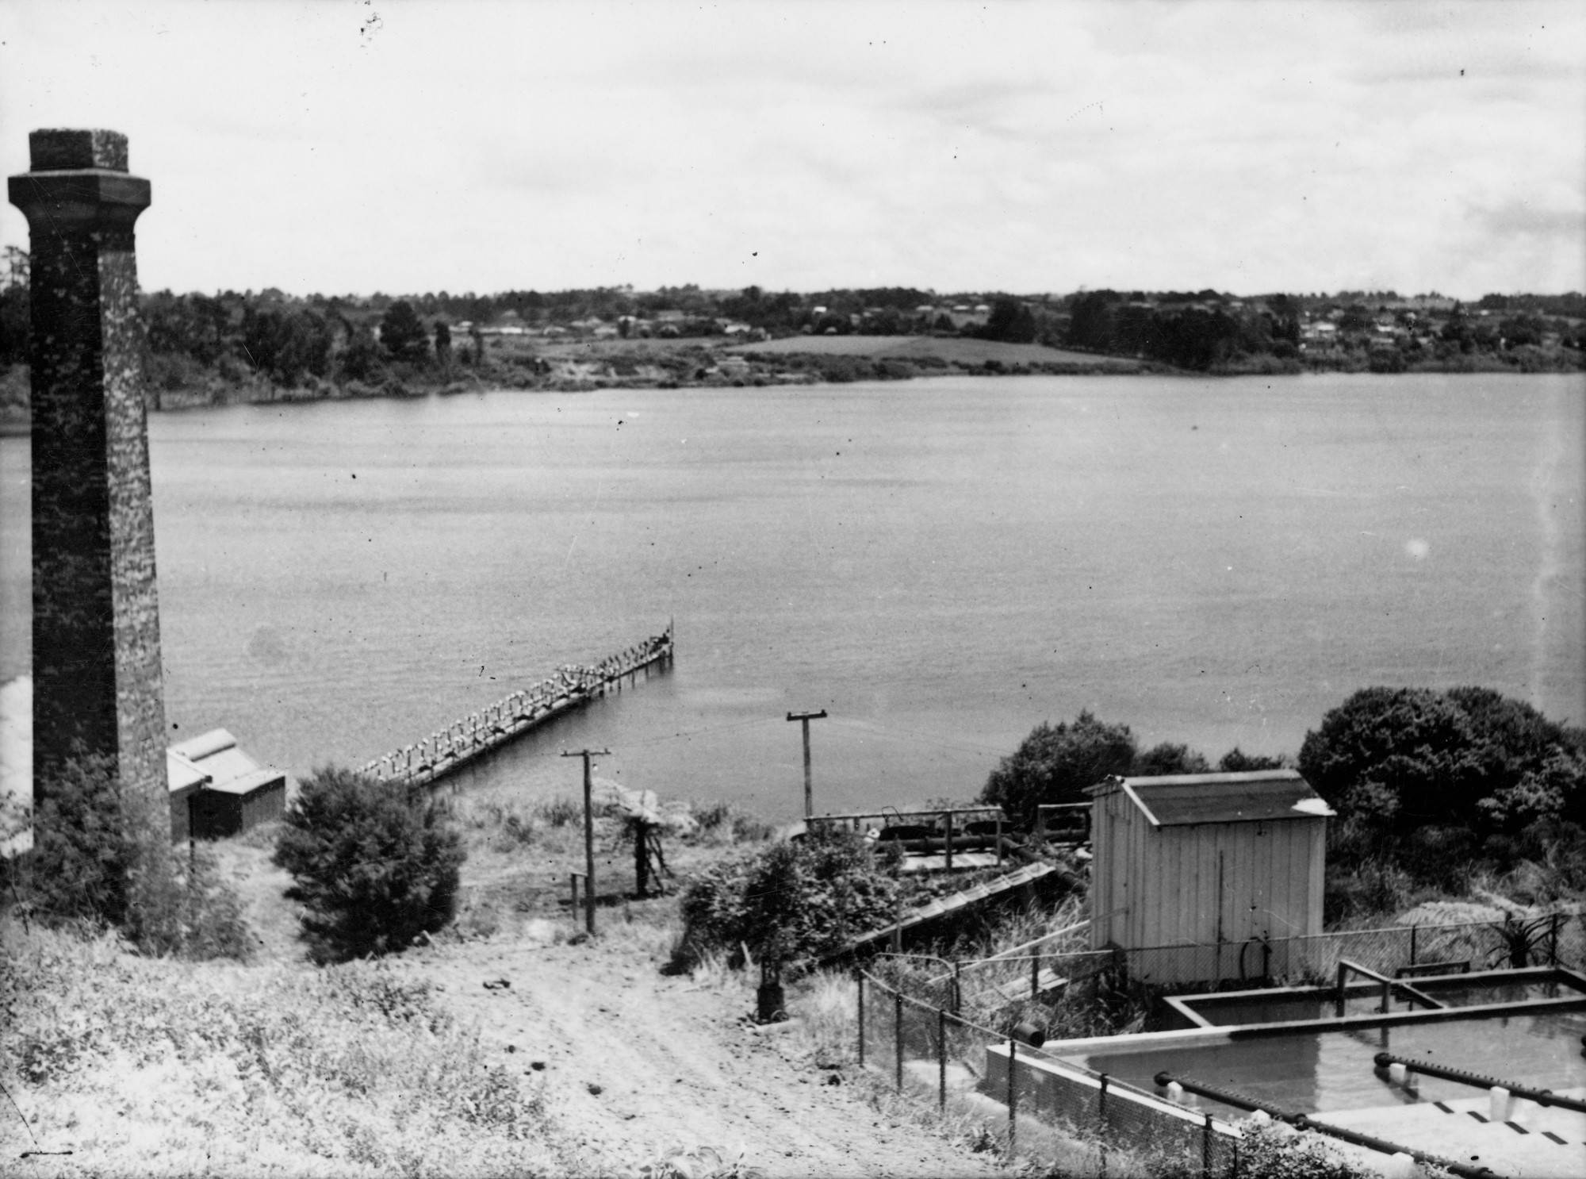

A view looking northwest over Lake Pupuke from the pumping station (Pumphouse) in the 1970s. [Auckland Libraries Heritage Collections T0318 [https://kura.aucklandlibraries.govt.nz/.../id/29906/rec/1](https://kura.aucklandlibraries.govt.nz/digital/collection/photos/id/29906/rec/1?fbclid=IwZXh0bgNhZW0CMTAAAR2Ra5io0161oLEhGmQqoGks34Jnh83Gfxhx2O49Nobqoutwf05NL_6x9Cc_aem_Aehf_f7FM-3735RIjewQOS4DRgwgUFO9yQ97WPfRpbiu9Hk4lQWx0QOk23uqHK4Owq7PIGxRtuFxD61tTBUHimZB)]

Pupuke Moana has the only permanent freshwater crater lake (Lake Pupuke) remaining in the AVF. The lake is roughly 1 km in diameter and 57 m deep. The lake water's surface is approximately 6 m above sea level, and natural outlets around Thorne Bay and Takapuna Reef control its level. Here, large volumes of freshwater flow from the lake through underground cracks in the basaltic lava flows and discharges intertidally. Lake water is derived from rain that falls on the lake and the surrounding area inside the tuff ring that slopes towards it.  
  
Water from Pupuke Moana was pumped out to provide the township of Devonport with the first reticulated water supply in 1894. The pumphouse, still standing in Killarney Park, pumped water to a buried storage reservoir on Takarunga/Mt Victoria beneath the summit's red and white 'mushroom' air vents. Water from the lake was also supplied to the Northcote, Birkenhead, and Takapuna Boroughs between the 1910s and 1940s; however, increasing demand and decreasing water quality meant that Pupuke Moana water was replaced by water from the Waitākere dams in the 1950s. Pictured is a view looking northwest over Lake Pupuke from the pumping station (Pumphouse) in the 1970s.

**Pupuke volcanic deposits along Northcote Road**

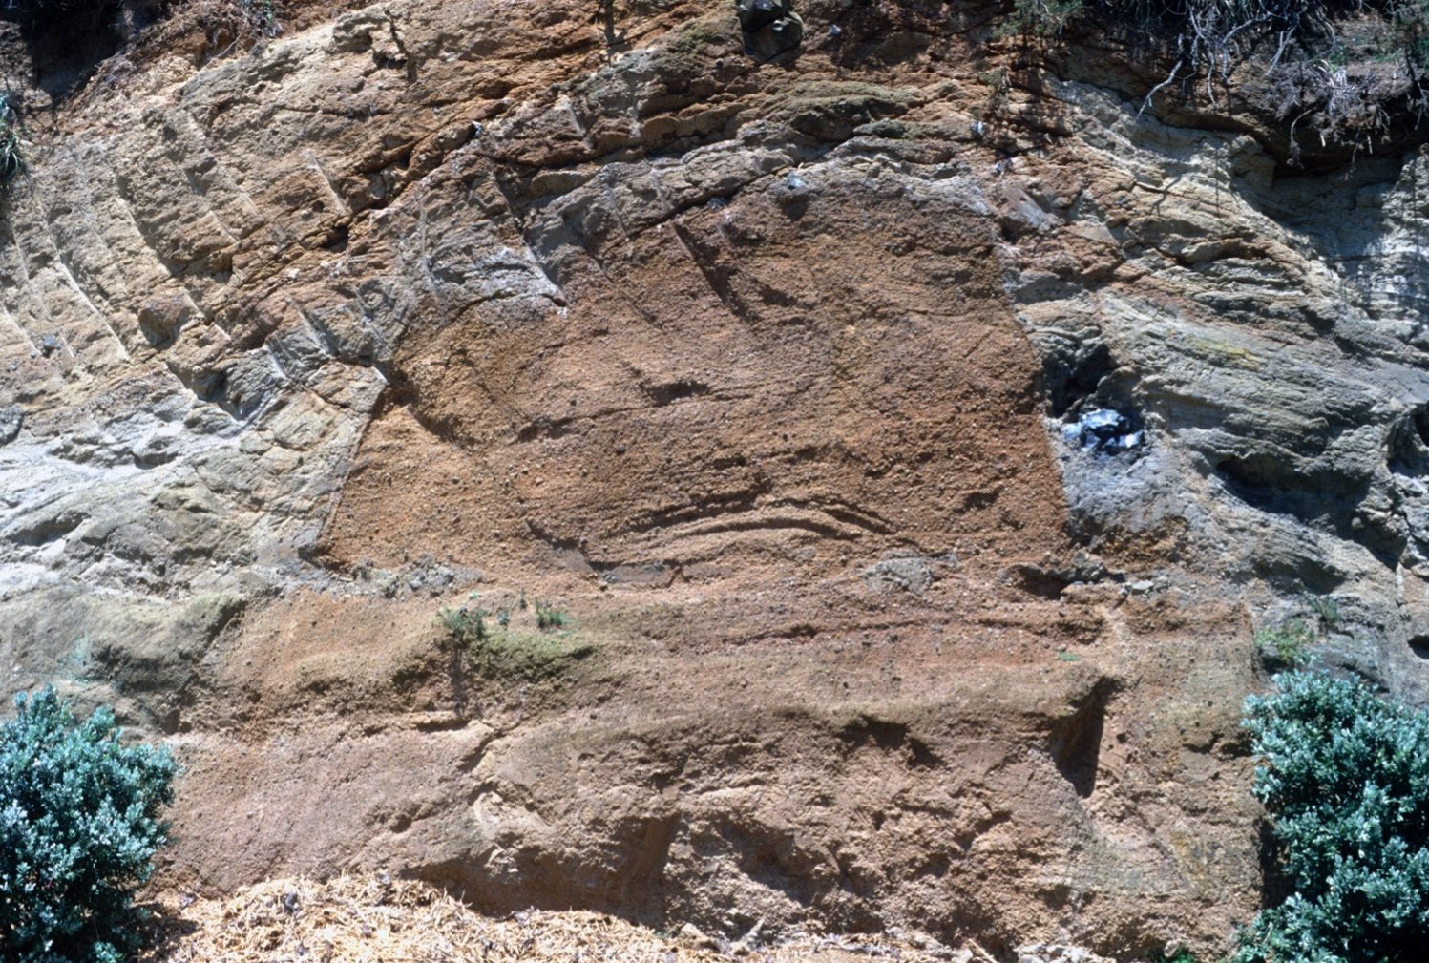

A steep-sided knoll of scoria within this tuff ring. Within the tuff, many cobble-sized lumps of sandstone ripped from the wall of the volcano's throat during the eruptions. [Bruce Hayward, 1994]

Near Northcote Road are exposed rocks that illustrate the sequence of eruptions that formed Pupuke Volcano. The base of the sequence is underlain by a dark grey basaltic lava flow, some of which was quarried away. The deep hole in Smales Quarry up the road on the east side was also formed by quarrying into the lava flow, part of Pupuke's early shield cone. Several thinner lava flows also part of this shield, separated by irregular horizons of broken basalt (breccia), form the uphill half of the road cutting. On top of these thinner flows is a layer of fine crumbly scoria that contains scattered light green olivine crystals. This mineral had crystallised out of the magma before it erupted and was ejected along with the semi-molten scoria in a dry fire-fountaining episode. Overlying the lava flow and comprising most of the road cutting is bedded tuff (ash) erupted by the subsequent wet explosive eruptions forming the tuff ring.

**Takapuna Fossil Forest**

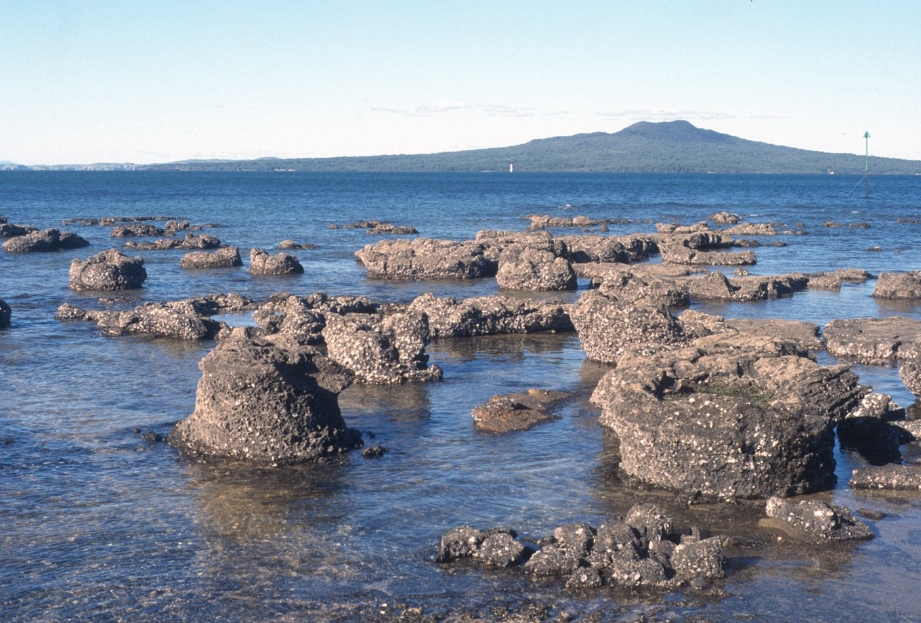

Some of the lava moulds you can see at Takapuna Reef. [Bruce Hayward, 1997]

During the eruption of Pupuke Volcano, sea level was much lower, and a kauri forest grew near the current-day Takapuna and Milford Beaches. The intertidal reef at the north end of Takapuna Beach is the best example in New Zealand of a forest killed and fossilised by passing lava flows. Takapuna Reef is composed of the remains of two thin lava flows from the initial eruptions of Pupuke Volcano that flowed through the forest, cooling and congealing around the tree stumps, forming cylindrical moulds composed of basalt around the trees before they slowly burned away. Most of the fluid lava between the moulds drained away later. As the tree moulds formed, the surface of the flow crusted over in some places, and some of this is preserved as arches between stumps that are close together.

**Takapuna-Milford Coastal Walk**

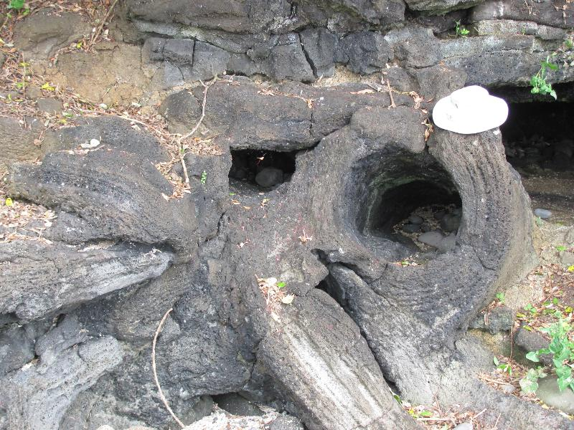

The hollow mounds of tree branches caught up in the lava flow from Pupuke erupting that can be rarely spotted from Takapuna to Milford Beach. [GEOTRIPS, J.Thomson/GNS Science, [https://www.geotrips.org.nz/trip.html?id=222](https://www.geotrips.org.nz/trip.html?id=222&fbclid=IwZXh0bgNhZW0CMTAAAR0SsEVUdIs9leyGhGOSrzwoM9PJaEXLwHCcJDbPZTi8XGAxKfKU-nMMwWQ_aem_AeikcLtdnHVhw2FKchTiHWQiooJi95yEm_Upiv-c9LrODICkKQYoKoxwe-Sja-8xPICiRUqRGsnfcU5rFrf72cW8)]

A popular walking path follows the coast from Takapuna Beach north to Milford Beach. Just past the end of Brett Ave, there is a 4-metre-deep and cylindrical lava mould of the lower trunk of a kauri tree growing here when Pupuke Volcano erupted. It is covered with a 1.5-metre-diameter metal cartwheel grill to prevent people from falling into the hole. As with Takapuna Reef, the lava flowed around the tree trunk and solidified around it, preserving its shape before it had time to slowly burn away. There was a shallow valley here, so the flow was thicker than at Takapuna Reef as it solidified. Because this lava flow was thicker, most of the smaller trees in this vicinity were wholly engulfed and burnt without leaving a mould. The outline of a second, similar-sized kauri tree mould filled with ash and debris can be seen under the path, 3 m south of the grill-covered one. A third, upright kauri tree mould can be found in the lava flow off the end of Minnehaha Avenue.

Don't forget to check out DEVORA's website <https://www.devora.org.nz/> and Instagram @devora.org.nz

FB post 16 Apr 2024