**A rare polar heatwave**

Adapted from NZ H 1 Aug 2024 by Jamie Morton[[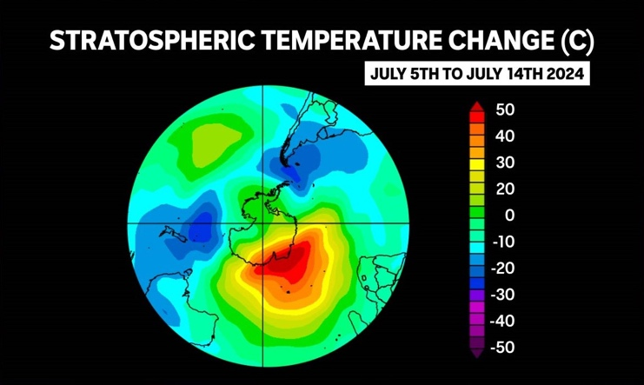](https://twitter.com/TheErimtanAngle/status/1817818873862947173/photo/1)](https://twitter.com/TheErimtanAngle/status/1817818873862947173/photo/1)

**Rare patterns unfolding high over the South Pole are putting an extra chill in New Zealand’s mid-winter weather.**

**What’s going on at the South Pole?**

Scientists are closely watching some unusual weather over Antarctica.

High temperatures over East Antarctica [NOAA]

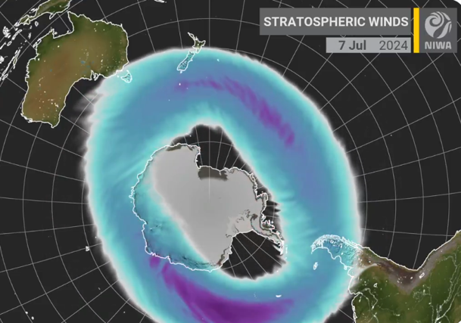In July, temperatures over the East Antarctica coastline suddenly climbed by an incredible 50oC. This sudden stratospheric warming (SSW) was accompanied by a dramatic decrease in wind speed in that atmospheric layer. This is a rare event, it has only been observed by satellites 3 times in the Southern Hemisphere (2002, 2010, 2019).

Particularly, the warmth is disrupting the polar vortex (its jet stream). Every winter, the polar vortex, a ring of fast-flowing stormy and freezing weather, forms high above Antarctica in the stratosphere. This year the polar vortex split in two, forming multiple centres of pressure. This was expected to drive both the temperature increase and the drop in wind speed in the stratosphere.

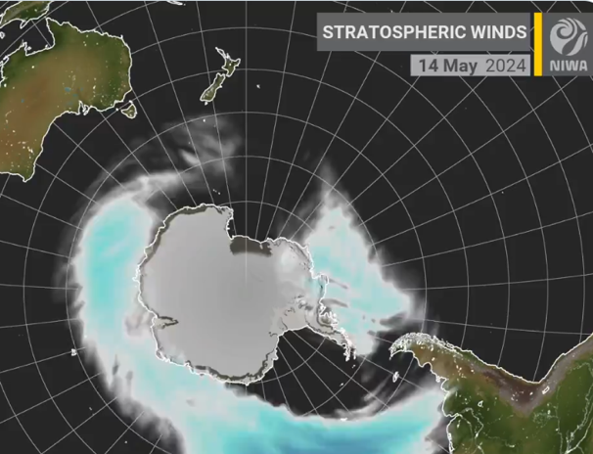Disturbances in the polar jet stream can lead to warmer conditions in Antarctica, while displacing some of its typically cold weather up to Australia and New Zealand. NIWA meteorologist, Ben Noll predicts “it does look like the core of some of that unusually cold air might shift toward South America, affecting weather right across the Southern Hemisphere.”

A normal polar vortex above and a disturbed polar vortex below. NIWA]

The SSW is also affecting the Southern Annular Mode (SAM). Westerly winds blow almost continually in our part of the Southern Hemisphere, but they can move North-South between us and the South Pole, alternating windiness and storm activity in NZ. This wind variability is the SAM.

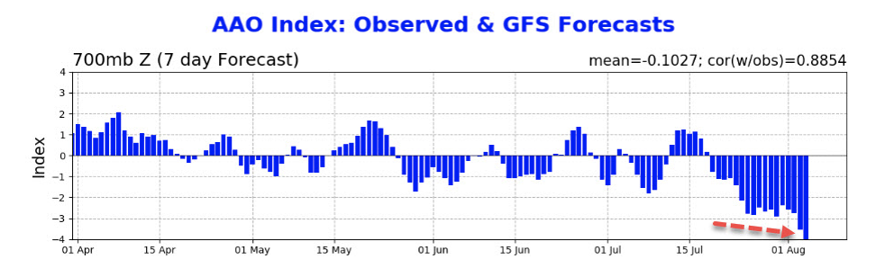The SSW is forcing the Southern Annular Mode down to negative values not recorded in July in over a decade. Lower SAM values mean high air pressure at the South Pole (and low pressure in NZ). Westerlies Increase around NZ, bringing stormy and chilly conditions. In the graph, AAO is a measure of the Southern Annular Mode.

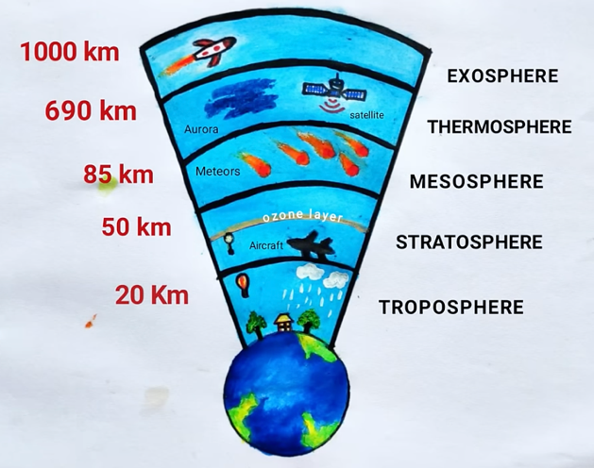**So what does that all mean for us?**

Strong SSW events in the past have typically spelt bitterly cold weather in New Zealand. Even if this event is weak we are still likely to experience colder temperatures than normal.

Rare disturbances in the stratosphere have flow-on effects for the weather in the troposphere – the lowest layer of the atmosphere.

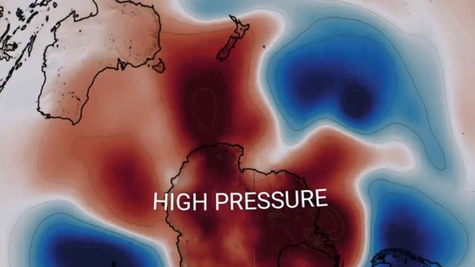Very high pressure over Antarctica, brings clear skies & calm winds, allowing for plenty of radiation cooling. Normally this would produce low temperatures, but with the weakened polar vortex temperatures are much warmer than normal at the South Pole.

# The layers of the atmosphere [MNSB]

On the other hand, NZ is likely to experience cold and even snow as a result of freezing air blown up from the Southern Ocean.

Dr Amy Butler, of the US National Oceanic and Atmospheric Administration, said the downstream impacts of this rare polar pattern were still unclear. It might “greatly reduce” the chances of a large Antarctic ozone hole - and hot and dry conditions in Australia often followed years when the polar vortex was weak.

Pressure anomaly over the South Pole. Red = above average pressure, white = near average, blue = below average. [NIWA]

Meanwhile, what will be our fourth La Nina climate pattern within a decade continues to develop in ocean waters near the equator - setting up an interesting wildcard amid the natural turbulence of spring weather.

According to Ben Noll, “We might be in for a bit of a bumpy ride as we watch these different climate drivers jockey for dominance.”

Questions

1. A. What normally happens in the stratosphere?
2. What normally happens in the troposphere?
3. In one sentence how are the 2 layers interacting here?
4. Describe 3 events happening at the South Pole this winter – try to summarise in 1 sentence each
5. Describe 2 effects on NZ’s weather
6. Do you think this is an example of climate change? Explain.

.