Types of investigations match-ups

Fair testing | This involves carefully noticing things around us.  This involves using our five senses: sight, touch, smell, sound and sometimes taste. | We used a carbon dioxide meter to observe the CO₂ levels in different areas around our school, including car exhaust. 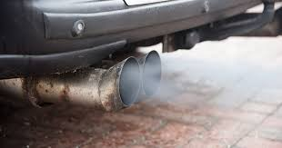 | This is a useful first step when investigating because you can use observations to design further investigations.  When exploring you can make a lot of different predictions, which you can go on to test.  If you notice carefully over time, you will be able to tell if there are changes happening in the environment.
Modelling | This type of investigation involves building recreations of a real -life phenomenon, often on a smaller or larger scale.  This can then be used to help us show or test how something works.  These can be built physically, or using a computer. | 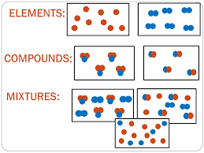We sorted chemicals into types: elements, compounds and mixtures | Find relationships between variables that can’t be controlled or manipulated to suggest causal links - ie) when we can’t do a fair test, like when we’re outside the lab.  However, there are many factors in the environment that can affect the data, so we don’t always know how reliable our conclusions are.
 |  | 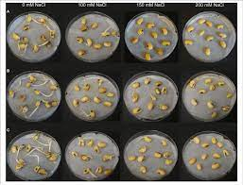  We re-created the effect of sea ice and land ice on sea level rise and re-created the effects of salt water on seeds. 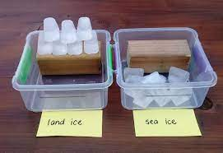 | We usually use this type of investigation when we carry out practical investigations in the lab, where conditions can easily be controlled.  This type of investigation doesn't really work when you need to do experiments outside or over a long period of time, or when you are investigating something very complicated (like the weather).
 | This type of investigation finds relationships between factors (variables).  In this type:  - Only one variable is changed (the variable you are testing = independent variable)  - Measure one variable (dependent variable)  - Keep all other variables the same (controlled variables) | 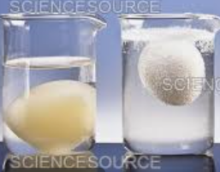We re-created ocean acidification by putting an egg in vinegar. | They are often used when we can’t test the actual thing, because it is either very small (eg an atom), very big (eg the universe), or a complex system (eg weather).  Useful because the recreation is often smaller, cheaper, or simpler scale to make than the real thing. They also help us make predictions into the future.  However, the model doesn’t always accurately represent the real thing.
Observing and Exploring |  | We took measurements and made calculations to figure out how fast different items moved.  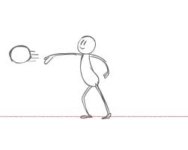

We watched and felt what happened to our sails when we pointed our sailing boats in different directions.

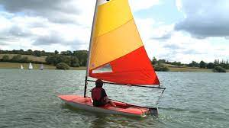
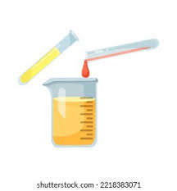
We made potions during our chemistry topic to see what would happen when we mixed a bunch of stuff together.

 | This type can be used when you are investigating something which cannot be tested using a “fair test” investigation. eg) When investigating with people or outside of the lab. Even though it’s not a fair test, we try to keep as many things the same as possible, so we can notice the things that are different eg) always observe the birds at the same time of the day.  This is very similar to observing and exploring but involves collecting numerical data (measurements or numbers of things). | Which bunsen burner flame lets out more heat energy - blue or yellow?  We did the same experiment twice, only changing the colour of the flame.  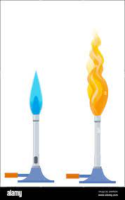
Pattern-seeking | Identifying and classifying involves naming things and sorting objects or events into groups or categories.  Keys are often used as criteria to carry out a classifying process for example, identifying and naming plants.  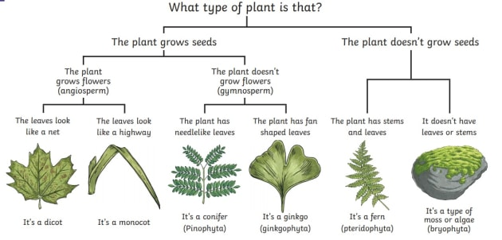 | We looked at climate change/ sea level rise graphs to find out the overall trend in changes.  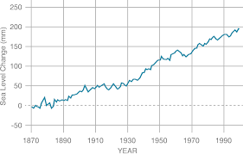
Identifying and Classifying |  | We sorted chemicals into the groups “acids”, “bases” and “neutral” using a universal indicator. 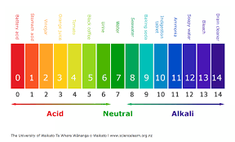 | Putting things into groups help us see the relationships between things.  Naming things helps us identify them again at a later time.  Sometimes, our knowledge changes about things, so we have to change the names or the groups that they go into.

