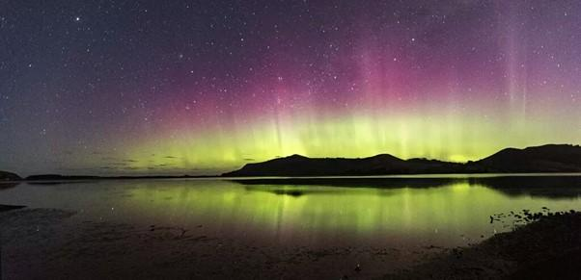
Earth and Space Science Educators of NZ Inc (ESSENZ)
Networks of Expertise: MOE10480_b-ac

Attn: ESSENZ PO Box 37-342 Christchurch 8245 admin@earthspacescience.org.nz
Earth and Space Science Te Riu-a-Māui NZ Geological History Webinar
When: 16th October, 4pm to 5pm
Where: Google Meet
Cost: No fee – the Network of Expertise funding covers this
What to bring: a good internet connection and plenty of questions. Feel free to send these through in advance.

To register: https://forms.gle/9PT7Gm86fr1E3BFB9

Outline:
4pm start
ESSENZ is running an Enrichment Webinar for ESS teachers nationwide. We will cover:
- Zealandia as a continent
- NZ's earliest rocks (greywacke and schist) from Gondwana
- Gondwana breaks up and the Oligocene "drowning" (limestone and fossil evidence)
- NZ Volcanoes over the last 25 million years
- Rising of the Southern Alps
Learning Outcomes
This will provide a deeper understanding of NZ Geological History to support teaching:
Year 7 – 10 Earth and Space Science
91189: Local Geology
91191 Extreme Earth Events
91412 Geological Dating
Other ESS standards.
- Now and the future

5pm finish
Justin Zani is the ESSE regional representative for the Otago/Southland area. Justin trained in in Outdoor and Science Education in Liverpool, and has been teaching in NZ for 14 years, the last 9 being at Otago Boys’ High School in charge of Earth and Space Science. Justin.zani@obhs.school.nz
Ross Stephen is the ESSE regional representative for the Auckland/Waikato area. Ross has trained and worked as a geologist, and has been teaching in NZ for 9 years at Avondale College in Auckland. R.Stephen@avcol.school.nz

