Age Of The Sea Floor

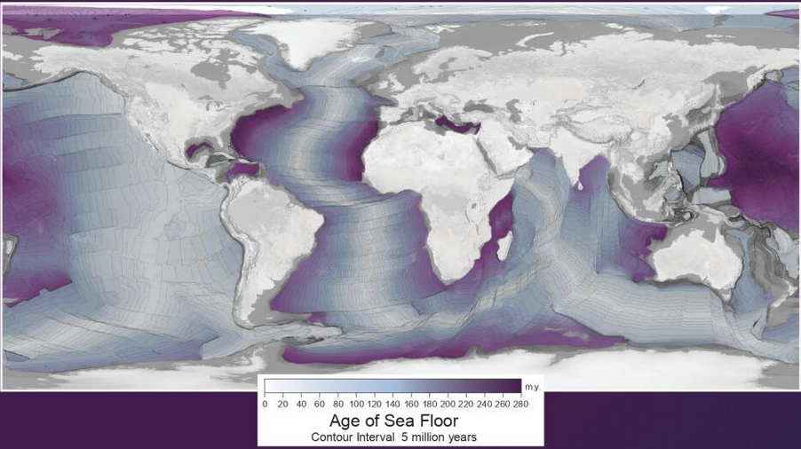

This map made for Earth Science week 2024, <https://agiweb-my.sharepoint.com/personal/smcgee_americangeosciences_org/_layouts/15/onedrive.aspx>

**Questions on the Age of Seafloor Map**

1. What patterns do you notice?
2. What is happening:
   1. At the parts of the ocean with a clear colour?
   2. At the parts of the ocean with a dark colour?
   3. What does it mean that the purple zone is so thin beside the western coast of South America?
3. How does this pattern relate to the tectonic plates (see image below)?
4. How do you think scientists know the age of the sea floor?
5. Referring to the large purple map overleaf, think also about these:
   1. What is left out?
   2. How does this representation get the message across?
   3. Why is it presented in this particular way?
6. Compare and contrast the purple map overleaf with this 3D image <https://sos.noaa.gov/catalog/datasets/age-of-the-seafloor/>.

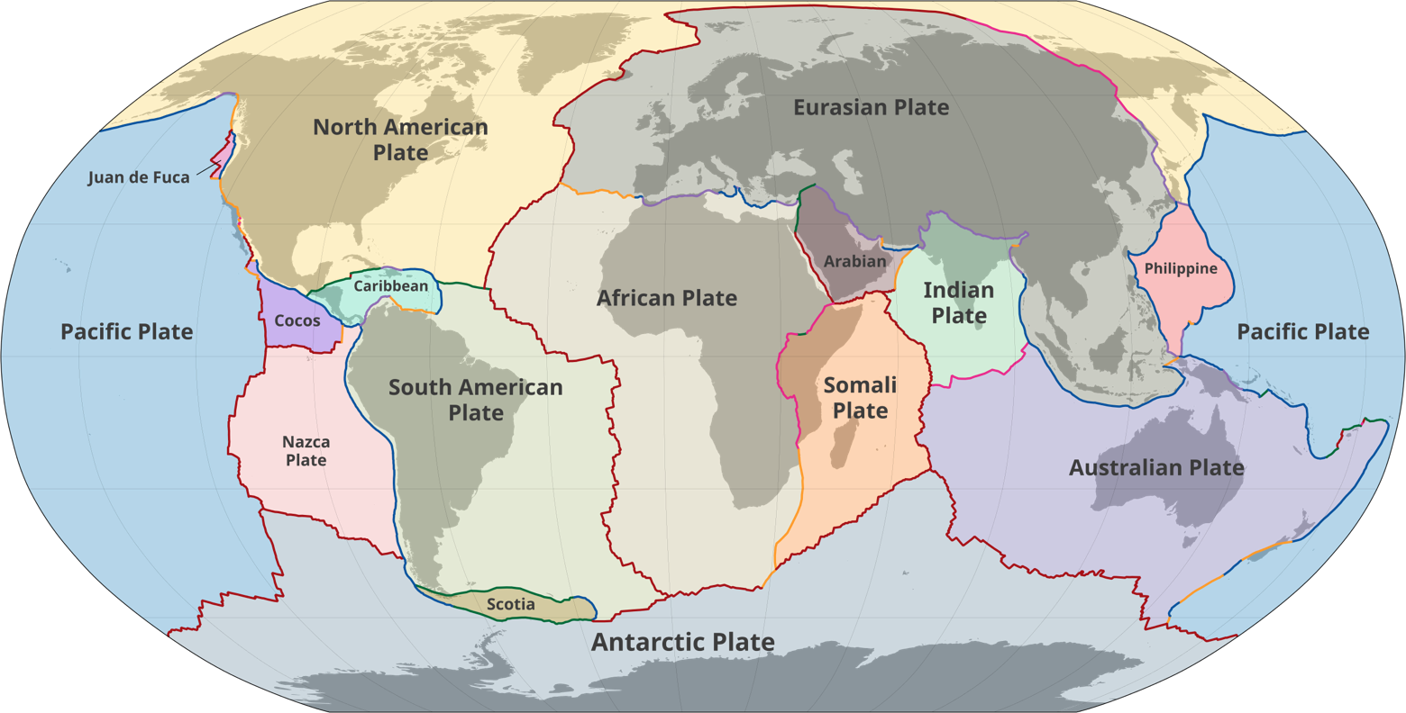



By M.Bitton - Own work based on: Hasterok, Derrick (8 June 2022). <https://commons.wikimedia.org/w/index.php?curid=130076176>

M Stone 2024